Chapter 2

Peripheral/Computer Connections

Questions & Answers
 | 2.1 | What is the main problem with priority interrupts? How can it be solved using nested interrupts? Explain with figure. [2004. Marks: 4]  The main problem with priority interrupts is that priorities of only 8 types of interrupts can be resolved as the PIC has only 8 IR input lines.  This problem can be solved using nested interrupts. In that case, many PICs can be attached to the master PIC in a nested way. Thus, more IRs can be handled through more IR lines.  8259A  (Master)  CAS0  CAS1  CAS2  8259A  (Slave #2)  CAS0  CAS1  CAS2  8259A  (Slave #1)  CAS0  CAS1  CAS2  Figure: Nested interrupts.
 | 2.2 | Draw a block diagram depicting the internal structure of the 8259A (Priority Interrupt Controller). Illustrate with example the use of IRR, IMR and IS register, INTA and EOI in resolving multiple interrupt requests. [2006. Marks: 4]  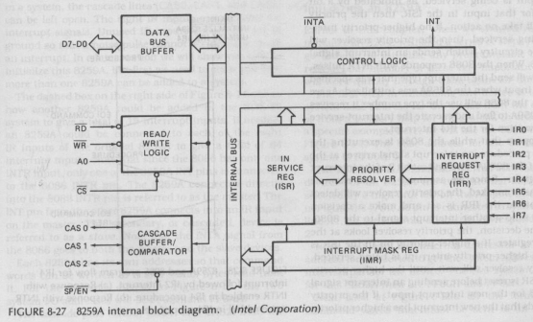  Figure: Block diagram of 8259A.  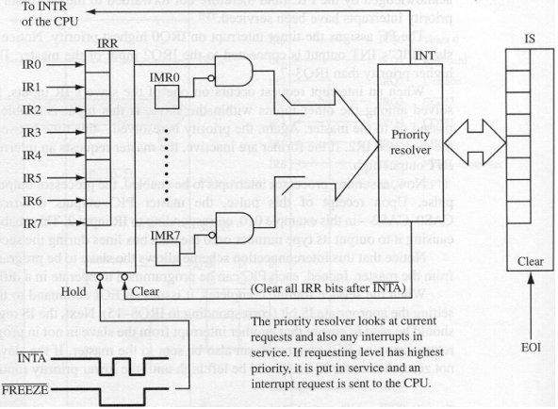  Figure: IRR, IMR and IS registers.  Interrupt Request Register:  Keeps track of which interrupts are asking for service. If a signal comes in the IR inputs the corresponding bit in the IRR register will be set.  Interrupt Mask Register:  Used to enable (Unmask) or disable (Mask) specific interrupts. Each bit in this register corresponds to the interrupt input with same number. To unmask a particular interrupt send a command word with a zero in the corresponding bit.  In Service Register:  Keeps track of which interrupts are currently in service. Used for priority interrupt handling. The corresponding bit of the current interrupt in service is SET.
 | 2.3 | Describe the bus operation of IEEE 488 instrumental interface. [2006. Marks: 3]
 | 2.4 | What is SCSI interface? Discuss on different types of SCSI systems with necessary figures. [2004. Marks: 4]  SCSI (Small Computer System Interface) is a parallel interface standard for attaching peripheral devices to computers.  There are three types of SCSI systems:  - One initiator, one target.  - One initiator, multiple targets.  - Multiple initiator, multiple targets.  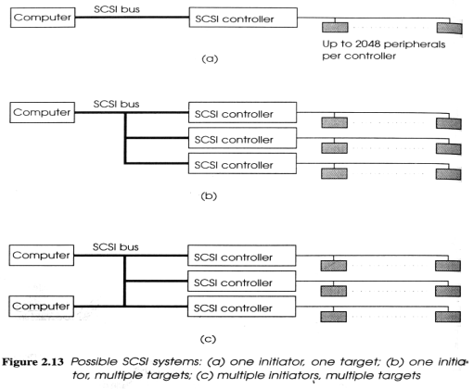
 | 2.5 | List down two major advantages of synchronous serial interface over asynchronous one. [2004. Marks: 2]  - In the synchronous serial transmission, the receiver uses a clock which is synchronized to the transmitter clock. Thus, the timing information is accurately aligned to the received data, allowing operation at much higher data rates.  - It also has the advantage that the receiver tracks any clock drift which may arise (for example, due to temperature variation).
 | 2.6 | What is software polling?  When using programmed I/O, if there are more than one devices being used, it is necessary to poll the ready bits of all the devices. The technique of testing a number of peripherals in turn is known as software polling.
 | 2.7 | How priority interrupts using daisy chain work?  Or, How priority of interrupts is maintained in priority interrupt scheme using daisy chain?  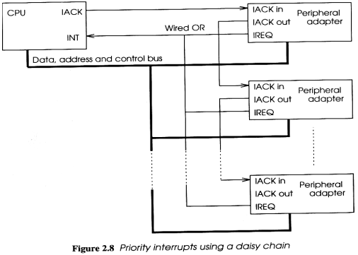  In daisy chain fashion, all the interrupt request lines are OR’ed together, but the CPU IACK line is connected directly to the highest priority device. So, if more than one request has been made, the highest priority device sees it first. If it has not made a request, it passes the IACK along to the next device. This continues down to the lowest priority device which will receive an acknowledgement only if no other device has made a request.
 | 2.8 | What are the advantages and disadvantages of memory-mapped I/O and Direct (or Port) I/O?  The advantage of memory-mapped I/O is that the device registers can be accessed and manipulated with any instruction or addressing mode that references memory operands.  The disadvantage of it is that some of the system memory address space is used up for ports and is therefore not available for memory.  The advantage of direct I/O is that no system memory address space is used; and its disadvantage is that new instructions or addressing modes are needed to access and manipulate the device registers.
 | 2.9 | What are the differences between block data transfer and DMA (Direct Memory Access)?  Block Data Transfer DMA  - While the block movement is in progress, CPU is unable to perform any other function. - DMA avoids the use of CPU completely for I/O transfers. (The CPU is used only to initiate the DMA controller.)  - Only suited to fast transfers where the CPU and peripheral speeds are reasonably well matched. - Suited for transfers of any speed.
 | 2.10 | What is cycle stealing?  In case of I/O transfers using DMA, the action of taking over the bus for a period of time and executing a memory access cycle instead of the CPU doing so is known as cycle stealing.
 | 2.11 | What are the advantages and disadvantages of parallel communication?  The advantage of parallel communication over serial communication is higher data rate due to the use of several lines. However, its disadvantages are cost and not being able to transfer data for a long distance.
 | 2.12 | Describe the input and output operations of a parallel interface.  In case of input from a device:  - The device puts a 1 in Data-in ready line.  - Data is kept on the Data IN bus.  - The interface then latches the data in Data-in buffer and puts a 1 in data-in ack line.  - After receiving the ACK, the device drops the Data and Ready signals.  - The interface then sets a Ready status bit and sends out an interrupt request (to the CPU).  - After CPU has taken data, the interface clears the Ready line and Data line.  In case of output to a device:  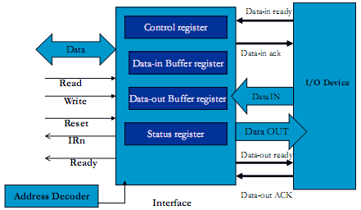  - The interface sets a Ready status bit and sends out an interrupt request when the data-out buffer is available.  - CPU outputs data to the interface.  - Interface then clears the Ready status bit, puts the data on the Data OUT bus and signals the I/O device over the Data-out ready line.  - The device would latch the data and return an ACK through the Data-out ACK line.  - The interface then drops the Data-out ready line and once again sets the output Ready status bit.
 | 2.13 | Why SCSI bus needs to be terminated?  If the SCSI bus is left open, electrical signals sent down along the bus might reflect back and interfere with communication between devices and the SCSI controller. So, the bus is terminated, closing each end with a resistor circuit.
 | 2.14 | Describe the types of bus signaling in SCSI.  - Single-ended (SE): Signal generated by controller is pushed to all the devices over a single data line. As each device acts as a ground, the signal quickly begins to degrade, which limits SE SCSI to a maximum of about 10 ft (3 m).  - High-voltage differential (HVD): Each device on the SCSI bus has a transceiver. Generated signal is received and retransmitted until it reaches the target device. The maximum distance in this case is 80 ft (25 m).  - Low-voltage differential (LVD): Similar to HVD, but in this case, the transceiver is built into the SCSI adapter of each device, thus making LVD SCSI devices much more affordable and less electricity-consuming. maximum distance in this case is 40 ft (12 m).
 | 2.15 | What are the types of SCSI termination?  - Passive termination: Used for SE SCSI devices.  - Active termination: Used for HVD and LVD SCSI devices.
 | 2.16 | Describe the mechanism of parallel-serial conversion.  OR, How does a UART (Universal Asynchronous Receiver/Transmitter) or USART (Universal Synchronous-Asynchronous Receiver/Transmitter) transmits data?  - Parallel data word is loaded into a shift register.  - A pulse on the clock input causes the data to be shifted.  - For an n-bit data word, n clock pulses will output the word in serial form.  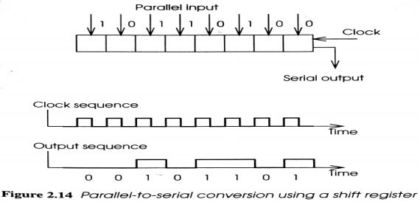
 | 2.17 | Describe the mechanism of serial-parallel conversion.  OR, How does a UART (Universal Asynchronous Receiver/Transmitter) or USART (Universal Synchronous-Asynchronous Receiver/Transmitter) receives data?  A sequence of n clock pulses causes the input to propagate along a shift register until all n bits are available in parallel. The first bit to arrive is shifted all the way through the shift register and appears at the right hand end.  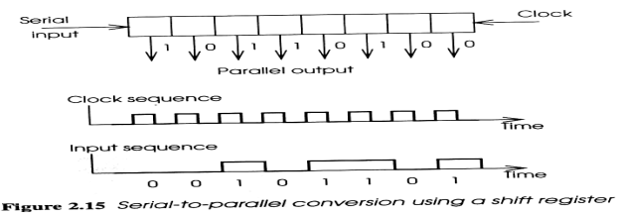
 | 2.18 | Describe asynchronous and synchronous transmission of serial data.  Lecture 7, slides 8, 9 and 12.
 | 2.19 | What is bit stuffing?  In case of synchronous transmission of serial data, to maintain the distinction between the opening/closing flag and the data, whenever five consecutive 1s are found in the data, a 0 is inserted after them. This technique is called bit stuffing.
 | 2.20 | What is a null modem?  Null modem is a communication method to connect two DTEs (computer, terminal, printer etc.) directly using a RS-232 serial cable.

Chapter 3

Display & Printing Devices

Theories & Concepts
3.1 | Liquid Crystal Display (LCD)  An LCD is a thin, flat display device made up of any number of color or monochrome pixels arrayed in front of a light source or reflector.  Liquid Crystal  Liquid crystals are substances that exhibit properties between those of a conventional liquid, and those of a solid crystal.  To which state liquid crystals are closer to and why /  Why liquid crystals are closer to liquid than solid /  Why liquid crystals are very sensitive to temperature  Liquid crystals are closer to liquid state than solid. It takes a fair amount of heat to change a suitable substance from a solid into a liquid crystal, and it only takes a little more heat to turn that same liquid crystal into a real liquid. That’s why liquid crystals are very sensitive to temperature.  Nematic Phase Liquid Crystals  Depending on the temperature and particular nature of a substance, liquid crystals can be in one of several distinct phases. Liquid crystals that are used in LCDs are from the nematic phase.  Twisted Nematics (TN)  Twisted nematics are a particular sort of nematic liquid crystals which is naturally twisted. Applying an electric current to these liquid crystals untwists them to varying degrees, depending on the current’s voltage. LCDs use these liquid crystals because they react predictably to electric current in such a way as to control light passage.  Polarization and Polarizers / Polarizing Filters  Polarization is a property of waves that describes the orientation of their oscillations. For transverse waves such as many electromagnetic waves (e.g., light waves), it describes the orientation of the oscillations in the plane perpendicular to the wave's direction of travel. In ordinary visible light, there are numerous wave components at random polarization angles.  A polarizer or polarization filter is a kind of optical filter which blocks or transmits light according to its polarization.  How polarization filters work /  How polarization filters control transmission of light  When ordinary visible light is passed through a polarization filter, the filter blocks all light except that having a certain polarization. When two polarizing filters are placed such that a ray of light passes through them both, the amount of light transmitted depends on the angle of the polarizing filters with respect to each other. The most light is transmitted when the two filters are oriented in the same direction. The least light is transmitted when the filters are oriented at right angles to each other.  How active matrix transmissive LCD works  See the image file accompanying the guide entitled “How LCD Works.jpg”. Note that in the image, it says that when a charge is applied to the electrodes, the liquid crystals twist; but it is wrong – when a charge is applied to the electrodes, the liquid crystals untwist. So, the concept of twisting with regard to applying current mentioned in the image is, in fact, opposite to the actual concept.  How twisted nematic liquid crystals work  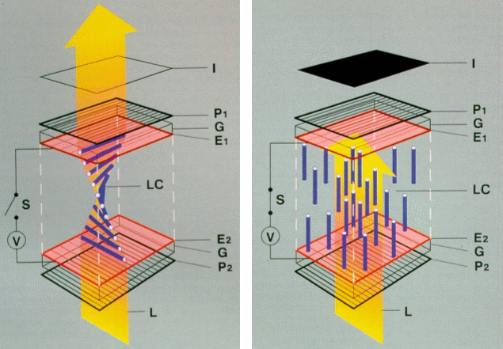  Rear side of the pixel  Rear side of the pixel  I = Cell  P₁ = Horizontal Polarizer  P₂ = Vertical Polarizer  G = Glass Plate  E₁ = Electrode Coated with Horizontal Alignment Layers  E₂ = Electrode Coated with Vertical Alignment Layers  LC = Liquid Crystal  L = Light  S = Switch  V = Voltage Source  Front side  of the pixel  Front side  of the pixel  (a) No voltage applied (OFF state) (b) Voltage applied (ON state)  Figure 3.1.1: Construction and operation of a single pixel of a twisted nematic liquid crystal cell.  A twisted configuration of nematic liquid crystal molecules (LC) is formed between two glass plates, G, which are separated by several spacers and coated with transparent electrodes, E₁, E₂. The electrodes themselves are coated with alignment layers (not shown) that precisely twist the liquid crystal by 90° when no external field is present (figure 3.1.1 (a)).  When light shines on the front of the LCD, light with the proper polarization will pass through the first polarizer (P₂) and into the crystal, where it is rotated by the helical (i.e, twisted) structure. The light is then properly polarized (through P₁) to pass through the second polarizer, set at 90° to the first. The light then passes through the back of the cell, which thus looks transparent.  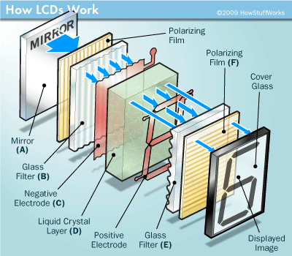  When a field is applied between the two electrodes, the crystal re-aligns itself with the external field (figure 3.1.1 (b)). This breaks the careful twist in the crystal and fails to re-orient the polarized light passing through the crystal. In this case the light is blocked by the rear polarizer (P₁), and the cell becomes opaque. The amount of opacity can be controlled by varying the voltage.  Figure 3.1.2: How Reflective LCD Works.  How active matrix reflective TN LCD works  The LCD has a mirror (A) in back, which makes it reflective. Then, we add a piece of glass (B) with a polarizing film on the bottom side, and a common electrode plane (C) made of ITO (Indium-Tin Oxide) on top. The common electrode plane covers the entire area of the LCD. Above that is the layer of liquid crystal substance (D). Next comes another piece of glass (E) with an electrode in the shape of the symbol to be displayed on the bottom, and on top, another polarizing film (F), at a right angle to the first one.  The electrodes are hooked up to a power source like a battery. When there is no current, light entering through the front of the LCD will simply hit the mirror and bounce right back out. But when the battery supplies current to the electrodes, the liquid crystals between the common-plane electrode and the electrode shaped like the symbol to be displayed untwist and block the light in that region from passing through. That makes the LCD show the symbol as a black area.  How active matrix reflective TN LCD works  Configuration  - Polarizing filter film with a vertical axis to polarize light as it enters.  - Glass substrate with ITO (Indium-Tin Oxide) electrodes. The shapes of these electrodes will determine the shapes that will appear when the LCD is turned ON. Vertical ridges etched on the surface are smooth.  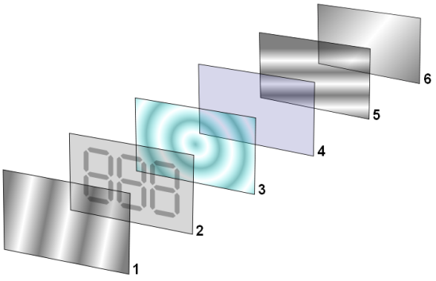  - Twisted nematic liquid crystal.  - Glass substrate with common electrode film (ITO) with horizontal ridges to line up with the horizontal filter.  Figure 3.1.3: Reflective TN LCD.  - Polarizing filter film with a horizontal axis to block/pass light.  - Reflective surface to send light back to viewer. (In a backlit LCD, this layer is replaced with a light source.)  Working Procedure  The electrodes are hooked up to a power source like a battery. When there is no current, light entering through the front of the LCD will simply hit the mirror and bounce right back out. But when the battery supplies current to the electrodes, the liquid crystals between the common-plane electrode and the electrode shaped like the symbol to be displayed untwist and block the light in that region from passing through. That makes the LCD show the symbol as a black area.  Different types of LCD  There are two types of LCD depending on the location of the light source:  - Transmissive LCD  A transmissive LCD is illuminated from the back by a backlight and viewed from the opposite side (front).  The illumination device used to illuminate the LCD in such a product usually consumes much more power than the LCD itself.  Applications: This type of LCD is used in applications requiring high luminance levels such as computer displays, televisions, PDAs (Personal Digital Assistant) and mobile phones.  - Reflective LCD  A reflective LCD is illuminated by external light reflected by a reflector from behind the display.  The absence of a lamp significantly reduces power consumption, allowing for longer battery life in battery-powered devices.  Applications: Digital watches and calculators.

Questions & Answers
 | 3.1 | How do active matrix LCDs work? [2005. Marks: 2]  OR, Describe the internal operation of LCD. [2007. Marks: 2.5]  When no current is applied to the LCD, light entering through the front of it will simply hit the mirror and bounce right back out. But when the battery supplies current to the electrodes in the LCD, the liquid crystals between the common-plane electrode and the electrode shaped like the symbol to be displayed untwist and block the light in that region from passing through. That makes the LCD show the symbol as a black area.
 | 3.2 | What are the different types of LCD? Explain their configuration. [2007. Marks: 5]  There are two types of LCD:  - Transmissive LCD  - Reflective LCD  Configuration of reflective LCD  See the “Configuration” section of “how active matrix reflexive TN LCD works” and figure 3.1.3.  Configuration of transmissive LCD  It is the same as the reflexive LCD except that it uses a backlight instead of a reflector to illuminate from the back.
 | 3.3 | What is liquid crystal? What is polarization?  Liquid crystals are substances that exhibit properties between those of a conventional liquid, and those of a solid crystal.  Polarization is a property of waves that describes the orientation of their oscillations. For transverse waves such as many electromagnetic waves (e.g., light waves), it describes the orientation of the oscillations in the plane perpendicular to the wave's direction of travel. In ordinary visible light, there are numerous wave components at random polarization angles.

Chapter 4

Input Devices

Theories & Concepts
4.1 | Keyboards  A keyboard is a bank of switches whose individual states can be detected by the computer system.
4.2 | Different Types of Key Switches  - Contact-Type Key Switches  - Contact type switch  - Membrane switch  - Dome switch  - Non-Contact Key Switches  - Hall effect key switch  - Capacitive key switch
4.3 | 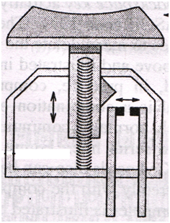Contact Type Switch  Figure 4.3: Contact Type Switch.  Key Plunger  Return Spring  Electrical Contacts  Working Procedure  Pressing the key plunger causes the contacts to touch and produce a voltage.  Key Bounce Effect  The contacts may bounce when the plunger is depressed giving the appearance of several rapid key depressions. This effect is known as key bounce.  This must be eliminated by special circuitry which effectively ignores the key after its first depression for a very short period of time.
4.4 | 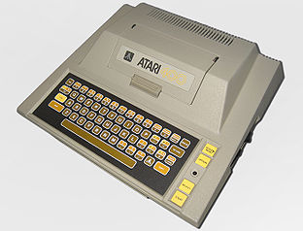  Membrane Switch Keyboard  A membrane keyboard is a computer keyboard whose keys are not separate moving parts, as with the majority of other keyboards, but rather are pressure pads that have only outlines and symbols printed on a flat, flexible surface. Very little, if any, tactile feedback is felt when using such a keyboard, and error-free blind typing can be difficult.  How it works  The membrane keyboard basically consists of three layers of material such as polyester or polycarbonate film. Two of these are membrane layers containing conductive traces. The center layer is a spacer containing holes wherever a key exists. It keeps the other two layers apart.  Figure 4.4.1: Membrane Keyboard.  Under normal conditions, the switch (i.e., the key) is open, because current cannot cross the non-conductive gap between the traces on the bottom layer. However, when the top layer is pressed down (with a finger), it makes contact with the bottom layer. The conductive traces on the underside of the top layer can then bridge the gap, allowing current to flow. The switch is now closed, and the parent device registers a key-press.  Membrane switches are inexpensive, thin, inherently sealed and can be waterproof. They are often used for control switches on peripherals such as printers.  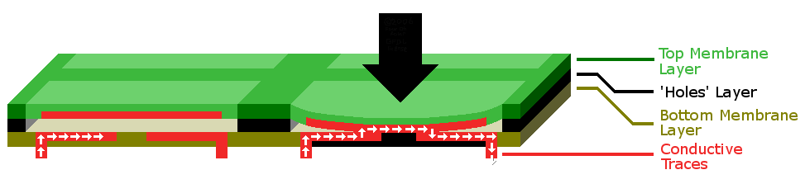  Figure 4.4.2: Cross-section diagram of a typical membrane keyboard. The thickness of the bottom three layers has been exaggerated for clarity; in reality, they are not much thicker than pieces of paper or cardboard.
4.5 | Capacitive Key Switch  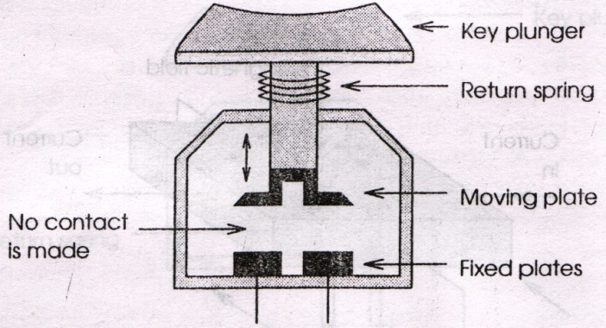  In capacitive key switch, two plates are mounted on the base of the switch. The key plunger holds a third plate which is brought close to the two fixed plates when depressed. An alternating current is applied to one fixed plate and sensed on the other fixed plate. As the two plates move closer together, the amount of current flowing through the matrix changes. The processor in the keyboard detects the change and interprets it as a key press for that location.  Figure 4.5: Capacitive key switch.  Advantages:  - Longer life than any other keyboard.  - Doesn’t suffer from key-bounce effect since the two surfaces never come into actual contact.  Disadvantage: This type of keyboards are expensive.
4.6 | 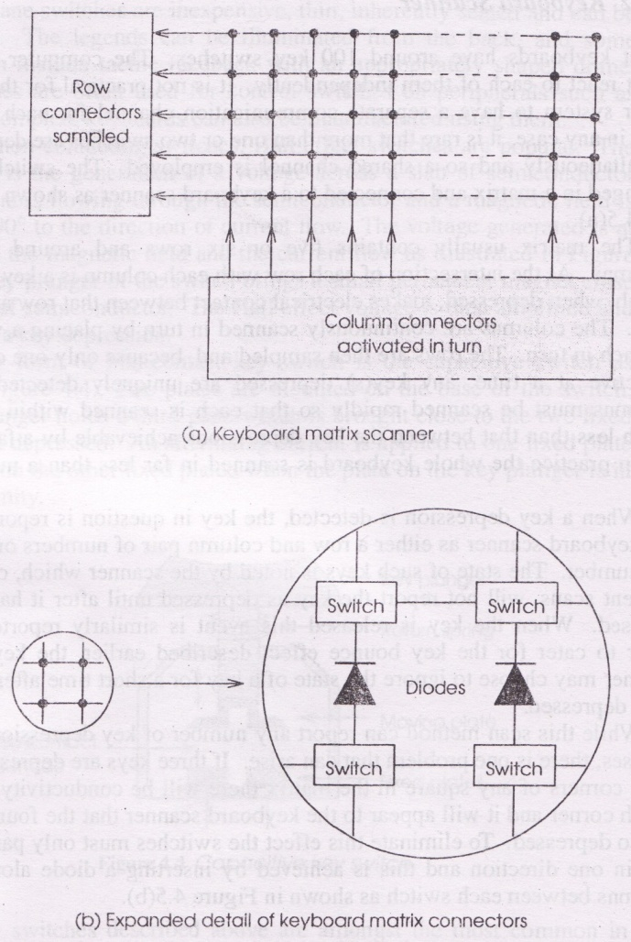  Keyboard Matrix Scanner  - Most keyboards have around 100 keys. The computer system must react to each of them independently. But it is not possible to have a separate communication channel for each switch. So, the switches are arranged in a matrix and connected to a keyboard scanner.  - The matrix usually contains 5 or 6 rows and around 20 columns.  - At the intersection of each row with each column is a key switch which, when depressed, makes electrical contact between that row and column.  - The columns are continuously scanned in turn by placing a voltage on each in turn.  - The rows are then sampled and because only one column is active at a time, any key depressed is uniquely detected.  - The columns must be scanned rapidly (far less than 1 millisecond) so that each is scanned within a time much less than that between the key depressions achievable by a fast typist.  - When a key depression is detected, the key is reported by the keyboard scanner as either a row and column pair of numbers or a single number (scancode).  Figure 4.6: Keyboard matrix scanner.  - When the key is released this event is similarly reported.  - To ignore the effect of key bounce, the keyboard scanner may choose to ignore the state of a key for a short time after it has been depressed.  - This scan method can report any number of key depressions and releases.  A problem that can arise with matrix scanner  If three keys are depressed on three corners of any square in the matrix, tehre will be conductivity at the fourth corner and it will appear to the keyboard scanner that the fourth key is also depressed.  To eliminate this effect, the switches must only pass current in one direction, and this is achieved by inserting a diode along the columns between each switch as shown in figure 4.6 (b).
4.7 | Keyboard Controller  The keyboard scanner produces key depression and release messages identifying the key by its position in the matrix. Sometimes this information may not be sufficient and further processing might be needed. This processing is done by the keyboard controller.  What is a keyboard controller  A keyboard controller is an IC which receives a series of events relating to key depressions and releases and, in response, sends a series of character codes to the system.  Functions of a keyboard controller  Keyboard  Scanner  Keyboard  Controller  Depression /  Release Codes  Character Codes  Figure 4.7: Role of keyboard controller interface.  The ‘processing’ that a keyboard controller does are primarily:  - The key identified by the position in the matrix must be translated to a code for that character such as its ASCII code. This can be performed using a look-up table.  - Keys such as Shift, Control must be interpreted. These keys do not result in a character being sent but affect the interpretation of the other keys. When these function keys are depressed, a different look-up table will be used until they are released.  - A common feature is to produce a character repeatedly while a key is held down. These productions of multiple characters for a single key depression are also a function of the keyboard controller.  Location of a keyboard controller  In a terminal which includes a keyboard and a screen, the controller exists inside the terminal. In a personal computer or workstation, the controller may exist inside the system unit.
4.8 | 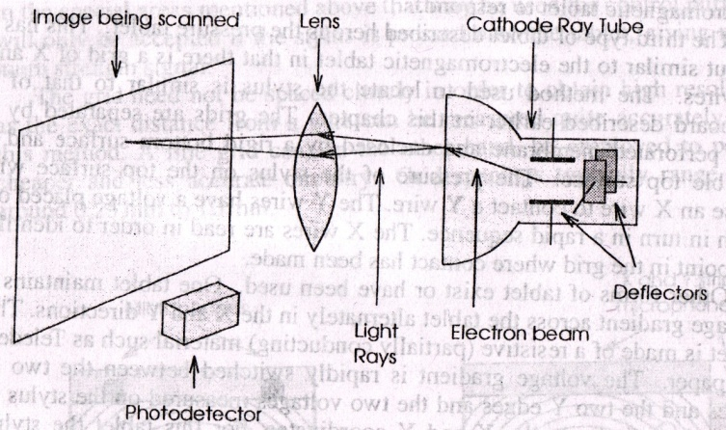  How CRT (Cathode Ray Tube) Scanner Works  - The image on paper is scanned row by row and each row is divided into a number of pixels.  - The intensity of the reflected light is measured as each pixel in turn is illuminated.  Figure 4.8: CRT Scanner.
4.9 | How Line Scanner Works  - This scanner illuminates the whole image and then focuses the light reflected at each pixel onto a photodetector.  - One whole row or line is scanned at a time and this requires a row of photodetectors – one for each pixel in a row.  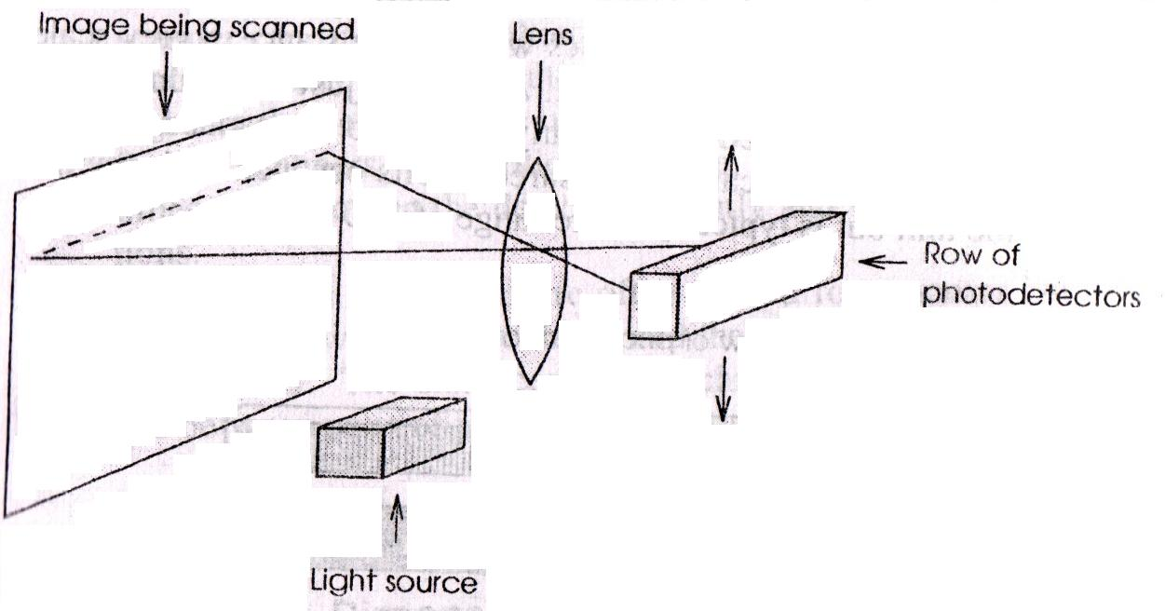  - This row of photodetectors is then used on each row in turn by adjusting the optical system.  Figure 4.9: Line Scanner.
4.10 | Quality Measures for a Scanner  - Resolution  Resolution is measured in dots per inch (dpi) or pixels per inch (ppi), sometimes more accurately referred to as samples per inch (spi). A good flatbed scanner has an optical resolution of 1600–3200 ppi.  - Color Depth  Color depth varies depending on the scanning array characteristics, but is usually at least 24 bits. High quality models have 48 bits or more color depth.
4.11 | Touch Screen  A touch screen is a display screen which has something attached so that when a finger touches the screen, the X and Y coordinates on the screen can be detected.  Working Principles  The screen employs a row of transmitters on one side of the screen and a corresponding row of receivers on the other side. There are transmitters and receivers along the top and bottom of the screen. The transmitters are continuously sending a signal to their receivers.  Figure 4.11: Touch screen.  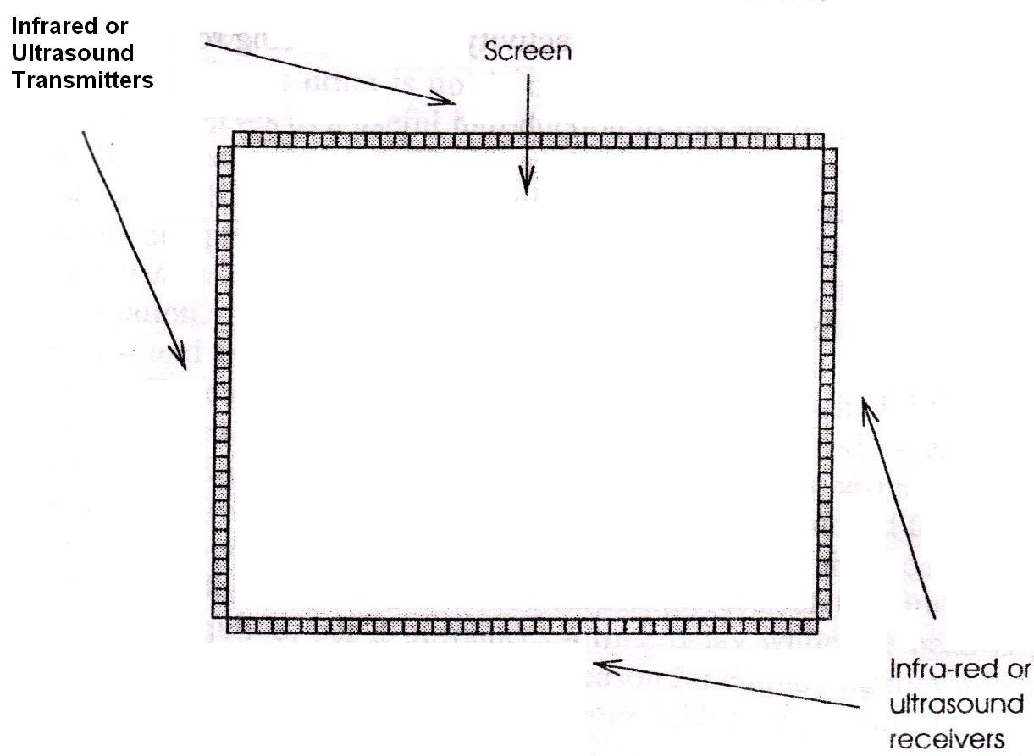  When the finger touches the screen, one or more receivers fail to receive the signal and the row-column touched are identified.  Components of a Touch Screen  A basic touch screen has three main components:  - Touch Sensor  A touch screen sensor is a clear glass panel with a touch responsive surface. The touch sensor/panel is placed over a display screen so that the responsive area of the panel covers the viewable area of the video screen. The sensor generally has an electrical current or signal going through it and touching the screen causes a voltage or signal change. This voltage change is used to determine the location of the touch to the screen.  - Controller  The controller is a small PC card that connects between the touch sensor and the PC. It takes information from the touch sensor and translates it into information that the PC can understand.  - Software Driver  The driver is a software for the PC system that allows the touch screen and computer to work together. It tells the computer’s operating system how to interpret the touch event information that is sent from the controller.
4.12 | Mouse  A mouse is a pointing device that functions by detecting two-dimensional motion relative to its supporting surface.
4.13 | 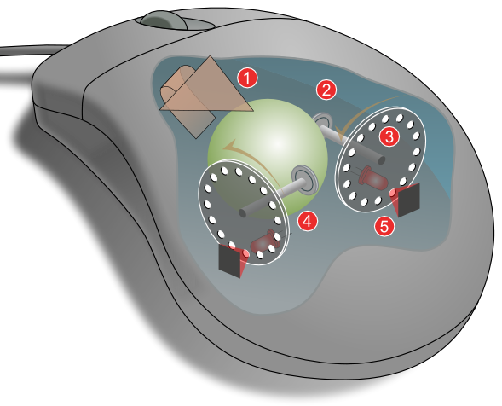  How Mechanical Mouse Works  1: moving the mouse turns the ball.  2: X and Y rollers grip the ball and transfer movement.  3: Optical encoding disks include light holes.  4: Infrared LEDs shine through the disks.  5: Sensors gather light pulses to convert to X and Y velocities.  Figure 4.13: How mechanical mouse works.
4.14 | Optical Mouse  An optical mouse actually uses a tiny camera to take thousands of pictures every second. It is able to work on almost any surface without a mouse pad.  Most optical mice use a small, red (LED) that bounces light off that surface onto a (CMOS) sensor. In addition to LEDs, a recent innovation are laser-based optical mice that detect more surface details compared to LED technology.  How Optical Mouse Works  An optical mouse has two LEDs inside, which shine down onto the work surface through two small windows in the casing. A second pair of windows allows the reflected light to retrurn into the mouse where it is detected by two photodetectors. One LED is the normal red visible variety, the other produces infrared light. This mouse requires a special mouse mat which has a series of alternate black and blue ilnes printed on it in both the X and Y directions as shown in figure 4.14.2.  How Modern Optical / Laser Mouses Work  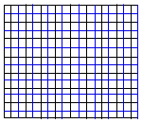  - The CMOS sensor sends each image to a digital signal processor (DSP) for analysis.  Figure 4.14.1: Optical Mouse.  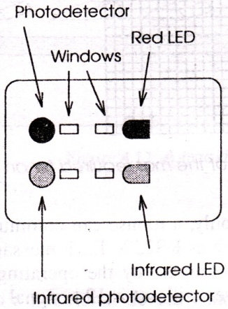  - The DSP detects patterns in the images and examines how the patterns have moved since the previous image.  Figure 4.14.2: An area of the mat required for an optical mouse.  - Based on the change in patterns over a sequence of images, the DSP determines how far the mouse has moved and sends the corresponding coordinates to the computer.  - The computer moves the cursor on the screen based on the coordinates received from the mouse. This happens hundreds of times each second, making the cursor appear to move very smoothly.  Advantages of optical mice over mechanical mice  - No moving parts means less wear and a lower chance of failure.  - There's no way for dirt to get inside the mouse and interfere with the tracking sensors.  - Increased tracking resolution means a smoother response.  - They don't require a special surface, such as a mouse pad.

Questions & Answers
4.1 | Differentiate between the working principle of contact type keyboard switch and membrane type keyboard switch. [2004. Marks: 3]  OR, Describe the operations of contact type keyboard switch and membrane switch. [In-Course 2, unknown year. Marks: 2.5 × 2]  See Theories & Concepts 4.3 and 4.4. Don’t be too descriptive. Describe the operation of each type within 2/3 lines. No need to describe their configuration, as the question asked for their operations only. And don’t forget to provide the figures.
4.2 | Describe different types of key-board switches. [2005. Marks: 3]  As the marks are only 3, therefore, very briefly describe contact-type, membrane and capacitive switches. Try to finish the working procedures of each switch within 2/3 lines. No need to describe their configuration. Just working principles should suffice. And don’t forget to provide the figures.
4.3 | How does keyboard matrix scanner detect unique key depression? [In-course 2, unknown year. Marks: 4]  The keyboard matrix usually contains 5 or 6 rows and around 20 columns. At the intersection of each row with each column is a key switch which, when depressed, makes electrical contact between that row and column.  The columns are continuously scanned in turn by placing a voltage on each in turn. The rows are then sampled and because only one column is active at a time, any key depressed is uniquely detected. The columns must be scanned rapidly (far less than 1 millisecond) so that each is scanned within a time much less than that between the key depressions achievable by a fast typist.  When a key depression is detected, the key is reported by the keyboard scanner as either a row and column pair of numbers or a single number (scancode). When the key is released this event is similarly reported.  Don’t forget to provide figure 4.6 (a).
4.4 | Draw the block diagram of keyboard interface and describe keyboard protocol. [2007. Marks: 8]  Block diagram of keyboard controller interface: See figure 4.7.  Keyboard protocol (i.e., how keyboard works):  First, write the answer to the question no. 4.3 (i.e., how a keyboard matrix scanner works). Then go for describing how the keyboard controller works. When describing the keyboard controller, first write the introductory paragraph in Concepts 4.7. Then directly write the functions of a keyboard controller.
4.5 | Describe the working principles of the following types of scanners:  (a) Cathode Ray Tube (b) Line [2007. Marks: 3]  See Theories & Concepts 4.8 and 4.9.
4.6 | Describe the working principles of touch screen. [2007. Marks: 2]  See Theories & Concepts 4.11. You should include the figure 4.11.
4.7 | With the aid of figure explain the working principle of an Optical Mouse. [2004. Marks: 3]  See Theories & Concepts 4.14 – “How optical mouse works”.

I couldn’t find anything in the book or in sir’s lecture to describe the SCSI systems – save these lines and the figure…
A transceiver is a device which receives signals and retransmits them.
An example of a USART controller chip is the Intel 8251A, or simply, 8251.
Opaque: opposite of transparent.
This section along with the figure is for your understanding only. For writing at the exam, see the next section and the next figure.
Ridge: Any long raised strip.
Etched: Cut or impressed into a surface.
Note that the marks are only 2 / 2.5. That’s why the answer should not contain the construction of LCD. If the marks are 4 or more, then the answer should also contain the construction and the figure.
Membrane: A thin pliable sheet of material / Tissue layer.
Tactile: Producing a sensation of touch.
Spacer: Something used to keep other things separate.

