Table of Contents
Basics of Graph Theory 1
Graph theory, vertex (node), edge, directed and undirected graph, weighted and unweighted graph 1
Representation of graphs 1
Adjacency List 1
Adjacency Matrix 1
Taking a graph as input from keyboard and storing it into memory 2
A simple C/C++ program to input and store a directed unweighted graph 2
BFS (Breadth-First Search) 3
Algorithm (informal) 3
Applications 3
Graph traversing using BFS (in C++) 3
Finding the shortest path between the source and another node 5
Finding the most distant node from the source node 6
Printing the (shortest) path from source to destination 6
Finding a cycle from source and printing its path 6
Detecting any cycle within an undirected graph 6
Testing a graph for bipartiteness 7
Finding all connected components in a graph 7
Finding all nodes within one connected component 7
DFS (Depth-First Search) 8
Algorithm (Pseudocode) 8
Graph traversing using DFS (in C++) 8
Checking whether a graph is connected 9
Edge detection 9
Use of time in DFS 10
Detecting cycles in a directed graph 11
Theorem: An undirected graph is acyclic iff a DFS yields no back edges 11
Topological Sort 11
Unique Topological Sort 12
Articulation Point / Cut-Vertex and Biconnected Components 12
Bridge 13
SCC (Strongly Connected Components) 14
Dijkstra’s Algorithm 15
Bellman-Ford Algorithm 17
Single-Source Shortest Paths in DAGs 18
Floyd-Warshall Algorithm 19
Prim’s Algorithm 20
Kruskal’s Algorithm 22

Basics of Graph Theory
Graph theory, vertex (node), edge, directed and undirected graph, weighted and unweighted graph
In mathematics and computer science, graph theory is the study of graphs: mathematical structures used to model pair-wise relations between objects from a certain collection. A graph in this context refers to a collection of vertices or nodes and a collection of edges that connect pairs of vertices. A graph may be undirected, meaning that there is no distinction between the two vertices associated with each edge; or its edges may be directed from one vertex to another. If some value is assigned to the edges of a graph, then that graph is called a weighted graph. If the weights of all the edges are the same, then the graph is called an unweighted graph.
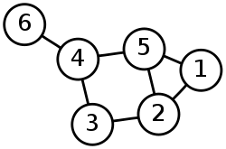Representation of graphs
Node / Vertex
Edge
Figure 1: An undirected unweighted graph.
Graphs are commonly represented in two ways:
- Adjacency List
- Adjacency Matrix
Adjacency List
In this representation, each vertex has a list of which vertices it is adjacent to. This causes redundancy in an undirected graph: for example, if vertices A and B are adjacent, A's adjacency list contains B, while B's list contains A. Adjacency queries are faster, at the cost of extra storage space.
For example, the undirected graph in Figure 1 can be represented using adjacency list as follows:
Node | Adjacency List
1 | 2, 5
2 | 1, 3, 5
3 | 2, 4
4 | 3, 5, 6
5 | 1, 2, 4
6 | 4
Adjacency Matrix
This is the n by n matrix, where n is the number of vertices in the graph. If there is an edge from some vertex x to some vertex y, then the element a_{x, y} is 1 (or, in case of weighted graph, the weight of the edge connecting x and y), otherwise it is 0. In computing, this matrix makes it easy to find subgraphs, and to reverse a directed graph.
For example, the undirected graph in Figure 1 can be represented using adjacency matrix as follows:
 | 1 | 2 | 3 | 4 | 5 | 6
1 | 0 | 1 | 0 | 0 | 1 | 0
2 | 1 | 0 | 1 | 0 | 1 | 0
3 | 0 | 1 | 0 | 1 | 0 | 0
4 | 0 | 0 | 1 | 0 | 1 | 1
5 | 1 | 1 | 0 | 1 | 0 | 0
6 | 0 | 0 | 0 | 1 | 0 | 0

Taking a graph as input from keyboard and storing it into memory
It is easier to store a graph into memory and perform operations on it using adjacency matrix rather than adjacency list. First, we need to declare a global 2D array. Then, we should prompt the user to input the edges. The user should provide 2 numbers (x, y) representing the edge between those two nodes (nodes will be denoted as numbers rather than letters). For each pair of (x, y), the corresponding location a_{x, y} at the matrix will be filled with a '1'. This is the case for an unweighted, but directed graph. In case of unweighted, but directed graph, the location a_{y, x} should also be filled with a '1'. In case of weighted graph, the user should input another number indicating the weight, and that number should be stored at the location instead of '1'. After the input of the edges, all other locations should be filled with '0'. However, in case of C, C++ or Java, this is automatically done as global variables are automatically zero-filled when initialized.
A simple C/C++ program to input and store a directed unweighted graph
1 #include <stdio.h>
2
3 int graph[100][100]; //A matrix for storing a graph containig 100 nodes maximum
4
5 int main(int argc, char** argv) {
6 printf("Enter number of edges: ");
7 int edges;
8 scanf("%d", &edges);
9 for (int i = 1; i <= edges; i++) {
10 printf("Enter edge %d: ", i);
11 int x, y; //Or, int x, y, weight; - for storing weight of edge
12 scanf("%d %d", &x, &y); //Or, scanf("%d %d %d", &x, &y, &weight); - for weighted graph
13 graph[x][y] = 1; //Or, graph[x][y] = weight; - for weighted graph
14 //graph[y][x] = 1; //This line should be added for undirected graph
15 }
16
17 return 0;
18 }
19

BFS (Breadth-First Search)
  - Finds single-source shortest path in unweighted graph
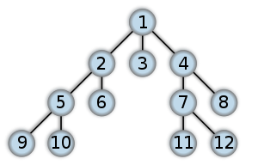In graph theory, breadth-first search (BFS) is a graph search algorithm that begins at the root node and explores all the neighboring nodes. Then for each of those nearest nodes, it explores their unexplored neighbor nodes, and so on, until it finds the goal.
Class: Search Algorithm
Data Structure: Graph
Time Complexity: O( | V | + | E | )
Space Complexity: O( | V | + | E | )
Optimal: Yes (for unweighted graphs)
Breadth-First Search
General Data
Order in which the nodes are expanded
Algorithm (informal)
- Put the root node on the queue.
- Pull a node from the beginning of the queue and examine it.
- If the searched element is found in this node, quit the search and return a result.
- Otherwise push all the (so-far-unexamined) successors (the direct child nodes) of this node into the end of the queue, if there are any.
- If the queue is empty, every node on the graph has been examined -- quit the search and return "not found".
- Repeat from Step 2.
Applications
Breadth-first search can be used to solve many problems in graph theory, for example:
- Finding all connected components in a graph
- Finding all nodes within one connected component
- Finding the shortest path between two nodes u and v
- Testing a graph for bipartiteness
Graph traversing using BFS (in C++)
Suppose, we have to traverse the directed graph of Figure 2. We’ll start from the node 'src'.
Let’s assume we have completed the preliminary task of taking input of the graph:
1 #include <stdio.h>
2
3 int nodes, edges, src;
4 int graph[100][100];
5
Figure 2: Traversing a graph using BFS
1
2
4
3
src = 1
6 int main() {
7 printf("No. of nodes, edges, and source node? ");
8 scanf("%d %d %d", &nodes, &edges, &src);
9 for (int i = 1; i <= edges; i++) {
10 printf("Edge %d: ", i);
11 int x, y;
12 scanf("%d %d", &x, &y);
13 graph[x][y] = 1;
14 }
15 return 0;
16 }
Now, let’s try to implement the BFS traverse algorithm:
19 //run BFS
20 queue<int> q; //create a queue
21 q.push(src); //1. put root node on the queue
22 do {
23 int u = q.front(); //2. pull a node from the beginning of the queue
24 q.pop();
25 printf("%d ", u); //print the node
26 for (int i = 1; i <= nodes; i++) { //4. get all the adjacent nodes
27 if (graph[u][i] == 1) { //if an edge exists between these two nodes
28 q.push(i); //4. push this node into the queue
29 }
30 }
31 } while (!q.empty()); //5. if the queue is empty, then all the nodes have been visited
Analysis of the above program (i.e. how it works)
Step | Line | Queue | u | graph[u][i] | Output
1 | 21 | 1 | - | - | -
2 | 23, 24, 25 | - | 1 | - | 1
3 | 26, 27 | - |  | graph[1][2]
4 | 28 | 2
5 | 26, 27 | 2 |  | graph[1][4]
6 | 28 | 4 2
7 | 31 | 4 2 | - | -
8 | 23, 24, 25 | 4 | 2 | - | 1 2
9 | 31 | 4 | - | -
10 | 23, 24, 25 | - | 4 | -
11 | 26, 27 | - |  | graph[4][3]
12 | 28 | 3
13 | 31 | 3 | - | -
14 | 23, 24, 25 | - | 3 | - | 1 2 3
15 | 31 | - |  |  | 1 2 3
i
 | 1 | 2 | 3 | 4
1 | 0 | 1 | 0 | 1
2 | 0 | 0 | 0 | 0
3 | 0 | 0 | 0 | 0
4 | 0 | 0 | 1 | 0
The graph array
A problem with the above program
Figure 3
1
2
4
3
However, our program is correct for the graph in Figure 2, but it won’t work for any graph. Consider the graph in Figure 3. When our program finds that node 1 is adjacent to node 4, it will enqueue it. Then, when it will see that node 4 is adjacent to node 1, it will enqueue it again. This will continue forever. So, we must have a mechanism to detect whether a node has already been visited.
We can use an array of nodes named visited, which will record a 1 if a node has been used (i.e., all the adjacent of it have been discovered), and a 0 otherwise. But there lies another problem. Again, this solution will work for the graph in Figure 3, but won’t work for any graph. Consider the graph of Figure 4. At the point of finding the adjacents of node 4, we enqueue nodes 2 and 3 and record a 1 to node 4. But when we’ll search for adjacents of 2, we’ll again queue node 3.
Figure 4
1
2
4
3
To solve this problem, we can use two numbers instead of one – we’ll assign 0 to nodes which haven’t yet been touched, 1 to nodes which we’ve just reached out, and 2 to a node when we’re finished with searching its adjacent nodes. We’ll try to search for adjacents of only those nodes whose assigned value is 1. Let’s call this process ‘graph coloring’. First, all the nodes are colored white (0). We’ll color each discovered node with gray (1) and then when we’re finished finding all the adjacent nodes of a particular node, we’ll color it with black (2).
The modified version of the program is as follows:
1 #include <stdio.h>
2 #include <queue>
3 using namespace std;
4
5 int nodes, edges, src;
6 int graph[100][100], color[100];
7 const int WHITE = 0;
8 const int GRAY = 1;
9 const int BLACK = 2;
10
11 int main() {
12 printf("Nodes, edges, source? ");
13 scanf("%d %d %d ", &nodes, &edges, &src);
14 for (int i = 1; i <= edges; i++) {
15 printf("Edge %d: ", i);
16 int x, y;
17 scanf("%d %d", &x, &y);
18 graph[x][y] = 1;
19 }
20
21 //run BFS
22 queue<int> q; //create a queue
23 q.push(src); //1. put root node on the queue
24 do {
25 int u = q.front(); //2. pull a node from the beginning of the queue
26 q.pop();
27 printf("%d ", u); //print the node
28 for (int i = 1; i <= nodes; i++) { //4. get all the adjacent nodes
29 if ((graph[u][i] == 1) //if an edge exists between these two nodes,
30 && (color[i] == WHITE)) { //and this adjacent node is still WHITE,
31 q.push(i); //4. push this node into the queue
32 color[i] = GRAY; //color this adjacent node with GRAY
33 }
34 }
35 color[u] = BLACK; //color the current node black to mark it as dequeued
36 } while (!q.empty()); //5. if the queue is empty, then all the nodes have been visited
37
38 return 0;
39 }
Finding the shortest path between the source and another node
Figure 5: Finding the shortest path.
src = 1
dest = 3
1
2
4
3
Suppose for a given directed unweighted graph, we have to find the shortest path from 'src' to 'dest', where 'src' is the source node and 'dest' is the destination node (Figure 5).
So, while taking input of the graph, we have to take another input – dest.
Now, first, how do we find the distance between two nodes (e.g. nodes 1 and 3) using BFS? (Forget about finding the shortest distance for the time being.) Let’s take the route 1 4 3. The distance between 1 and 4 is 1, and 4 and 3 is also 1. So, the total distance between 1 and 3 is 1 + 1 = 2. Therefore, starting from the root, the most adjacent nodes of the source are of distance 1. The distance of the next level of nodes from the source is of distance 1 plus the distance of their just previous adjacent nodes. So, we can use an array – something named distance – to store the distance of each node (from the source node).
Now, because in BFS a node is enqueued only once, we can be assured that its distance from the source is the shortest distance.
Then, what changes should we bring to our program?
- Declare an int array distance[100] on line 6.
- Add the statement distance[i] = distance[u] + 1; after line 32.
- Finally, the shortest path between 'src' and 'dest' is the value of distance[dest].
Finding the most distant node from the source node
The lastly queued node is the most distant node from the source node. So, the value of the variable u after finishing the BFS is our most distant node from the source node. However, in our program, u is declared as a local variable inside the do-while loop. To get its value after the loop, we need to declare it outside the loop.
Printing the (shortest) path from source to destination
To print the path from a source to a destination, we need to keep track of the intermediate nodes between those two nodes. We can use an array to store the previous node of the current node. Thus we can get a chain of nodes between the source and destination nodes from that array.
To store the previous node in an array, we can simply declare a global array prev[100], and add the statement prev[i] = u; after line 32.
1 | 0
2 | 4
3 | 4
4 | 1
Now, how do we print the path from that array? The prev array for the graph of Figure 4 would somewhat look like the array in Figure 6. Here, we have to backtrack from destination to source. So, to print forward from source to destination, we can use a recursion like the following:
Figure 6
13 void print(int node) {
14 if (node == 0)
15 return;
16 print(prev[node]);
17 printf("%d -> ", node);
18 }
Finding a cycle from source and printing its path
For any node, if we can find out that there is an edge from it to the source, we can easily say that a cycle exists from source to that node. Now, to print the path, simply print the path from source to that node as described above, and then print the source node again. The code is somewhat like below:
57 //find and print cycle from source
58 for (int i = 1; i <= nodes; i++) {
59 if (graph[i][src] == 1) {
60 print(i);
61 printf("%d\n\n", src);
62 }
63 }
Detecting any cycle within an undirected graph
If we can detect that there exists an edge from a WHITE or GRAY node to a BLACK node, we can easily say that a cycle exists from that BLACK node to the WHITE / GRAY node.
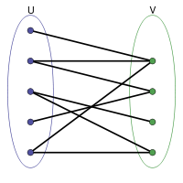
Testing a graph for bipartiteness
In graph theory, a bipartite graph (or bigraph) is a graph whose vertices can be divided into two disjoint sets U and V such that every edge connects a vertex in U to one in V.
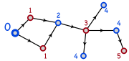
First, we should color the source node with a particular color – say BLUE. Then, we have to color all the adjacent nodes with another color – say RED. Similarly, we’ll color all the adjacent nodes of RED nodes as BLUE and all the adjacent nodes of BLUE nodes as RED. While performing this, if we encounter any node which already has a similar color to his adjacent node, then we can conclude that the graph is not bipartite. Else, after finishing running the BFS, we can conclude that the graph is bipartite.
Figure 8: Testing a graph for
bipartiteness
Figure 7: Bipartite Graph
To apply this logic, we need to define another array of nodes containing another three colors – say GREEN, RED and BLUE. If an adjacent node’s color is GREEN, we’ll color it with a different color than the current node (i.e., BLUE if the color of current node is RED and vice-versa). If we find that the adjacent’s color is already different from the color of the current node, then no problem; we’ll simply skip. However, if we find that the adjacent’s color is already the same as the color of the current node, then we’ll stop and notify that the graph is not bipartite. The code for this might look like the following:
31 if (parity[i] == GREEN) {
32 if (parity[u] == BLUE) {
33 parity[i] = RED;
34 } else {
35 parity[i] = BLUE;
36 }
37 } else if (parity[i] == parity[u]) {
38 //Break and notify that the graph is not bipartite...
39 }
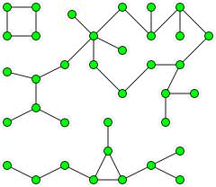
Remember: Every tree is bipartite. Also, cycle graphs with an even number of edges are bipartite.
Finding all connected components in a graph
In an undirected graph, a connected component, or simply, component is a maximal connected subgraph. There are three connected components in Figure 9. Two vertices are defined to be in the same connected component if there exists a path between them. A graph is called connected when there is exactly one connected component.
Figure 9: A graph with
three components
To find all the connected components in a graph, first, run a BFS from any node. After the BFS ends, detect which nodes aren’t traversed (using color). From any of those untraversed nodes, run another BFS. Repeat the process until all the nodes have been traversed. The number of times the BFS is run, the number of components the graph has.
Finding all nodes within one connected component
Simple – just run the BFS once!

DFS (Depth-First Search)
  - Generates spanning tree from a graph
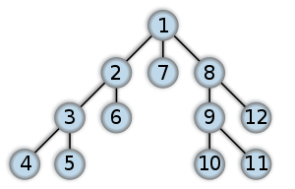In graph theory, depth-first search (DFS) is an uninformed search that progresses by expanding the first child node of the search tree that appears and thus going deeper and deeper until a goal node is found, or until it hits a node that has no children. Then the search backtracks, returning to the most recent node it hadn't finished exploring.
Class: Search Algorithm
Data Structure: Graph
Time Complexity: O( | V | + | E | )
Space Complexity: O(h) , where h = length of the longest simple path in the graph.
Optimal: No
Depth-First Search
General Data
Order in which the nodes are expanded
Algorithm (Pseudocode)
function dfs(vertice v) {
mark v as visited;
preorder-process(v);
for all vertices i adjacent to v such that i is not visited {
dfs(i);
}
postorder-process(v);
}
Applications
Here are some algorithms where DFS is used:
- Finding connected and strongly connected components
- Detecting biconnectivity (articulation points / cut-vertex) and bridges
- Topological sorting
- Edge detection
- Finding all-pair paths between source and destination nodes
- Solving puzzles with only one solution, such as mazes
Graph traversing using DFS (in C++)
Suppose, we have to traverse the directed graph of figure 2. We’ll start from the node 'src'.
Let’s assume we have completed the preliminary task of taking input of the graph:
1 #include <stdio.h>
2
3 int nodes, edges, src;
Figure 2: Traversing a graph using DFS
src = 1
1
2
4
3
5
6
4 int graph[100][100];
5
6 int main() {
7 printf("No. of nodes, edges, and source node? ");
8 scanf("%d %d %d", &nodes, &edges, &src);
9 for (int i = 1; i <= edges; i++) {
10 printf("Edge %d: ", i);
11 int x, y;
12 scanf("%d %d", &x, &y);
13 graph[x][y] = 1;
14 }
15 return 0;
16 }
Now, let’s try to implement the DFS traverse algorithm:
18 void dfs(int node) {
19 color[node] = GREY; //mark node as visited
20 printf("%d ", node); //preorder-process(node)
21 for (int i = 1; i <= nodes; i++) {
22 if ((graph[node][i] == 1) && (color[i] == WHITE)) {
23 dfs(i);
24 }
25 }
26 //postorder-process(node) [none in this case]
27 }
Checking whether a graph is connected
An undirected graph can be easily checked for connectivity. A directed graph, however, poses a problem. So, if we convert a directed graph into an undirected graph, then we can easily find whether the graph is connected. To convert a directed graph into an undirected graph, just add reversed edges to all the edges (figure 3(b)). Now, run DFS (or BFS) from any node. After the traversing finishes, check whether there is any node marked as WHITE. If no such node can be found, then the graph is connected.
(a) Directed graph (b) Undirected graph
Figure 3: Converting a directed graph into an undirected graph.
1
2
4
3
5
6
1
2
4
3
5
6
Edge detection
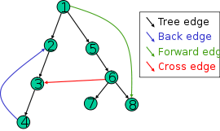
The most natural result of a depth first search of a graph (if it is considered as a function rather than a procedure) is a spanning tree of the vertices reached during the search. Based on this spanning tree, the edges of the original graph can be divided into four classes:
- Tree edge, edges which belong to the spanning tree itself.
- Back edge, which point from a node to one of its ancestors.
- Forward edge, which point from a node of the tree to one of its descendants (except the tree edge).
- Cross edge, which point from a node to another node which is not its descendant.
Figure 4: The four types of edges defined by a spanning tree.
It can be shown that if the graph is undirected, then all of its edges are either tree edges or back edges.
- Tree edge detection
Just run the DFS. Whenever we traverse an adjacent white node (and in turn, its adjacent node) from a source node, that’s a tree edge.
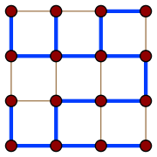
Figure 5: A spanning tree (blue heavy edges) of a grid graph.
Spanning tree: a spanning tree of a connected, undirected graph G is a selection of edges of G that form a tree spanning every vertex. That is, every vertex lies in the tree, but no cycles (or loops) are formed.
A spanning tree of a connected graph G can also be defined as a maximal set of edges of G that contains no cycle, or as a minimal set of edges that connect all vertices.
- Back edge detection
Consider the graph in figure 6(a). If we try to traverse from 3 to 1, we find that 1 is already GREY. So, if we can find a GREY node while traversing, then there’s a back edge.
Figure 6: Back, forward and cross edge detection.
1
2
3
1
2
3
(a) Back edge
(b) Forward edge
1
2
3
(c) Cross edge
- Forward and cross edge detection
Consider the graph in figure 6(b). After getting back to 1, we find that another path exists from 1 to 3. Here, 3 is already GREY. According to our just-taken decision, this edge should be a back edge. But is it in fact?
So, we might introduce another color – BLACK. Whenever we finish searching all the adjacent nodes of a particular node, we mark it as BLACK. Thus, in figure 6(b), when we try to traverse from 1 to 3, we find it as BLACK. So, if we can find a BLACK node while traversing, then there’s a forward edge.
However, there lies a problem with this decision. Let’s change the appearance of the graph in figure 6(b) so that it looks like the graph in figure 6(c). Now, while in figure 6(b) 2 was 3’s ancestor, in figure 6(c), 2 is not 3’s ancestor. So, in that case, the edge (2, 3) is a cross edge rather than a forward edge. But note, however, that the graphs are the same.
Therefore, finding a BLACK means there might be either a forward edge, or a cross edge. Then how would we differentiate between the two?
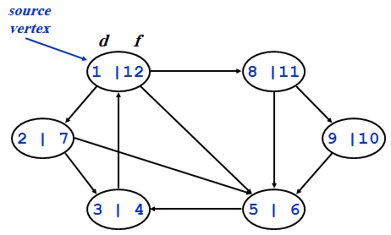
Use of time in DFS
While traversing a graph using DFS, we can set a starting time (or discovery time) and a finishing time for each node. This technique will help us solve the edge detection problems as well as all the other problems following those.
The technique is fairly simple – while running DFS, just set the starting time of a node whenever we discover it, and set the finishing time when we are sure that all its adjacent nodes have been discovered. An example is given in figure 7.
Figure 7: Using time in DFS
Figure 8: Forward and cross edge detection.
(a) Forward edge
(b) Cross edge
2|5
1|6
3|4
4|5
1
2
3
1|6
2|3
1
2
3
So, how would you program it? Simple – take a global variable – say, time – and initialize it with 1. Take two global arrays – e.g. start_time and finish_time – where the starting and finishing time of all the nodes will be stored. Whenever a node is discovered, we set the current time as its start time and increment the value of time. After the for loop in the code for DFS, i.e., when working with that node is done, we set the current time as its finishing time and again increment the value of time.
Now, let’s try to solve the problem of detecting forward and cross edges. Consider figure 8 (a) and (b). The graphs are the same as those in figure 6 (b) and (c). In case of figure 8(a), we find that the discovery time of 1 is less than the discovery time of 3. So, 3 is 1’s descendant. Hence, the edge (1, 3) is a forward edge. On the other hand, in case of figure 8(b), we find that the discovery time of 2 is greater than the discovery time of 3. So, 2 is not an ancestor of 3, and hence the edge (2, 3) is a cross edge.
Summing up the edge detection techniques, we can conclude the following:
Let, (u, v) is an edge.
- If (color[v] == WHITE), then (u, v) is a tree edge.
- If (color[v] == GREY), then (u, v) is a back edge.
- If (color[v] == BLACK), then (u, v) is a forward or cross edge.
  - If (start_time[u] < start_time[v]), then (u, v) is a forward edge.
  - If (start_time[u] > start_time[v]), then (u, v) is a cross edge.
Detecting cycles in a directed graph
If we can detect a back edge while running DFS, then we can say that the graph has a cycle. If a graph does not contain any cycle, then it is called an acyclic graph.
Theorem: An undirected graph is acyclic iff a DFS yields no back edges
After running DFS, if no back edges can be found, then the graph has only tree edges. (As the graph is undirected, therefore, there will be no forward/cross edges but only tree and back edges.) Only tree edges imply we have a tree or a forest, which, by definition, is acyclic.
Topological Sort
Topological sort of a directed acyclic graph (DAG) G = (V, E): a linear order of vertices such that if there exists an edge (u, v), then u appears before v in the ordering.
The main application of topological sort is in scheduling a sequence of jobs. The jobs are represented by vertices and there is an edge from x to y if job x must be completed before job y can be done. (For example, washing machine must finish before we put the clothes to dry.) Then, a topological sort gives an order in which to perform the jobs.
Another application of topological sort is in open credit system, where courses are to be taken (in order) such that, pre-requisites of courses will not create any problem.
The algorithm for applying topological sort is quite simple – just sort the nodes in descending (or non-increasing) order according to their finishing time. Why? Because, in DFS, the deepest node is finished processing first. Then its parent is finished processing. Thus, we can say that the deepest node must come after its parent.
So, how do we write the code for sorting the nodes? Easy! Just create an array – e.g. top_sort – and whenever you blacken out a node (or, in other words, assign its finishing time), insert the node into it. Now, after the DFS finishes, you get an array with nodes inserted according to the increasing order of their finishing time. How? The first time you assign a node its finishing time, the finishing time is of the lowest value. Eventually, you end up assigning the highest finishing time to the last blacked out node. Thus, you get an array of nodes inserted according to the increasing order of their finishing time. Now what? Just print the array in reverse. That’s the topologically sorted list.
Figure 9: Graph for topological sort.
2|3
6|7
5|8
1
2
4
3
5
6
1|12
4|11
9|10
Unique Topological Sort
The above trick for applying topological sort is fine. But how can we find whether the topological sort of a particular graph is unique or not? For example, topological sort of the graph in Figure 9 is not unique. The sort might be any of the followings:
- 1 – 4 – 5 – 3 – 6 – 2
- 1 – 2 – 4 – 3 – 6 – 5
- 1 – 2 – 4 – 5 – 3 – 6
One thing we may do is to run the DFS algorithm multiple times while choosing different paths each time. If we get multiple topological sorts, then we can conclude that the sort for the graph is not unique. However, coding this is complex and inefficient. There is another algorithm for finding topological sort using in-degree of edges which is efficient to find out whether the sort is unique.
In this algorithm, we first determine the in-degree of all the nodes. Now, the node with the lowest in-degree must come before a node with a greater in-degree than that. We put that node as the first node in the topological sort order. Then, we have to find its adjacent nodes. At least one of them must come immediately after the first node. To find the next node in the sort order, we simply decrement the in-degree of the first node’s adjacent nodes by 1 and then repeat the previous steps again. We repeat these steps for n times where n is the number of nodes in the graph.
A formal approach of describing the algorithm is as follows:
- Take an array – named, for example, indegree – and put the in-degree of all the nodes in it.
- Take another array – named, for example, sorted – where the nodes will be kept in topological sort order. The values in this array after the algorithm finishes are the final result.
- From the indegree array, determine the node with the lowest in-degree. Put the node in the sorted array.
- Set the in-degree of this node to ∞ in the indegree array.
- Decrement the in-degree of the adjacent nodes of this node by 1 in the indegree array.
- Repeat steps 3 to 5 for n times, where n is the number of nodes in the graph.
Now let’s return to our concerned problem – how we can determine whether a topological sort is unique. Easy! While running the above algorithm, at step 3, if we detect that there are more than one lowest in-degree values, then we can easily conclude that the topological sort is not unique.
Articulation Point / Cut-Vertex and Biconnected Components
The articulation points or cut-vertices of a graph are those nodes, deleting which causes the graph to become disconnected. If a graph contains no articulation points, then it is biconnected. If a graph does contain articulation points, then it is useful to split the graph into the pieces where each piece is a maximal biconnected subgraph called a biconnected component.
So, how do we find the articulation points? One way is to delete a node and then run BFS/DFS to see whether the graph is connected. If the graph is not connected, then that deleted node is an articulation point. But this brute-force method is highly inefficient.
Here is an efficient algorithm. We’ll observe how far above the parent a child can go. If we find that no child of a particular parent can go higher than the parent node, then we can conclude that the parent node is an articulation point.
So far, so good. But how would we code this? From the algorithm, we find that we need to find out whether any child of a parent can go above it. Therefore, we need to keep track of how far above a node can travel. Let’s take an array of nodes where the value of a particular node will represent the maximum ancestor node that can be reached by it. Let’s call this array low. Why? We’ll see later.
Figure 10: Articulation Point.
A
B
C
D
E
F
1|(1,1)

2|(2,2)

3|(3, 2)

4|(4, 2)

5|(5,5)
Discovery Time |
(Initial low value,
Updated low values…)

6|(6,6)

Now, while running DFS, we’ll first set the discover time of a node as its low value, because the node can go from itself to itself. Now, while backtracking, when we’ve visited all the adjacents of a parent, we have to update the low value of it. How? We’ll take the low values of all its children. We’ll also take the discovery time of all the nodes it has a back edge with. And we already have the discovery time of that node. Then, the updated low value of the parent would be the lowest low value among all these low values. In other words, if the parent node is v and its child or back-edged node is w, then:
$$low\left[v\right]= min. \left\{\begin{aligned}d\left[v\right] \\ lowest d\left[w\right]among all back edges \left(v,w\right) \\ lowest low[w] among all tree edges (v,w)\end{aligned}\right\}$$
Now, if the low value of any of the parent’s children is greater than or equal to the discovery time of the parent, then that parent is an articulation point. In other words, a parent node, v will be an articulation point if, for any node w connected with v as a back edge or tree edge,
low(w) >= d[v]
Note that to update the low value, we’re taking the lowest of all the other values. That’s why we’re calling the array low.
Note further that, when doing the actual coding, we need to perform the checking before updating the low value of the parent.
Now, there lies a problem. When we compare the low value of B with the discovery time of A (figure 10), we will get that A is an articulation point. But in fact, it isn’t. So, as A is the root of this tree, it needs to be handled separately. A root might or might not be an articulation point. For example, the root in figure 10 is not an articulation point, whereas the root in figure 9 is. Actually, a root is an articulation point iff it has two or more children. To determine whether a root is an articulation point, we should run a DFS from the root, and after traversing the first path from the root, if there is any WHITE node left, we can conclude that the root is an articulation point.
Bridge
A bridge is an edge deleting which causes the graph to become disconnected.
A
B
C
D
E
Figure 11: Graph with bridges marked.
Any edge in a graph that does not lie on a cycle is a bridge. Bridges either end in articulation points or in dead-ends. As an example, in the graph of figure 11, (C, D) and (D, E) are bridges, C and D are articulation points, while E is a dead-end. Note that (A, B), (A, C) and (B, C) are not bridges as they lie on the cycle ABC.

SCC (Strongly Connected Components)
A directed graph is called strongly connected if there is a path from each vertex in the graph to every other vertex.
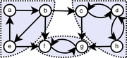
The strongly connected components (SCC) of a directed graph are its maximal strongly connected subgraphs.
পাশের গ্রাফে a, b আর e নোডগুলা নিয়ে একটা SCC; কারণ a থেকে কোন না কোনভাবে b, e দুটোতেই যাওয়া যায়, b থেকে e, a দুটোতেই যাওয়া যায়, আর e থেকে a, b দুটোতেই যাওয়া যায়। একইভাবে, (f, g) আর (c, d, h)–ও দুটো SCC।
So, how can we find the SCCs? Follow the steps below:
Figure 22: Graph with strongly connected components marked.
- Run DFS from any node (for example a) to compute the finishing time of all the nodes.
- Reverse the direction of the edges.
- Now run DFS again from the node whose finishing time is the lengthiest. (You can find it from the topologically sorted array populated in step 2).
- While running the second DFS, output the nodes in the DFS tree. These nodes comprise an SCC.
- If there are still unvisited (i.e., white colored) nodes, then repeat steps 3 and 4 from the WHITE node whose finishing time is the lengthiest; until there are no more WHITE nodes.
Figure 12
1
2
4
3
Note that a node itself is a strongly connected component if nowhere cannot be gone from that node. For example, in Figure 12, nodes 1, 2 and 4 comprise an SCC. Again, only node 3 is also an SCC.

Dijkstra’s Algorithm
  - Finds single-source shortest path in weighted graph
The problem with BFS is that it won’t produce correct result when applied to a weighted graph. Consider the graph in figure 1. BFS would say that (1, 3) is the shortest path. But considering weight, we find that (1, 2, 3) is the shortest path. Therefore, how would we calculate shortest path from a weighted graph?
Figure 1: Limitation of BFS.
1
2
3
1
5
1
Dijkstra comes to the rescue! Dijkstra’s algorithm is a greedy algorithm where each time we try to take the route with the lowest cost (or weight). So, whenever we find more than one adjacents of a node, we’ll take the adjacent node whose cost is the lowest and proceed.
First, let’s take an array cost where the cost of the nodes from the source node would be placed. Now, let’s set the cost of the source node as 0, because the cost to visit the source node from itself is 0. Well, let’s set the cost of all the other nodes as ∞. Why? Because, initially, we’re considering that we can go nowhere from the source node. When we’ll discover that we’re able to go somewhere, then we’ll update the cost with some other values.
Now, follow the steps below:
- Put all the nodes into a priority queue and sort them according to the non-decreasing order of their cost.
- Pop the front node v from queue.
- For all adjacent nodes i of v, update the cost of i if cost[v] + graph[v][i] < cost[i]; i.e., the cost from the source to node i (via node v) is less than the cost of node i (via some other route).
- Repeat steps 2 and 3 until the queue is empty.
If we save the previous node while updating into another array, then we’ll be able to find the shortest path of all the nodes from the source node using that array.
Note: Dijkstra’s algorithm might fail if negative cost is used.
Figure 2: Dijkstra’s Algorithm.
1
2
4
3
5
6
5
9

3
2
4
9
2
10
cost
0
queue
2
4

3
5
6

queue
4
3

5
6

queue
1
2

3
4
5
6
cost
0
5
15

8
8 + 2 = 10

∞

Step 3
queue
5
3

6

cost
0
5
10 + 4 = 14

8
10

10 + 9 = 19

Step 4
queue
3
6

cost
0
5
14

8
10

14 + 2 = 16

Step 5
queue
6

cost
0
5
14

8
10

16

Step 6
queue

cost
0
0 + 5 = 5
∞

0 + 9 = 9
∞

∞

Step 1
cost
0
5
5 + 10 = 15

5 + 3 = 8
∞

∞

Step 2
∞
∞

∞

∞

∞

Initial
0

prev
0
1

1

prev
0
1
2
2

prev
0
1
2
2
4

prev
0
1
5
2
4
5
prev
0
1
5
2
4
3
prev
0
1
5
2
4
3
prev
1 2 3 4 5 6 1 2 3 4 5 6 1 2 3 4 5 6
Source

The run-time complexity of Dijkstra’s algorithm is:
- O(n²) – when we use array instead of heap.
- O(E logV) – when min-heap is used to find the minimum element from KEY. (KEY[v] is the minimum cost of any edge connecting a vertex v to a vertex in the tree being generated from the source node.)
- O(E + V logV) – when fibonacci-heap is used to find the minimum element from KEY.

Bellman-Ford Algorithm
  - Finds single-source shortest path in weighted graph and detects negative cycles
If negative cost is used, Dijkstra’s algorithm might fail. As an example, for the graph of figure 1(a), Dijkstra would produce correct result, whereas for the graph of figure 1(b), if would get into an infinite loop when printing shortest path.
1
2
4
3
5
-3
1

1
1
4
-5
1
2
4
3
5
-2
9

3
2
4
10
final cost
-6
-14

-8
-3
-4
1 2 3 4 5
prev
4
3

2
5
3
Infinite loop
Figure 1: Dijkstra’s Algorithm with negative cost.
(a)
(b)
If the graph does contain a cycle of negative weights, Bellman-Ford, however, can only detect this; Bellman-Ford cannot find the shortest path that does not repeat any vertex in such a graph.
Bellman-Ford is in its basic structure very similar to Dijkstra's algorithm, but instead of greedily selecting the minimum-weight node not yet processed to relax, it simply relaxes all the edges, and does this |V| − 1 times, where |V| is the number of vertices in the graph. The repetitions allow minimum distances to accurately propagate throughout the graph, since, in the absence of negative cycles, the shortest path can only visit each node at most once.
v
Initial
0
∞
2
∞
3
-8
u
w
v
Pass 2
-6
-1
2
2
3
-8
u
w
d[v] > d[u] + w(u, v)
Fig. 2: Negative Cycle
v
Pass 1
-3
2
2
5
3
-8
u
w
The algorithm is as follows:
// Step 1: Initialize graph
for each vertex v in vertices:
if v is source then v.distance := 0
else v.distance := infinity
v.predecessor := null

// Step 2: relax edges repeatedly
for i from 1 to size(vertices)-1:
for each edge uv in edges: // uv is the edge from u to v
u := uv.source
v := uv.destination
if v.distance > u.distance + uv.weight:
v.distance := u.distance + uv.weight
v.predecessor := u

// Step 3: check for negative-weight cycles
for each edge uv in edges:
u := uv.source
v := uv.destination
if v.distance > u.distance + uv.weight:
error "Graph contains a negative-weight cycle"
In words, we have to update all the nodes’ cost for (|V| - 1) times. Then, we have to perform the checking for negative cycles for each edge.
Bellman–Ford runs in O(|V|·|E|) time.
Note: Negative cycle is guaranteed if negative weight undirected edge can be found. For example:
1
2
-1

Single-Source Shortest Paths in DAGs
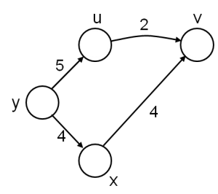
So far we’ve seen algorithms to solve single-source shortest path problem for undirected graphs. What about directed graphs, or, more precisely, directed acyclic graphs (as shortest path cannot be calculated for a directed graph containing cycles)?
The idea is to topologically sort the vertices of the graph and relax the edges according to the order given by the topological sort. For each vertex, we relax each edge that starts from that vertex.
The running time of this algorithm is O(V + E).
Note that shortest paths are well defined in a DAG as (negative weight) cycles cannot exist.
Example
In the following graph, we have to find the shortest paths from node s. Let, the topologically sorted order of the nodes is r – s – t – x – y – z. We initialize the costs of all nodes as ∞ – except the source node, s, which we initialize to 0.
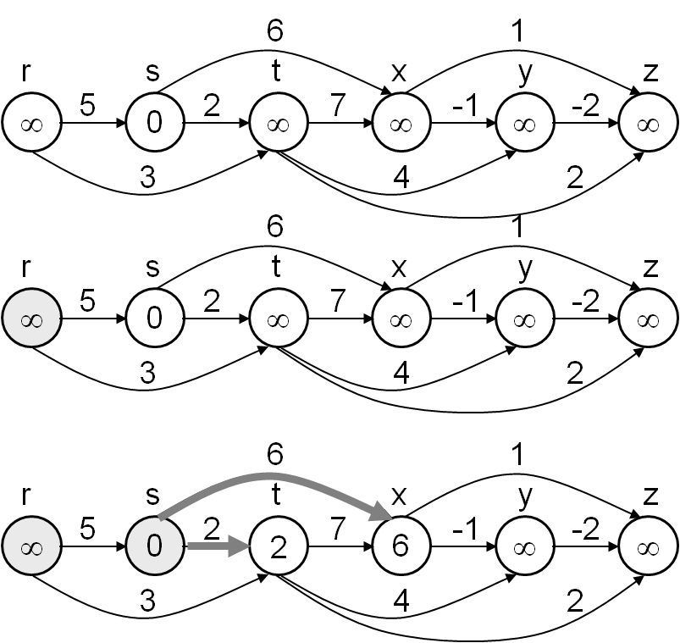
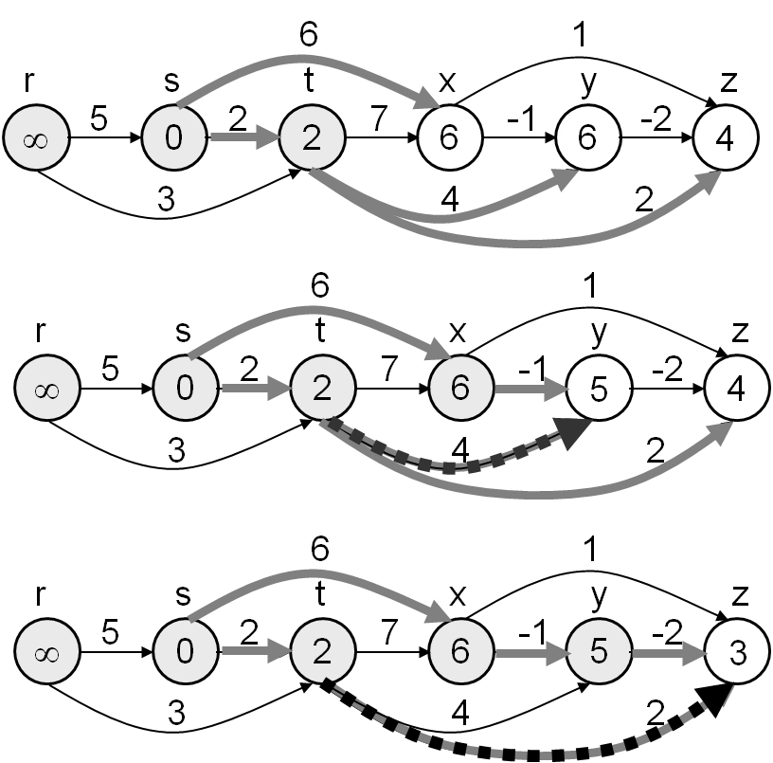
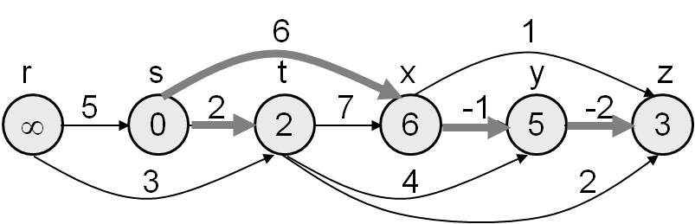

Floyd-Warshall Algorithm
  - Finds all-pair shortest paths in weighted graph
The Floyd-Warshall algorithm compares all possible paths through the graph between each pair of vertices. Here, all we do is to find out the shortest path between two nodes i and j via all the nodes (1, 2, …, n).
The Floyd-Warshall algorithm is an example of dynamic programming.
Algorithm
/* Assume a function edgeCost(i,j) which returns the cost of the edge from i to j
(infinity if there is none).
Also assume that n is the number of vertices and edgeCost(i,i)=0
*/

int path[][];
/* A 2-dimensional matrix. At each step in the algorithm, path[i][j] is the shortest path from i to j using intermediate values in (1...via). Each path[i][j] is initialized to edgeCost(i,j).
*/

procedure FloydWarshall()
for via = 1 to n
for each (i, j) in (1...n)
path[i][j] = min ( path[i][j], path[i][via] + path[via][j] );
The time complexity of this algorithm is O(|V|³).
Behavior with negative cycles
For numerically meaningful output, Floyd-Warshall assumes that there are no negative cycles (in fact, between any pair of vertices which form part of a negative cycle, the shortest path is not well-defined, because the path can be arbitrarily negative). Nevertheless, if there are negative cycles, Floyd–Warshall can be used to detect them. A negative cycle can be detected if the path matrix contains a negative number along the diagonal. If path[i][i] is negative for some vertex i, then this vertex belongs to at least one negative cycle.
Example
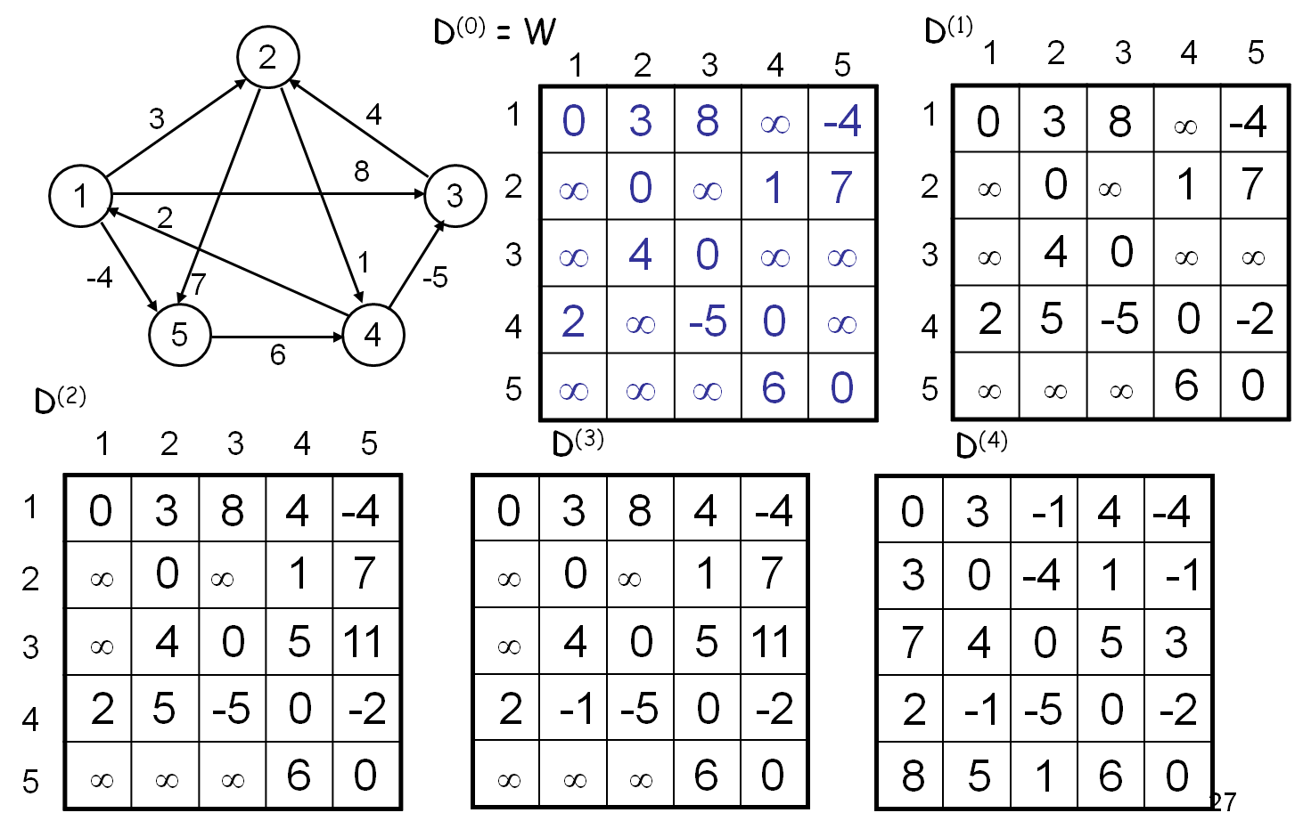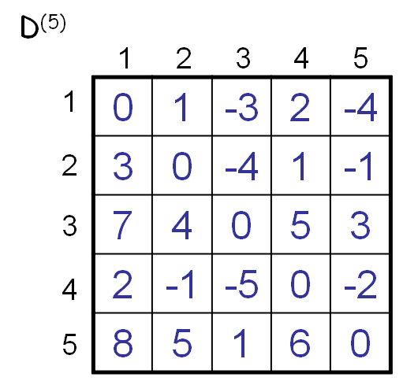

Prim’s Algorithm
  - Generates minimum spanning tree (MST) (using node-based approach)
In case of a weighted graph, there might be several spanning trees. But if we need to find the minimum spanning tree, i.e., the spanning tree which has the minimum total cost, we have to use Prim’s or Kruskal’s algorithm.
The main idea of Prim’s algorithm is to grow an MST from the current spanning tree by adding the nearest (lowest weight) vertex and the edge connecting the nearest (lowest weight) vertex to the MST. The algorithm may be presented informally as follows:
Select a vertex to be a tree-node.
while (there are non-tree vertices) {
if there is no edge connecting a tree node with a non-tree node
return “no spanning tree”.
Select an edge of minimum weight between a tree node and a non-tree node.
Add the selected edge and its new vertex to the tree.
}
return tree.
The run-time complexity of Prim’s algorithm is the same as that of Dijkstra’s algorithm. In fact, Prim’s algorithm is similar to Dijkstra’s algorithm – the only difference is that Dijkstra’s algorithm may or may not produce a spanning tree, whereas Prim’s algorithm always produces a spanning tree.
Example
Image | Description
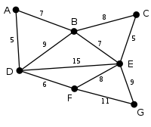 | This is our original weighted graph. The numbers near the arcs indicate their weight.
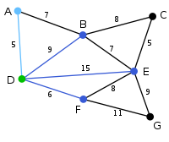 | Vertex D has been arbitrarily chosen as a starting point. Vertices A, B, E and F are connected to D through a single edge. A is the vertex nearest to D and will be chosen as the second vertex along with the edge AD.
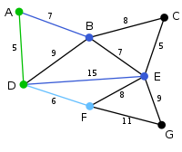 | The next vertex chosen is the vertex nearest to either D or A. B is 9 away from D and 7 away from A, E is 15, and F is 6. F is the smallest distance away, so we highlight the vertex F and the arc DF.
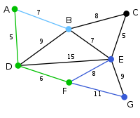 | The algorithm carries on as above. Vertex B, which is 7 away from A, is highlighted.
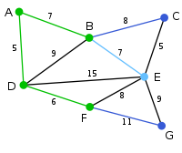 | In this case, we can choose between C, E, and G. C is 8 away from B, E is 7 away from B, and G is 11 away from F. E is nearest, so we highlight the vertex E and the arc BE.
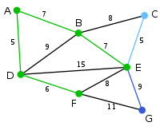 | Here, the only vertices available are C and G. C is 5 away from E, and G is 9 away from E. C is chosen, so it is highlighted along with the arc EC.
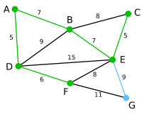 | Vertex G is the only remaining vertex. It is 11 away from F, and 9 away from E. E is nearer, so we highlight it and the arc EG.
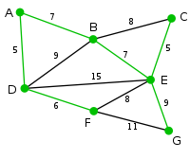 | Now all the vertices have been selected and the minimum spanning tree is shown in green. In this case, it has weight 39.

Kruskal’s Algorithm
  - Generates minimum spanning tree (MST) (using edge-based approach)
The main idea of Kruskal’s algorithm is to grow an MST from a forest of spanning trees by adding the smallest edge connecting two spanning trees. A formal algorithm along with complexity analysis is as follows:
MST-Kruskal(G,w)
01 A ← ∅
02 for each vertex v ∈ V[G] do
O(V)
O(ElogE)
O(E)
O(V)

03 Make-Set(v)
04 sort the edges of E by non-decreasing weight w
05 for each edge (u,v) ∈ E, in order by non-decreasing weight do
06 if Find-Set(u) ≠ Find-Set(v) then
07 A ← A ∪ {(u,v)}
08 Union(u,v)
09 return A
The overall complexity of the algorithm is: O(VE).
The operations used in the above algorithm are described as follows:
  - Make-Set(x) – creates a new set whose only member is x.
  - Union(x, y) – unites the sets that contain x and y, say, S_{x} and S_{y}, into a new set that is the union of the two sets.
  - Find-Set(x) – returns a pointer to the representative of the set containing x.
The algorithm (from coding point of view) is as follows:
- Sort the edges in ascending order.
- Now begin choosing the lowest cost edges.
- However, while choosing edges, we should pay attention so that a cycle is not formed. To prevent forming cycles, we need to keep track of whose parent is who. Initially, all the nodes’ parents are their values, themselves. Now, while choosing edges, we’ll check whether the parents of the two nodes belonging to the edge are the same. If so, then we’ll discard that edge. But if they’re not the same, then we’ll replace the higher parent value with the lower parent value. However, when we update the parent value of a particular node, we need to update its all other adjacent nodes’ parent values with its parent value.
- The process continues until all the edges have been visited.
Example
 | This is our original graph. The numbers near the arcs indicate their weight. None of the arcs are highlighted.
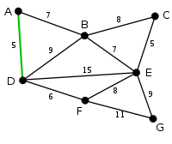 | AD and CE are the shortest arcs, with length 5, and AD has been arbitrarily chosen, so it is highlighted.
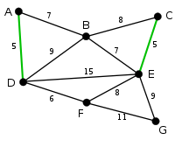 | CE is now the shortest arc that does not form a cycle, with length 5, so it is highlighted as the second arc.
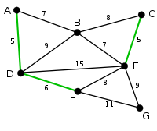 | The next arc, DF with length 6, is highlighted using much the same method.
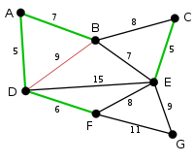 | The next-shortest arcs are AB and BE, both with length 7. AB is chosen arbitrarily, and is highlighted. The arc BD has been highlighted in red, because there already exists a path (in green) between B and D, so it would form a cycle (ABD) if it were chosen.
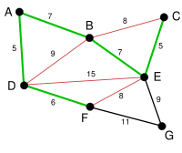 | The process continues to highlight the next-smallest arc, BE with length 7. Many more arcs are highlighted in red at this stage: BC because it would form the loop BCE, DE because it would form the loop DEBA, and FE because it would form FEBAD.
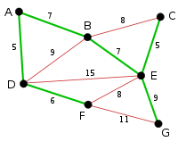 | Finally, the process finishes with the arc EG of length 9, and the minimum spanning tree is found.

Notice that we’re taking the number of nodes as input. Why? Initially, we’re taking a large matrix for 100 nodes. But we need the actual number of nodes in the graph when we try to traverse it. We’ll be using a loop, and it should stop running when we’ve completed examining the last node.
We need to color the dequeued node with BLACK if we want to detect a cycle within a graph. We’ll be discussing it in a while.
An uninformed search algorithm is one that does not take into account the specific nature of the problem. As such, they can be implemented in general, and then the same implementation can be used in a wide range of problems. The drawback is that most search spaces (i.e., the set of all possible solutions) are extremely large, and an uninformed search (especially of a tree) will take a reasonable amount of time only for small examples.
Notice that we’re taking the number of nodes as input. Why? Initially, we’re taking a large matrix for 100 nodes. But we need the actual number of nodes in the graph when we try to traverse it. We’ll be using a loop, and it should stop running when we’ve completed examining the last node.
Note that the result of DFS might vary according to traversal algorithm. If the graph in figure 8(a) is traversed as 1-2-3, then (1, 3) would be its forward edge. On the contrary, if the graph is traversed as 1-3-2, then (2, 3) would be its cross edge. For this reason, in most applications of DFS, we don’t need to distinguish between a forward edge and a cross edge.
i.e., if and only if.
Relaxing an edge (u, v) means testing whether we can improve the shortest path to v found so far by going through u.

