DBMS: An Interactive Tutorial
Organized & Prepared By
Sharafat Ibn Mollah Mosharraf
12th Batch (05-06)
Dept. of Computer Science & Engineering
University of Dhaka

Table of Contents
Introduction to Database and Designing Relational Databases 1
Database: What it is and why it is needed 1
Designing a database 1
Example Database Design 5
Entity-Relationship Model 7
E-R Model: What it is 7
Basic Concepts 7
Entity Sets and Attributes 7
Types of Attributes 8
Relationship Sets 8
Constraints 9
Cardinality Constraints / Mapping Cardinalities / Cardinality Ratios 10
Participation Constraints 11
Cardinality Limits 11
Weak Entity Sets 11
Discriminator / Partial Key of a Weak Entity Set 12
How the primary key of a weak entity set is formed 12
Placement of descriptive attributes in a weak entity set 12
Participation of weak entity sets in relationships 12
Weak entity sets – should they be designed as multivalued attributes? 13
Specialization and Generalization 13
Specialization 13
Generalization 13
Reduction of E-R Schemas to Tables 14
Strong Entity Sets 14
Weak Entity Sets 14
Relationship Sets 14
One-to-One Relationship 14
One-to-Many Relationship 14
Many-to-One Relationship 14
Many-to-Many Relationship 15
Composite Attributes 15
Multivalued Attributes 15
Generalization 15
E-R Diagram Symbols at a Glance 16
DML: Data-Manipulation Language 18
DML (Data-Manipulation Language): What it is 18
Query Language 18
The SELECT Operation / Statement 18
Relational Algebra 21
Fundamental Relational Algebra Operations 21
The Selection Operation 21
The Projection Operation 21
Composition of the Relational Operations 21
The Union Operation 22
The Set-Difference Operation 22
The Cartesian-Product Operation 23
The Rename Operation 24
Additional Relational Algebra Operations 25
The Set-intersection Operation 26
The Natural Join Operation 26
Extended Relational Algebra Operations 27
The Outer Join Operation 27
Generalized Projection 28
Aggregate Functions 28
Modification of Database 31
Insertion 31
Deletion 31
Update 32
Indexing and Hashing 33
The Problem 33

Basic Concepts 33
Types of Indices 33
Index Technique Choosing Factors 33
Ordered Indices 34
Primary / Clustering Index 34
Secondary / Non-Clustering Index 34
Index-Sequential Files 34
Contents of an index record / entry 34
Types of ordered indices 34
Dense Index 35
Dense index for primary indices 35
Another implementation of dense indices 35
Sparse Index 35
Comparative Analysis of Dense and Sparse Index 36
A good trade-off 36
Why this trade-off is good 36
Multi-Level Indices 36
The problem with single-level indices 36
Solution to this problem 36
Secondary Indices 37
B⁺ Tree Index 37
The Problem with Indexed-Sequential File Organization 37
How B⁺ Tree Index Solves the Problem 37
Structure of a B⁺ Tree 37
Operations on a B⁺ Tree 38
Adding Records to a B⁺ Tree 38
Deleting records from a B⁺ Tree 40
B⁺ Tree File Organization 41
B-Tree Index 42
Advantages of B-Tree 43
Disdvantages of B-Tree 43
Hashing 43
The Problem with Sequential File Organization and How Hashing Solves It 43
Hash File Organization 43
Manipulation of Records in Hash Files 43
Hash Functions 43
Distribution Qualities for Choosing a Hash Function 44
Some Examples Illustrating These Qualities 44
How Hash Functions Should be Designed 44
Handling of Bucket Overflows 44
Causes of bucket overflows 45
Reducing bucket overflows 45
Handling bucket overflows 45
Hash Indices 46
Static and Dynamic Hashing 46
Drawbacks of Hashing 47
Comparison of Ordered Indexing and Hashing 47
Multiple-Key Indices 48
Problem with Multiple Single-Key Indices 48
Advantages of Using Multiple-Key Indices 48
Index Definitions in SQL 49
Creating an Index 49
Removing an Index 49

Meanings of Special Formatting used
Formatting | Meaning | Example
Bold text | Technical terms in Database | tuple, one-to-many
Italic text | Attribute names, table names | account, customer-name
Dark red colored text | Topic heading | Designing a database
Dark red colored text and objects within a diagram or table | Newly added item compared to previous diagram or table or text
Blue colored text | Points to be remembered | What we’ve learnt from here is that, when …
Blue colored text under a figure | Figure Caption | Figure 1: …
Red colored text | Conclusion | To sum-up, we have …

Introduction to Database and Designing Relational Databases

Database: What it is and why it is needed
A database is a structured collection of records or data that is stored in a computer system.
Fine. But we can implement a database using files – we can write a program to put some information into a file and when needed, we can retrieve that information. Then what’s the point of introducing a course on databases???
Well, that’s true… But think about this situation: suppose your employer wants to manage a student database. So you write a file containing students’ class, roll number and marks in each subject. Now, your employer wants to get the list of students who have failed in a particular course. You write some code to display the list. However, some time later, your employer wants to get the list of students who scored A⁺ in a particular course. You again write some code to display the list. Now, once again, your employer wants the total number of students in a particular class. You have to modify your program again. But how many times are you going to take the pain of modifying your code?
If there were such a system which would instantly respond to your any kind of query within a database, then that would make your life much comfortable. Here comes the Database Management System (DBMS). This system provides you with an easy way to store and retrieve data and handle all your queries about those data. There are much more functionalities of a DBMS, of course.
The objective of our course on DBMS is to learn how to implement, manage and use a DBMS.
At the preliminary level, for the time being, our main learning objectives are:
- Designing a database (efficiently).
- Using queries (efficiently) to store data into and retrieve data from a database.

Designing a database
Suppose, we have to design a database to manage a banking system.
First, we need to know what data we should need to manage a banking system. Let’s start with information on customers. For each customer, we can record his name, street address, city, and most importantly, his account number in the bank. These name, street address, city and account number are called attributes or fields of customer.
Now that we’ve got our attributes, let’s try to establish a relationship among them. In this case, it’s quite simple: a customer with a name ‘name’ lives in ‘street address’ in city ‘city’ and has an account number specified by the attribute ‘account number’ in the bank.
In relational database model, we depict the above relation by placing the attributes into a box, which is called a schema and giving a name to the schema, somewhat like the following:
customer
customer-name
customer-street
customer-city
account-number
The customer relation (also called a table) with two sample records (also called rows or tuples) might be as follows:

customer-name | customer-street | customer-city | account-number
Somebody | Mirpur Road | Dhaka | A-101
Anybody | XYZ Road | Khagrachhori | A-104
A question may arise – why would we ever need to define a relationship among the attributes? Well, we’ll find the answer soon…
Let’s take a closer look at the relation. A customer can live at only one street address and in only one city at a time. So, we can say that the relationships of customer-name with customer-street and customer-city are one-to-one. But as for account-number, we know that a customer might have more than one account at a time; hence the relationship of customer-name with account-number is one-to-many.
customer-name
customer-street
customer-city
account-number
Figure 1: Relationships among the attributes of customer table.

Legend
One-to-one
One-to-many
So why does it matter? Suppose, the customer from above table named Somebody has three accounts at the bank (A-101, A-102 and A-103). Then we can store that information into the table as follows:
customer-name | customer-street | customer-city | account-number
Somebody | Mirpur Road | Dhaka | A-101, A-102, A-103
Now, when we query for the details of the customer who has an account number of A-103, we have to specifically search through each field for the account number; thus implementing our own search program (as the built-in query naturally do not search into a field). So, the objective of DBMS cannot be achieved.
However, we can implement a work-around for the problem by placing each account number in a single record like the following:
customer-name | customer-street | customer-city | account-number
Somebody | Mirpur Road | Dhaka | A-101
Somebody | Mirpur Road | Dhaka | A-102
Somebody | Mirpur Road | Dhaka | A-103
But this makes several copies of the same data and thus wastes storage space:
customer-name | customer-street | customer-city | account-number
Somebody  Duplicate  data | Mirpur Road | Dhaka | A-101
Somebody | Mirpur Road | Dhaka | A-102
Somebody | Mirpur Road | Dhaka | A-103
To solve both the problems, let’s split up the table into two tables as below:
 |  |  |  | account-number | customer-name
customer-name | customer-street | customer-city |  | A-101 | Somebody
Somebody | Mirpur Road | Dhaka |  | A-102 | Somebody
 |  |  |  | A-103 | Somebody
customer |  |  |  | account
Now, when we query for the details of the customer who has an account number of A-103, the account table will be queried first. From the account table, it will be found that a customer named Somebody holds that account number. Next, the details of the customer will be queried from the customer table using that customer name ‘Somebody’. Thus, we’ll be able to easily and successfully retrieve all the necessary data using a DBMS.
In the two tables, the field customer-name is acting as a link between records.
What we’ve learnt from here is that, when a one-to-many relationship exists – suppose – from field A to field B, we’ll create two tables: in the first one, we’ll keep the field A, and in the second one, we’ll place the field B and also the field A.
This is the reason why we need to define relationships among the attributes – so that we can distribute the attributes among different tables when designing and implementing a database.
Well, if you haven’t figured out yet, there is a problem with the above solution. We all know that it is possible that any two customers might have the same name. Consider the following situation:
customer-name | customer-street | customer-city |  | account-number | customer-name
Somebody | Mirpur Road | Dhaka |  | A-101 | Anybody
Somebody | Aga Kha Road | Bogra |  | A-102 | Anybody
Anybody | XYZ Road | Khagrachhori |  | A-103 | Somebody
customer |  |  |  | account
From account table, we find that account A-103 is owned by Somebody. Now, from customer table, how can we determine whether this Somebody is the one living in Dhaka, or the one in Bogra?
It seems that we need to use such a linking field in account table, which can uniquely identify a record in the customer table. So, which field in customer table uniquely indentifies a record therein? There might be several customers who have the same name or live at the same street or even in the same city. Therefore, a value may appear more than once in any of the fields.
In such cases where none of the attributes uniquely identifies a record in the table, we have to use a field – usually named id – in which unique integer values are assigned for each record. Thus, the above two tables become:
customer-id | customer-name | customer-street | customer-city |  | account-number | customer-id
1 | Somebody | Mirpur Road | Dhaka |  | A-101 | 3
2 | Somebody | Aga Kha Road | Bogra |  | A-102 | 3
3 | Anybody | XYZ Road | Khagrachhori |  | A-103 | 1
customer |  |  |  |  | account
Now we can definitely say that the owner of the account A-103 is a customer named Somebody who lives in Dhaka (and not in Bogra).
A field which uniquely identifies a record in a table is called a primary key. In customer table, customer-id is a primary key. Again, a primary key which is used as a field in another table for linking (i.e., relationship establishing) purposes, is called a foreign key. In account table, customer-id is a foreign key. Primary key and foreign key attributes are usually underlined to express their nature.
Primary Key
Foreign Key

customer-id | customer-name | customer-street | customer-city |  | account-number | customer-id
1 | Somebody | Mirpur Road | Dhaka |  | A-101 | 3
2 | Somebody | Aga Kha Road | Bogra |  | A-102 | 3
3 | Anybody | XYZ Road | Khagrachhori |  | A-103 | 1
customer |  |  |  |  | account
Note that we can also define a primary key for the account table, and it would be the account-number field.
So what we’ve learnt from this section is that we need a primary key to uniquely identify a record in a table, and we need to uniquely identify a record in a table to properly establish relationship among attributes; thus design an efficient database. However, primary key is also used to prevent inserting records which contain duplicate primary key field values.
You might have started thinking, “Well, we’ve solved the problem quite well!” But you’re wrong! It’s true that a customer might have more than one account at a time; but it’s also true that more than one customer might own a single account (which we call joint-account). So, the actual relationship between customer-name and account-number is many-to-many.
customer-name
customer-street
customer-city
account-number
Figure 2: Relationships among the attributes of customer table.

Legend
One-to-one
Many-to-many
Now, what happens when the account number A-104 is owned by both the customers named Somebody and Anybody? In the account table, we’ll either have to break the rule of atomic data, or we’ll have to keep duplicate records. Both of the solutions are unacceptable.
So, again, let’s split up the table account into two tables:
Foreign Key
Foreign Key
Primary Key
Primary Key

customer-id | customer-name | customer-street | customer-city |  | account-number |  | account-number |  | customer-id
1 | Somebody | Mirpur Road | Dhaka |  | A-101 |  | A-101 |  | 3
2 | Somebody | Aga Kha Road | Bogra |  | A-102 |  | A-102 |  | 3
3 | Anybody | XYZ Road | Khagrachhori |  | A-103 |  | A-103 |  | 1
 |  |  |  |  |  |  | A-104 |  | 1
 |  |  |  |  |  |  | A-104 |  | 3
customer |  |  |  |  | account |  |  | depositor
What we’ve done here is, we’ve created a link table named depositor containing two foreign keys – each of which refers to the corresponding primary key in the tables customer and account. Thus, from the depositor table, we can say that the account number A-104 is owned by two customers whose ids are 1 and 3. And then from the customer table, we can find the details about those customers. The interesting fact is that, the previous queries we’ve tried can also be executed easily from these tables with this configuration. Why don’t you try those for yourself right now?
[Umm… you might think that the account table seems to be lonely. However, when you’ll be designing a database in a real situation, you’ll definitely find that the account table does not consist of only one attribute. It will contain more than one fields, for example, balance – the amount of money currently available under that account number.]
What we’ve learnt from this section is that when a many-to-many relationship exists – suppose – from field A to field B, we’ll create three tables: in the first one, we’ll keep the field A and the fields related to it; in the second one, we’ll place the field B and the fields related to it; and finally, in the last table, we’ll put two fields from the previous two tables which are primary keys of those tables. The last table is just a linking table.
To sum-up, we have to follow the following steps when designing a database:
- Identify which attributes we need and place them into relevant tables.
- Identify the primary keys of the tables.
- Identify the relations among the attributes and modify table design accordingly.
Note that these steps are the primary steps for designing a database. There are other issues to consider when designing a database efficiently. We’ll discuss those later.

Example Database Design
Let’s design a database for bank management.
First, we have to determine which information we need to manage the bank. Suppose we need the following information:
- Branch details – which might include branch name, branch city and total assets of that branch.
- Customer details – customer name, his street address and the city he lives in.
- Account details – the account numbers, which branches the accounts are from, their owners and their balances.
- Loan details – the loan numbers, which branches the loans are from, their borrowers and their amounts.
Next, let’s try to figure out the relationships among these attributes so that we can determine which tables we should need and which attributes should go to which table.
First, we’ve to figure out which attributes are not related to each-other. The bank details are not in any way related to customer details. So, we can safely create two tables named – for example – branch and customer. We can fill those tables with necessary attributes – branch-name, branch-city and assets in branch table; and customer-name, customer-street and customer-city in customer table. Our database schema up to this point should look like the following:
branch customer
branch-name  branch-city  assets |  | customer-name  customer-street  customer-city
Now, the account details seems to contain attributes which relate to attributes in both branch details and customer details. So, we can create a table named accounts and put the necessary attributes (account-number, branch-name and balance) in it.
branch account customer
branch-name |  | account-number  branch-name  customer-name  balance |  | customer-name
branch-city  assets |  |  |  | customer-street  customer-city
Note that the branch-name attribute in account table refers to the branch-name attribute in branch table. So, branch-name should uniquely identify each record in branch table. In other words, branch-name should be a primary key. Let’s assume branch-name is unique for the bank, i.e., all the branches of the bank have different names. So, we can say that branch-name is a primary key in branch table, and hence, a foreign key in account table.
Again, the customer-name attribute in account table refers to the customer-name attribute in customer table. Let’s assume that customer names are unique (although in real situation it is not, let’s just assume it for ease of our design), and thus customer-name is a primary key in customer table and a foreign key in account table.
Note that when drawing a schema diagram for a database, the following rules are maintained:
- Each relation appears as a box, with the attributes listed inside it and the relation name above it.
- If there are primary key attributes, a horizontal line crosses the box, with primary key attributes listed above the line.
- It is customary to list the primary key attributes of a relation schema before the other attributes.
- Foreign key dependencies appear as arrows from the foreign key attributes of the referencing relation (or table – both denotes the same thing) to the primary key of the referenced relation.
Okay, let’s get back to our business. If we analyze more carefully, we can confirm that a customer may have multiple accounts and a single account can be shared by multiple customers. So, the relationship with customer-name and account-number is many-to-many. So, according to what we learned previously, let’s split-up the account table and design a link table named – for example, depositor – like the following:
branch account depositor customer
branch-name |  | account-number |  | customer-name  account-number |  | customer-name
branch-city  assets |  | branch-name  balance |  |  |  | customer-street  customer-city
Now remains the loan details. It’s much like the account details in relationship’s point of view. We need a foreign key branch-name and we know that the relationship between loan-number and customer-name is many-to-many (as a customer may take multiple loans and a single loan can be jointly taken by multiple customers). So, we can easily design a table named loan and a link table named – for example, borrower:
branch account depositor customer
branch-name |  | account-number |  | customer-name  account-number |  | customer-name
branch-city  assets |  | branch-name  balance |  |  |  | customer-street  customer-city

loan borrower
loan-number |  | customer-name  loan-number
branch-name
amount
So that’s our final database schema diagram for the bank management system.
We can represent a schema diagram in textual form, known as relation schema. The relation schema of the above diagram is as follows:
Branch_schema = (branch-name, branch-city, assets)
Customer_schema = (customer-name, customer-street, customer-city)
Account_schema = (account-number, branch-name, balance)
Loan_schema = (loan-number, branch-name, amount)
Borrower_schema = (customer-name, loan-number)
Depositor_schema = (customer-name, account-number)
Note that in relation schema, no foreign relation is depicted. Further note that the schema names start with uppercase letters.
So, the general form of a relation schema is:
S = (A₁, A₂, … , A_{n}), where A stands for Attribute.
A table filled with some records is called a relation instance. A relation instance r on a schema S can be written as:
r(S) or r(A₁, A₂, … , A_{n})
For example, to denote that account is a relation on Account_schema, we can write:
account(Account_schema) or account(account-number, branch-name, balance)
Note that relation instance names start with lowercase letters.

Entity-Relationship Model

E-R Model: What it is
The entity-relationship (E-R) data model perceives the real world as consisting of basic objects, called entities, and relationships among these objects. It was developed to facilitate database design by allowing specification of an enterprise schema, which represents the overall logical structure of a database. The E-R data model is one of several semantic data models; the semantic aspect of the model lies in its representation of the meaning of the data. The E-R model is very useful in mapping the meanings and interactions of real-world enterprises onto a conceptual schema.

Basic Concepts
The E-R data model employs three basic notions: entity sets, relationship sets, and attributes.

Entity Sets and Attributes
An entity is a “thing” or “object” in the real world that is distinguishable from all other objects. For example, each person in an enterprise is an entity. An entity has a set of properties. For example, a person has a name, address etc.
An entity set is a set of entities of the same type that share the same properties, or attributes. The set of all persons who are customers at a given bank, for example, can be defined as the entity set customer.
An entity is represented by a set of attributes. Attributes are descriptive properties possessed by each member of an entity set. The designation of an attribute for an entity set expresses that the database stores similar information concerning each entity in the entity set; however, each entity may have its own value for each attribute. Possible attributes of the customer entity set are customer-id, customer-name, customer-street and customer-city.
Each entity has a value for each of its attributes. For instance, a particular customer entity may have the value 321-12-3123 for customer-id, the value Jones for customer-name, the value Main for customer-street, and the value Harrison for customer-city.
For each attribute, there is a set of permitted values, called the domain or value set of that attribute. The domain of attribute customer-name might be the set of all text strings of a certain length.
A database thus includes a collection of entity sets, each of which contains any number of entities of the same type. The following figure shows part of a bank database that consists of two entity sets: customer and loan:
customer
customer-street
customer-name
customer-city
customer-id
loan
amount
loan-no
customer
customer-id
customer-name
customer-street
customer-city

loan
loan-no
amount

customer-id | customer-name | customer-street | customer-city
321-12-3123 | Jones | Main | Harrison
321-12-3124 | Smith | North | Rye
119-15-4569 | Hayes | Dupont | Harrison
123-45-6789 | Adams | Spring | Princeton
customer
loan-no | amount
L-17 | 1000
L-23 | 500
L-46 | 9000
L-12 | 30000
loan
Figure (c): Relation instances of customer and loan.

Figure (a): E-R diagram notations for entity sets and attributes.

Figure (b): Alternative E-R diagram notations.

Types of Attributes
An attribute, as used in the E-R model, can be characterized by the following attribute types:
- Simple and Composite Attributes
Attributes that cannot be divided into subparts are called simple attributes.
For example, telephone-no, salary etc.
Attributes that can be divided into subparts are called composite attributes.
For example, the composite attribute address can be divided into attributes street-number, street-name and apartment-number.
- Single-valued and multivalued attributes
Attributes that have a single value for a particular entity are called single-valued attributes.
For example, customer-name, salary etc.
Attributes that have multiple values for a particular entity are called multivalued attributes.
For example, an employee may have multiple telephone numbers. So, the attribute telephone-no is a multivalued attribute.

A
Figure: Symbol for multivalued attribute in E-R diagram.

- Derived Attributes
If the value of an attribute can be derived from the values of other related attributes or entities, then that attribute is called a derived attribute.
The attribute from which another attribute is derived is called the base or stored attribute.
The value of a derived attribute is not stored, but is computed when required.
For example, if an entity set employee has two attributes date-of-birth and age, then the attribute age is a derived attribute and the attribute date-of-birth is the base or stored attribute.
Figure: Symbol for derived attribute in E-R diagram.

A

Relationship Sets
A relationship is an association among several entities.
For example, we can define a relationship that associates customer Hayes with loan L-15. This relationship specifies that Hayes is a customer with loan number L-15.
A relationship set is a set of relationships of the same type.
For example, consider the two entity sets customer and loan. We define the relationship set borrower to denote the association between customers and the bank loans that the customers have. The following figure depicts this association:
customer
customer-street
customer-name
customer-city
customer-id
loan
amount
loan-no
Figure: E-R diagram for customer and loan entity sets and the relationship set borrower.

borrower
The association between entity sets is referred to as participation; that is, the entity sets E₁, E₂, ..., E_{n} participate in relationship set R.
A relationship instance in an E-R schema represents an association between the named entities in the real-world enterprise that is being modeled.
As an illustration, the individual customer entity Hayes, who has customer identifier 677-89-9011, and the loan entity L-15 participate in a relationship instance of borrower. This relationship instance represents that, in the real-world enterprise, the person called Hayes who holds customer-id 677-89-9011 has taken the loan that is numbered L-15.
A relationship may also have attributes called descriptive attributes. For example, consider the entity sets customer and loan and the relationship set borrower. We could associate the attribute date-issued to that relationship to specify the date when the loan was issued:
customer
customer-street
customer-name
customer-city
customer-id
loan
amount
loan-no
Figure: Descriptive attribute date-issued.

borrower
date-issued
Most of the relationship sets in a database system are binary – that is, they involve two entity sets. Occasionally, however, relationship sets involve more than two entity sets.
As an example, consider the entity sets employee, branch, and job. Examples of job entities could include manager, teller, auditor, and so on. Job entities may have the attributes title and level. The relationship set works-on among employee, branch, and job is an example of a ternary relationship. A ternary relationship among Jones, Perryridge, and manager indicates that Jones acts as a manager at the Perryridge branch. Jones could also act as auditor at the Downtown branch, which would be represented by another relationship. Yet another relationship could be between Smith, Downtown, and teller, indicating Smith acts as a teller at the Downtown branch.
employee
employee-name
employee-id
job
level
title
Figure: Ternary relationship.

works-on
branch
branch-name
branch-city
branch-street
The number of entity sets that participate in a relationship set is called the degree of the relationship set. A binary relationship set is of degree 2; a ternary relationship set is of degree 3.

Constraints
An E-R enterprise schema may define certain constraints to which the contents of a database must conform. Different types of constraints can be depicted in E-R model:
- Cardinality Constraints – one-to-one, one-to-many, many-to-one, many-to-many
- Participation Constraints – partial, total
- Key Constraints – superkey, candidate key, primary key

Cardinality Constraints / Mapping Cardinalities / Cardinality Ratios
Cardinality constraints express the number of entities to which another entity can be associated via a relationship set.
For a binary relationship set R between entity sets A and B, the mapping cardinality must be one of the following:
- One to one. An entity in A is associated with at most one entity in B, and an entity in B is associated with at most one entity in A.
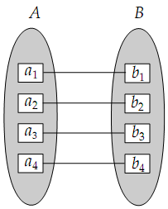
A
B
R
A
B
R
Figure (a): One-to-one mapping cardinality.

Figure (b): E-R diagram notation for
one-to-one relationship

Figure (c): Alternative notation.

- One to many. An entity in A is associated with any number (zero or more) of entities in B. An entity in B, however, can be associated with at most one entity in A.
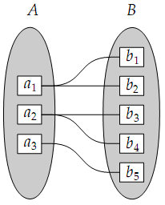
A
B
R
A
B
R
Figure (a): One-to-many mapping cardinality.

Figure (b): E-R diagram notation for
one-to-many relationship

Figure (c): Alternative notation.

- Many to one. An entity in A is associated with at most one entity in B. An entity in B, however, can be associated with any number (zero or more) of entities in A.
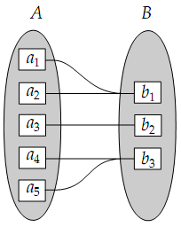
A
B
R
Figure (a): many-to-one mapping cardinality.

Figure (b): E-R diagram notation for
many-to-one relationship

Figure (c): Alternative notation.

A
B
R
- Many to many. An entity in A is associated with any number (zero or more) of entities in B, and an entity in B is associated with any number (zero or more) of entities in A.
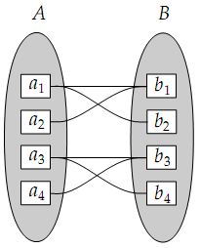
A
B
R
A
B
R
Figure (a): many-to-many mapping cardinality.

Figure (b): E-R diagram notation for
many-to-many relationship

Figure (c): Alternative notation.

Participation Constraints
The participation constraints used in E-R model are:
- Total
- Partial
The participation of an entity set E in a relationship set R is said to be total if every entity in E participates in at least one relationship in R. If only some entities in E participate in relationships in R, the participation of entity set E in relationship R is said to be partial.
For example, we expect every loan entity to be related to at least one customer through the borrower relationship. Therefore the participation of loan in the relationship set borrower is total.
In contrast, an individual can be a bank customer whether or not she has a loan with the bank. Hence, it is possible that only some of the customer entities are related to the loan entity set through the borrower relationship, and the participation of customer in the borrower relationship set is therefore partial.
E
R
Figure: E-R notation for total participation of entity set in relationship.

Cardinality Limits
E-R diagrams also provide away to indicate more complex constraints on the number of times each entity participates in relationships in a relationship set.
An edge between an entity set and a binary relationship set can have an associated minimum and maximum cardinality, shown in the form l..h, where l is the minimum and h the maximum cardinality.
A minimum value of 1 indicates total participation of the entity set in the relationship set.
A maximum value of 1 indicates that the entity participates in at most one relationship, while a maximum value ∗ indicates no limit.
Note that a label 1..h on an edge is equivalent to a double line.
For example, consider the following figure. The edge between loan and borrower has a cardinality constraint of 1..1, meaning the minimum and the maximum cardinality are both 1. That is, each loan must have exactly one associated customer. The limit 0..∗ on the edge from customer to borrower indicates that a customer can have zero or more loans. Thus, the relationship borrower is one to many from customer to loan, and further the participation of loan in borrower is total.
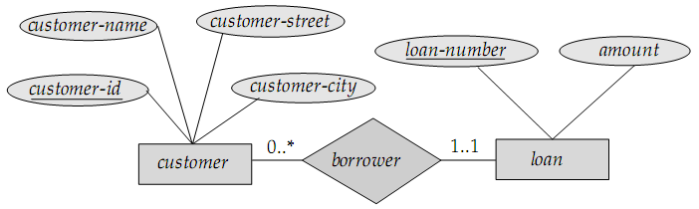
Figure: Cardinality limits on relationship sets.

Weak Entity Sets
An entity set that do not have sufficient attributes to form a primary key is called a weak entity set.
An entity set that has a primary key is termed a strong entity set.
As an illustration, consider the entity set player, which has two attributes – name and number. Now, name cannot be a primary key as there might be more than one player with the same name. However, number is unique for a particular team, but different teams have the same player number. For example, there might be player A with number 1 of team X, and player A with number 1 of team Y. So, the entity set player cannot be complete without being somehow associated with the entity set team.
As another illustration, consider the entity set payment, which has the three attributes: payment-number, payment-date, and payment-amount. Payment numbers are typically sequential numbers, starting from 1, generated separately for each loan payment. Thus, although each payment entity is distinct, payments for different loans may share the same payment number. Thus, this entity set does not have a primary key; it is a weak entity set.
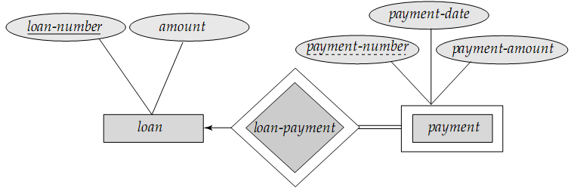
Figure: E-R diagram with a weak entity set.
- For a weak entity set to be meaningful, it must be associated with another entity set, called the identifying or owner entity set.
- Every weak entity must be associated with an identifying entity; that is, the weak entity set is said to be existence dependent on the identifying entity set. The identifying entity set is said to own the weak entity set that it identifies.
- The relationship associating the weak entity set with the identifying entity set is called the identifying relationship.
- The identifying relationship is many to one from the weak entity set to the identifying entity set, and the participation of the weak entity set in the relationship is total.
- In our example, the identifying entity set for payment is loan, and a relationship loan-payment that associates payment entities with their corresponding loan entities is the identifying relationship.

Discriminator / Partial Key of a Weak Entity Set
Although a weak entity set does not have a primary key, we nevertheless need a means of distinguishing among all those entities in the weak entity set that depend on one particular strong entity. The discriminator or partial key of a weak entity set is a set of attributes that allows this distinction to be made.
For example, the discriminator of the weak entity set payment is the attribute payment-number, since, for each loan, a payment number uniquely identifies one single payment for that loan.

How the primary key of a weak entity set is formed
The primary key of a weak entity set is formed by the primary key of the identifying entity set, plus the weak entity set’s discriminator.
In the case of the entity set payment, its primary key is {loan-number, payment-number}, where loan-number is the primary key of the identifying entity set, namely loan, and payment-number distinguishes payment entities within the same loan.

Placement of descriptive attributes in a weak entity set
The identifying relationship set should have no descriptive attributes, since any required attributes can be associated with the weak entity set.

Participation of weak entity sets in relationships
- A weak entity set can participate in relationships other than the identifying relationship.
For instance, the payment entity could participate in a relationship with the account entity set, identifying the account from which the payment was made.
- A weak entity set may participate as owner in an identifying relationship with another weak entity set.
- It is also possible to have a weak entity set with more than one identifying entity set.
A particular weak entity would then be identified by a combination of entities, one from each identifying entity set.
The primary key of the weak entity set would consist of the union of the primary keys of the identifying entity sets, plus the discriminator of the weak entity set.

Weak entity sets – should they be designed as multivalued attributes?
In some cases, the database designer may choose to express a weak entity set as a multivalued composite attribute of the owner entity set.
In our example, this alternative would require that the entity set loan have a multivalued, composite attribute payment, consisting of payment-number, payment-date, and payment-amount.
A weak entity set may be more appropriately modeled as an attribute if it participates in only the identifying relationship, and if it has few attributes.
Conversely, a weak-entity set representation will more aptly model a situation where the set participates in relationships other than the identifying relationship, and where the weak entity set has several attributes.

Specialization and Generalization

Specialization
The process of designating subgroupings within an entity set is called specialization.
For example, consider an entity set person, with attributes name, street and city. A person may be further classified as a customer or an employee. Each of these person types is described by a set of attributes that includes all the attributes of entity set person plus possibly additional attributes. For example, customer entities may be described further by the attribute customer-id, whereas employee entities may be described further by the attributes employee-id and salary. The specialization of person allows us to distinguish among persons according to whether they are employees or customers.

Generalization
There are similarities between the customer entity set and the employee entity set in the sense that they have several attributes in common. This commonality can be expressed by generalization, which is a containment relationship that exists between a higher-level entity set and one or more lower-level entity sets. In our example, person is the higher-level entity set and customer and employee are lower-level entity sets. Higher- and lower-level entity sets also may be designated by the terms superclass and subclass, respectively. The person entity set is the superclass of the customer and employee subclasses.
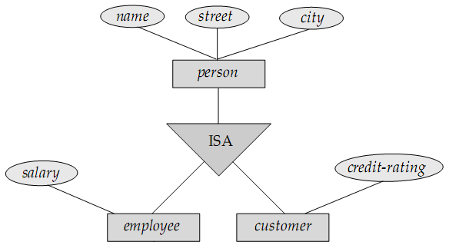
Figure: Specialization and Generalization. [Note: ISA means “is a”]

Reduction of E-R Schemas to Tables

Strong Entity Sets
E
A₁
A₂
A_{n}
…
E (A₁, A₂, …, A_{n})
E-R Schema
Relational Schema

Weak Entity Sets
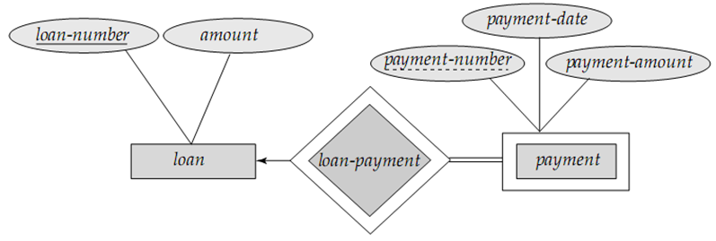
loan (loan-number, amount)
payment (loan-number, payment-number, payment-date, payment-amount)
E-R Schema
Relational Schema

Relationship Sets

One-to-One Relationship
E₁
A₁
A₂
A_{n}
…
E (A₁, A₂, …, A_{n}, B₁, B₂, …, B_{n})
E-R Schema
Relational Schema
E₂
B₁
B₂
B_{n}
…
R

One-to-Many Relationship
E₁
A₁
A₂
A_{n}
…
E₁ (A₁, A₂, …, A_{n})
E₂ (B₁, A₁, B₂, …, B_{n}, C₁, C₂, …, C_{n})
E-R Schema
Relational Schema
E₂
B₁
B₂
B_{n}
…
R
C₁
C₂
C_{n}
…

Many-to-One Relationship
Just the reverse of one-to-many.

Many-to-Many Relationship
E₁
A₁
A₂
A_{n}
…
E₁ (A₁, A₂, …, A_{n})
E₂ (B₁, B₂, …, B_{n})
R (A₁, B₁, C₁, C₂, …, C_{n})
E-R Schema
Relational Schema
E₂
B₁
B₂
B_{n}
…
R
C₁
C₂
C_{n}
…

Composite Attributes
E
A₁
A₂
A₃
E (A₁, A₂, B₁, B₂)
E-R Schema
Relational Schema
B₁
B₂

Multivalued Attributes
E
A₁
A₂
A₃
E (A₁, A₂)
E_A (A₃, A₁)
E-R Schema
Relational Schema

Generalization
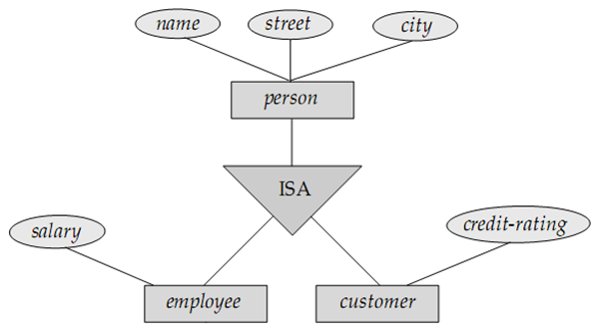
E-R Schema
Relational Schema
person (person-id, name, street, city)
employee (person-id, salary)
customer (person-id, credit-rating)

E-R Diagram Symbols at a Glance
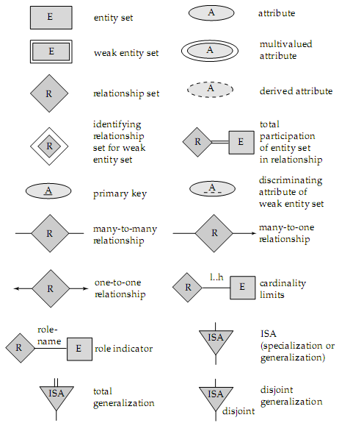

Figure: Symbols used in E-R diagram.

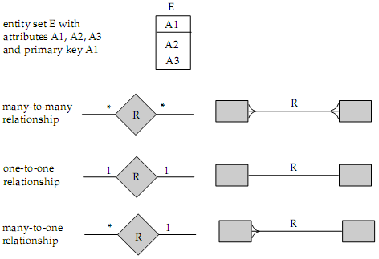

Figure: Alternative E-R notations.

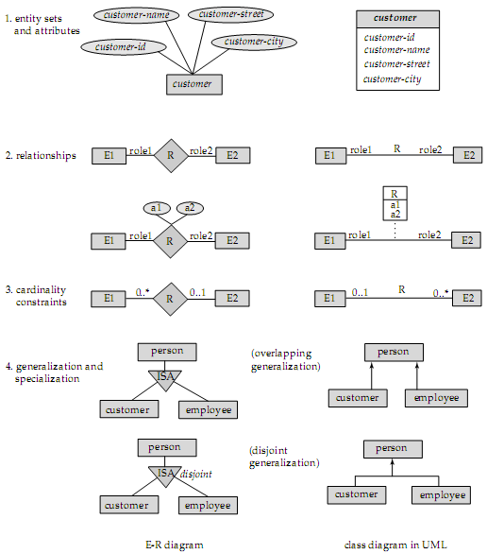

Figure: Symbols used in the UML class diagram notation.

DML: Data-Manipulation Language

So far we’ve seen how to use table manipulation commands [sorry, we couldn’t include the commands due to lack of time… ]. Now we’ll observe how to put data into tables, retrieve data from tables and manipulate these data.

DML (Data-Manipulation Language): What it is
A data-manipulation language is a language that enables users to access or manipulate data as organized by the appropriate data model.
Data-manipulation is
- The retrieval of information stored in the database
- The insertion of new information into the database
- The deletion of information from the database
- The modification of information stored in the database

Query Language
A query is a statement requesting the retrieval of information. The portion of a DML that involves information retrieval is called a query language. Although technically incorrect, it is common practice to use the terms query language and data-manipulation language synonymously.

The SELECT Operation / Statement
The SELECT statement is used to retrieve information from the database according to provided conditions.
To demonstrate the use of SELECT statement, let’s assume the following two relation instances.
customer_name | customer_street | customer_city |  | account_number | customer_name | balance
Somebody | Mirpur Road | Dhaka |  | A-101 | Anybody | 1000
Somebody | Aga Kha Road | Bogra |  | A-102 | Anybody | 1500
Anybody | XYZ Road | Khagrachhori |  | A-103 | Somebody | 2000
Nobody | Mirpur Road | Dhaka |  | A-104 | Nobody | 2500
customer |  |  |  | account
Q1. From the customer table, find out the information of all the customers who live in Dhaka.
select * from customer where customer_city = 'Dhaka';
Output:
customer_name | customer_street | customer_city
Somebody | Mirpur Road | Dhaka
Nobody | Mirpur Road | Dhaka
Q2. From the customer table, find out the information of all the customers who live in either Dhaka or Bogra.
select * from customer where customer_city = 'Dhaka' or customer_city = 'Bogra';
Output:
customer_name | customer_street | customer_city
Somebody | Mirpur Road | Dhaka
Somebody | Aga Kha Road | Bogra
Nobody | Mirpur Road | Dhaka

Q3. Find out the customers along with their account numbers who have account balances of at least 2000 taka.
select customer_name, account_number from account where balance >= 2000;
Output:
customer_name | account_number
Somebody | A-103
Nobody | A-104
From the above three queries, we can observe the general structure for the select statement:
SELECT attribute_1, attribute_2, ... , attribute_N
FROM table
WHERE expression
- The attributes after the SELECT phrase are those attributes which we want to display at the output result.
If an asterisk (*) is placed after the select phrase instead of attribute names, it would mean that we want all the attributes at the output.
- The table name after the FROM clause refers to the relation from which we want to perform the query.
- The expressions after the WHERE clause contains the actual query. The expressions may contain the following operators:
Comparison operators: <, <=, >, >=, =, <>
Logical connectives: AND, OR, NOT
Simplified operators: this BETWEEN some_value AND some_other_value,
this NOT BETWEEN some_value AND some_other_value
[These are the substitutes for:
this <= some_value AND this >= some_other_value]
Q4. From the following table named result, find out the students (along with their marks) who have scored more than 80 marks, and display them in the descending order of their marks.
student_name | marks
A | 55
B | 90
C | 40
D | 80
E | 85
F | 95
G | 82
select student_name, marks from result where marks > 80 order by marks desc;
Or, as the table contains only these two fields, we can write:
select * from result where marks > 80 order by marks desc;
Output:
student_name | marks
F | 95
B | 90
E | 85
G | 82

Q5. From the above table in Q4, we want to find out the top-most 3 students (to give them prizes for obtaining the 1st, 2nd and 3rd places). How would you find them?
select student_name from result order by marks desc limit 3;
Output:
student_name
F
B
E
Q6. From the table in Q4, we want to find out the student who stood 2nd. How would you find him?
select student_name from result order by marks desc limit 1, 1;
Output:
student_name
B
Q7. From the table in Q4, we want to find out how many students scored >= 80. How would you find it?
select count(*) from result where marks >= 80;
Output:
count(*)
5
Q8. We want to know how the results of the students (in Q4) would look like if we were to give away 5 marks as grace. How would you find it?
Select student_name, marks + 5 from result;
Output:
student_name | marks + 5
A | 60
B | 95
C | 45
D | 85
E | 90
F | 100
G | 87
From the queries Q4 to Q8, we can observe the general structure for the select statement:
SELECT attribute(s) and/or function(s)
FROM table
WHERE expression
ORDER BY attribute(s)
LIMIT number_of_rows / starting_row_index, number_of_rows

Relational Algebra
We’ve seen various query statements for retrieving information according to our needs. But did you ever wonder how these queries are executed by the computer? Put in other words, how does the computer interpret these queries? To get the answer, we have to go back into 1970; we need to know the history of how the DBMS was born.
History omitted for lack of time…

Fundamental Relational Algebra Operations
These operations are called fundamental as they are sufficient for expressing any relational algebra query, although some common queries become lengthy to express.
- Selection (unary)
- Projection (unary)
- Rename (unary)
- Union (unary)
- Set-difference (binary)
- Cartesian product (binary)

The Selection Operation
Q9. From the customer table in Q1, find out the information of all the customers who live in Dhaka.
SQL: select * from customer where customer_city = 'Dhaka';
RA: σ _{customer_city = "Dhaka"} (customer)
So, the general structure for the select operation of relational algebra is:
σ _{expression} (relation)

The Projection Operation
Q10. From the customer table in Q1, find out the names and street addresses of all the customers.
SQL: select customer_name, customer_street from customer
RA: П _{customer_name, customer_city} (customer)
So, the general structure for the projection operation of relational algebra is:
П _{attributes} (relation)

Composition of the Relational Operations
Q11. From the customer table in Q1, find out the names of all the customers who live in either Dhaka or Bogra.
SQL: select customer_name
from customer
where customer_city = 'Dhaka' or customer_city = 'Bogra';
RA: П _{customer_name} (σ customer_city = "Dhaka" ⋁ customer_city = "Bogra" (customer))

The Union Operation
Q12. From the tables below, find the names of all the customers who have either an account or a loan or both.
customer_name | loan_number |  | customer_name | account_number
Somebody | L-101 |  | Anybody | A-102
Somebody | L-102 |  | Somebody | A-103
Anybody | L-103 |  | Nobody | A-104
borrower |  |  | depositor
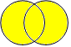SQL: select customer_name from borrower
borrower
depositor
customers
union
select customer_name from depositor;
RA: П _{customer_name} (borrower) ∪ П _{customer_name} (depositor)
Output:
customer_name
Somebody
Anybody
Nobody

The Set-Difference Operation
Q13. From the tables in Q12, find all the customers who have accounts but no loans.
SQL: select customer_name from depositor
customers
borrower
depositor
minus (or except)
select customer_name from borrower;
RA: П _{customer_name} (depositor) – П _{customer_name} (borrower)
Output:
customer_name
Nobody
Notes on the union and set-difference operations:
- Unlike the SELECT clause, the UNION, MINUS and EXCEPT clauses will eliminate duplicate values.
- For a union operation r₁ ∪ r₂ or a set-difference operation r₁ – r₂ to be valid, two conditions must hold:
- The relation r₁ and r₂ must be of the same arity; i.e., they must have the same number of attributes.
- For all i, the domains of i-th attribute of r₁ and the domains of i-th attribute of r₂ must be the same.
Note that r₁ and r₂ can be, in general, temporary relations that are the result of relational algebra expressions.
- MySQL does not support the MINUS or EXCEPT clauses. Rather, set-difference is performed via outer join operations. We’ll learn about outer join operation later.

The Cartesian-Product Operation
Q14. From the tables below, find all the customers who have a loan at Dhaka branch.
loan_number | branch_name | amount |  | customer_name | loan_number
L-101 | Dhaka | 1000 |  | Somebody | L-101
L-103 | Khulna | 2000 |  | Nobody | L-103
 |  |  |  | Anybody | L-103
loan |  |  |  | borrower
The problem is, customer_name is in one table, whereas branch_name is in another table. Then how would we perform a select operation? Well, the good news is, we have the loan_number in common. So, we can solve the problem by the following algorithm: for each loan_number in loan table where branch_name is Dhaka, find out the customer_name corresponding to that loan_number.
Step 1: Find the loan_numbers from loan table where branch_name is Dhaka.
SQL: select loan_number from loan where branch_name = 'Dhaka';
RA: П _{loan_number} (σ _{branch_name = "Dhaka"} (loan))
Step 2: Find the customer_names from borrower table where loan_numbers are equal to the loan_numbers derived from step 1.
SQL: select customer_name from borrower
where loan_number = any_loan_number_in_the_relation_found_from_step_1;
RA: П _{customer_name} (σ loan_number = any_loan_number_in_the_relation_found_from_step_1 (borrower))
But the problem is, how can we express any_loan_number_in_the_relation_found_from_step_1? The problem arises as that expression is a set of values, not a single value that we can compare with another value.
The solution comes with the Cartesian-product (also known as cross-product) operation. From set theory, we know that,
if A = {1, 2, x}
and B = {x, b}
then A × B = {(1, x), (1, b), (2, x), (2, b), (x, x), (a, b)}
If our requirement is to get the common value (in this case, x), then we can cross-product the sets and find our required value by checking where both parts of a pair are the same (in this case, (x, x)).
Similarly, if we cross-product the above two relations, we will get the following relation:
loan_number | branch_name | amount | customer_name | loan_number
L-101 | Dhaka | 1000 | Somebody | L-101
L-101 | Dhaka | 1000 | Nobody | L-103
L-101 | Dhaka | 1000 | Anybody | L-103
L-103 | Khulna | 2000 | Somebody | L-101
L-103 | Khulna | 2000 | Nobody | L-103
L-103 | Khulna | 2000 | Anybody | L-103
The above relation can be obtained by the following query or relational algebra expression:
SQL: select * from loan, borrower;
RA: σ (loan × borrower)
Now, let’s filter-out the rows where both the loan_numbers are the same. Then we’ll get the following relation:
loan_number | branch_name | amount | customer_name | loan_number
L-101 | Dhaka | 1000 | Somebody | L-101
L-103 | Khulna | 2000 | Anybody | L-103
The above filtration (along with the cross-product) can be done by the following query or RA expression:
SQL: select * from loan, borrower where loan_number = loan_number;
RA: σ _{loan_number = loan_number} (loan × borrower)
But the DBMS system will complain if we try to execute the above query. How is the program supposed to know that these two loan_numbers are to be checked for equality from both the sides and not from only the left side or only the right side?
That’s why we need to specify the attribute names along with their table names:
SQL: select * from loan, borrower
where loan.loan_number = borrower.loan_number;
RA: σ loan.loan_number = borrower.loan_number (loan × borrower)
Fine. Now, to get our desired result, we need to filter–out the records which contain ‘Dhaka’ as the branch_name. Then we’ll get the following relation:
loan_number | branch_name | amount | customer_name | loan_number
L-101 | Dhaka | 1000 | Somebody | L-101
The above filtration (along with the cross-product and the previous filtration) can be done by the following query or RA expression:
SQL: select * from loan, borrower
where loan.loan_number = borrower.loan_number and branch_name = 'Dhaka';
RA: σ _{branch_name = "Dhaka"} (σ loan.loan_number = borrower.loan_number (loan × borrower))
Finally, we only need the customer_names. So, the final query for performing all these steps would be:
SQL: select customer_name from loan, borrower
where loan.loan_number = borrower.loan_number and branch_name = 'Dhaka';
RA: П _{customer_name} (σ _{branch_name = "Dhaka"} (σ loan.loan_number = borrower.loan_number (loan × borrower)))
And the final output would be:
customer_name
Somebody

The Rename Operation
Let’s go through an example.
Q15. From the table named result below, find the highest marks.
student_name | marks
A | 60
B | 70
C | 80
SQL: select max(marks) from result;
But how would you express this in relational algebra? Solution:
Step 1: Compute the Cartesian-product relation:
student_name | marks | student_name | marks
A | 60 | A | 60
A | 60 | B | 70
A | 60 | C | 80
B | 70 | A | 60
B | 70 | B | 70
B | 70 | C | 80
C | 80 | A | 60
C | 80 | B | 70
C | 80 | C | 80
RA: σ (result × result)
Step 2: Filter out the tuples in which the marks on the left side are lesser than the marks on the right side (or vice-versa):
student_name | marks | student_name | marks
A | 60 | B | 70
A | 60 | C | 80
B | 70 | C | 80
RA: σ _{marks < marks} (result × result)
Now the problem is obvious. How can we distinguish the two marks? Using the relation name (i.e., result.marks = result.marks) can’t remove the ambiguity. In this case, we have to rename one or both the relations. It can be done as below (renaming only one of the relations into res):
RA: σ _{result.marks < res.marks} (result × ρ _{res} (result))
SQL: select * from result, result as res where result.marks < res.marks;
The general structure of the rename operation is as follows:
ρ_{new-name} (old-name)
Step 3: Take only the marks field:
marks
60
70
RA: П _{result.marks} (σ _{result.marks < res.marks} (result × ρ _{res} (result)))
SQL: select distinct result.marks from result, result as res
where result.marks < res.marks;
Note that we’re using the keyword DISTINCT to get unique values. RA automatically provides distinct values, whereas SQL select query doesn’t.
Step 4: Take the set-difference between the marks attribute in result relation and this temporary relation:
RA: П _{marks} (result) – П _{marks} (σ _{result.marks < res.marks} (result × ρ _{res} (result)))
SQL: select marks from result
minus
(select distinct result.marks from result, result as res
where result.marks < res.marks);

Additional Relational Algebra Operations
These operations do not add any power to the algebra, but they simplify common queries.
- Set-intersection (binary)
- Natural join (binary)
- Division (binary)
- Assignment (unary)

The Set-intersection Operation
r₁
r₂
Note: r₁ ∩ r₂ = r₁ – (r₁ – r₂) = r₂ – (r₂ – r₁)
Q16. From the table in Q12, find all the customers who have both an account and a loan.
RA: П _{customer_name} (borrower) ∩ _{customer_name} (depositor)
SQL: select customer_name from borrower
intersect
select customer_name from depositor;
Note that MySQL doesn’t support the INTERSECT operation. So, the following query is used instead:
SQL: select distinct borrower.customer_name from borrower, depositor
where borrower.customer_name = depositor.customer_name;
OR, select distinct customer_name from borrower
where customer_name in (select customer_name from depositor);
OR, select distinct borrower.customer_name from borrower
where exists
(select * from depositor
where borrower.customer_name = depositor.customer_name);
RA: П _{borrower.customer_name} (σ borrower.customer_name = depositor.customer_name (borrower × depositor))
Output:
customer_name
Somebody
Anybody

The Natural Join Operation
This operation simplifies the Cartesian-product operation in that it automatically applies the conditions that common fields are to be matched. Also, the common fields are displayed as a single field at output.
Thus, the operation
П _{borrower.customer_name} (σ borrower.customer_name = depositor.customer_name (borrower × depositor))
becomes
П _{borrower.customer_name} (borrower ⋈ depositor)
Q17. From the table in Q12, find the customers (along with all their information) who have both an account and a loan.
SQL: select * from borrower natural join depositor;
RA: σ (borrower ⋈ depositor)
Output:
customer_name | loan_number | account_number
Somebody | L-101 | A-103
Somebody | L-102 | A-103
Anybody | L-103 | A-102

Extended Relational Algebra Operations
These operations simply extend the basic operations in several ways.
- Outer join – allows relational algebra expressions to deal with null values by extending join operation
- Generalized Projection – allows arithmetic operations as part of projection
- Aggregate Functions – sum, avg, count, min, max

The Outer Join Operation
Consider the following two tables:
id | name |  | id | name
1 | A |  | 1 | A
2 | B |  | 2 | C
x |  |  | y
Both the tables have a common name – A. However, table x has a name (B) which table y doesn’t have. On the other hand, table y has a name (C) that table x doesn’t have.
If we cross-join the tables, we’ll get:
id | name | id | name
1 | A | 1 | A
1 | A | 2 | C
2 | B | 1 | A
2 | B | 2 | C
Now, if we use natural join, we’ll come up with only the first row. But what if we want to keep all the records from the left table or right table or both anyway? For example, we want to know which records in table x doesn’t match with records in table y?
Outer join answers to this query. There are three types of outer joins:
Left Outer Join
Keeps all the records from the left table and assigns null values to those records which do not match on the right table.
id | name | id | name
1 | A | 1 | A
2 | B | null | null
Right Outer Join
Keeps all the records from the right table and assigns null values to those records which do not match on the left table.
id | name | id | name
1 | A | 1 | A
null | null | 2 | C
Full Outer Join
Keeps all the records from the both the tables and assigns null values to those records which do not match.
id | name | id | name
1 | A | 1 | A
2 | B | null | null
null | null | 2 | C

Q18. From the tables in Q12, find all the customers who have accounts but no loans.
SQL: select customer_name
customers
borrower
depositor
from depositor left outer join borrower
on depositor.customer_name = borrower.customer_name
where loan_number is null
OR, select customer_name
from depositor left outer join borrower
using (customer_name)
where loan_number is null
RA: П _{customer_name} (σ _{loan_number = null} (depositor ̲̅⋈ borrower))
Output:
customer_name
Nobody
Q19. From the table in Q12, find the names of all the customers who have either an account or a loan but not both.
customers
borrower
depositor
SQL: select customer_name
from depositor full outer join borrower
on depositor.customer_name = borrower.customer_name
where loan_number is null or account_number is null
OR, select customer_name
from depositor full outer join borrower
using (customer_name)
where loan_number is null or account_number is null
OR, select customer_name
from depositor natural full outer join borrower
where loan_number is null or account_number is null
RA: П _{customer_name} (σ loan_number = null ⋁ account_number = null (depositor ̲̅⋈ ̲̅ borrower))
Output:
customer_name
Nobody

Generalized Projection
This operation extends the projection operation by allowing arithmetic functions to be used in the projection list.
As an example, let’s revisit query Q8: we want to know how the results of the students (in Q4) would look like if we were to give away 5 marks as grace. How would we find it?
SQL: select student_name, marks + 5 from result;
RA: П _{student_name, marks + 5} (result)

Aggregate Functions
Aggregate functions take a collection of values and return a single value as a result.
For example, consider the following employee table:

employee_name | branch_name | branch_city | salary
A | DU | Dhaka | 1000
B | DU | Dhaka | 2000
C | BUET | Dhaka | 3000
D | KUET | Khulna | 4000
E | KU | Khulna | 5000
F | RU | Rajshahi | 6000
Q20. Find the number of branches appearing in the employee relation.
SQL: select count(distinct branch_name) from employee;
RA: G _{count-distinct(branch_name)} (employee)
Output:
count(distinct branch_name)
5
Q21. Find the total salary of all employees at each branch of the bank.
SQL: select branch_name, sum(salary) from employee group by branch_name;
RA: _{branch_name}G _{sum(salary)} (employee)
Output:
branch_name | sum(salary)
BUET | 3000
DU | 3000
KU | 5000
KUET | 4000
RU | 6000
Note that the column header for the second column is not very meaningful. To give it a meaningful name, e.g., total_salary, we can rewrite the above query as below:
SQL: select branch_name, sum(salary) as total_salary from employee group by branch_name;
RA: _{branch_name}G _{sum(salary) as total_salary} (employee)
Output:
branch_name | total_salary
BUET | 3000
DU | 3000
KU | 5000
KUET | 4000
RU | 6000
Q22. Find branch city, branch name wise total salary, average salary and also number of employees.
SQL: select branch_city, branch_name, sum(salary), avg(salary), count(employee_name)
from employee group by branch_city, branch_name;
RA: _{branch_city, branch_name}G sum(salary), avg(salary), count(salary) (employee)
Output:
branch_city | branch_name | sum(salary) | avg(salary) | count(employee_name)
Dhaka | BUET | 3000 | 3000.0000 | 1
Dhaka | DU | 3000 | 1500.0000 | 2
Khulna | KU | 5000 | 5000.0000 | 1
Khulna | KUET | 4000 | 4000.0000 | 1
Rajshahi | RU | 6000 | 6000.0000 | 1
Q23. From the following table, find the average balance for each customer who lives in Dhaka and has at least two accounts.
customer_name | customer_city |  | customer_name | account_no | balance
A | Dhaka |  | A | A-101 | 1000
B | Dhaka |  | A | A-102 | 2000
C | Khulna |  | B | A-103 | 3000
D | Dhaka |  | C | A-104 | 4000
 |  |  | D | A-105 | 5000
 |  |  | D | A-106 | 6000
customer |  |  | account
Here, we cannot insert both the conditions into the where clause, because counting how many accounts a customer has can only be done using an aggregate function (count). As aggregate functions operate on groups whereas the where clause operates on tuples, these two conditions cannot be put together. For solving this problem, SQL introduces another clause having where the conditions to be operated on groups are to be placed.
So how would we write this query?
Step 1: Find the customers (with all the other information) who live in Dhaka.
SQL: select * from customer natural join account where customer_city = 'Dhaka';
This would yield the following relation:
customer_name | customer_city | account_no | balance
A | Dhaka | A-101 | 1000
A | Dhaka | A-102 | 2000
B | Dhaka | A-103 | 3000
D | Dhaka | A-105 | 5000
D | Dhaka | A-106 | 6000
Step 2: Because we need to find average balance for each customer, we need to group the records by customer_name; but remember that we have to take only those customers who have at least two accounts.
SQL: select * from customer natural join account
where customer_city = 'Dhaka'
group by customer_name
having count(distinct account_no) >= 2;
This would yield the following relation:
customer_name | customer_city | account_no | balance
A | Dhaka | A-101 | 1000
D | Dhaka | A-105 | 5000
Step 3: However, we need to find the average balance for each customer.
SQL: select customer_name, avg(balance)
from customer natural join account
where customer_city = 'Dhaka'
group by customer_name
having count(distinct account_no) >= 2;
Thus, the final output will be:
customer_name | avg(balance)
A | 1500.0000
D | 5500.0000

Modification of Database
It addresses how to add, remove or change information in the database. Database modification is expressed by assignment operation, ←.

Insertion
Inserting records in a database is quite easy. We either specify a tuple to be inserted or write a query whose result is a set of tuples to be inserted. Consider the following two tables:
customer | loan_no | branch | amount |  | customer | account_no | branch | balance
A | 101 | Dhaka | 1000
B | 102 | Rajshahi | 2000
C | 103 | Dhaka | 3000
loan account
Now, let’s insert a record in the loan table:
SQL: insert into loan values ('D', 104, 'Bogra', 4000);
RA: loan ← loan ∪ {("D", 104, "Bogra", 4000)}
Easy, isn’t it? Let’s try another example (a bit complex, however). We want to provide a new savings account of Tk. 200 for all the loan holders of Dhaka branch. The query would be as follows:
SQL: insert into account
select customer, loan_no, branch, 200 from loan where branch = 'Dhaka';
RA: account ← account ∪ (П _{customer, loan_no, branch, 200} (σ _{branch = "Dhaka"} (loan)))
Note that we’re directly projecting 200 to forcefully set the value of balance as 200.
Therefore, we’ve seen that to insert data to a relation, we either specify a tuple to be inserted or write a query whose result is a set of tuples to be inserted. However, two conditions must be met:
- The attribute values for inserted tuples must be members of the attribute’s domain.
- Tuples inserted must be of the same arity.

Deletion
Deletion removes the selected tuple/tuples from the database. Only the whole tuples can be deleted, not values of particular attributes.
The SQL syntax for deletion is fairly simple:
delete from table where expression
So how does the delete operation work? Let’s discover through an example. Consider the following table named employee:
employee_name | branch_name | branch_city | salary
A | DU | Dhaka | 1000
B | RU | Rajshahi | 2000
C | BUET | Dhaka | 3000
Suppose we want to delete the employee named B. What the delete statement does is, it first selects the rows which we want to delete:
σ _{employee_name = "B"} (employee)
So, the second row from the table would be selected.
Now, we’ll try to get a relation where this selected row doesn’t exist. How? Very simple. Just use set difference:
employee – σ _{employee_name = "B"} (employee)
The above set-difference operation will produce the following relation:
employee_name | branch_name | branch_city | salary
A | DU | Dhaka | 1000
C | BUET | Dhaka | 3000
Now, we can just replace the original employee table with this new table using the assignment operation:
employee ← employee – σ _{employee_name = "B"} (employee)
Voilá, it’s done!

Update
Update is used to change or modify values of one or more attributes of a tuple/tuples. The SQL syntax for updating is:
update table
set attribute_1 = value_1, ..., attribute_n = value_n
where expression
So how does the update operation work? Consider the above table again. Suppose we want to change employe B’s city from Rajshahi to Comilla. To do this, we’ll first use projection to project the attributes of that row. But instead of projecting branch_city, we’ll directly project “Comilla”. This will forcibly place “Comilla” as the attribute’s value. The projection is as follows:
П employee_name, branch_name, "Comilla", salary (employee)
We’ll get a relation containing the following tuple:
employee_name | branch_name | branch_city | salary
B | RU | Comilla | 2000
Now, we’ll delete the row to be updated (i.e., the row containing employee_name B) from the original table:
employee ← employee – σ _{employee_name = "B"} (employee)
The original table should look like the following:
employee_name | branch_name | branch_city | salary
A | DU | Dhaka | 1000
C | BUET | Dhaka | 3000
Now, let’s add our previously projected record to this new table using union operation:
employee ← employee ∪ (П employee_name, branch_name, "Comilla", salary (employee))
Thus, in the final employee table, the attribute will be updated. Therefore, the steps for updating the above attribute can be expressed as follows:
t ← П employee_name, branch_name, "Comilla", salary (employee)
employee ← employee – σ _{employee_name = "B"} (employee)
employee ← employee ∪ (t)

Indexing and Hashing

The Problem
Many queries reference only a small fraction of records in a file. For example, “find all accounts at Mirpur branch” only returns records from account file where branch_name = “Mirpur”. It is inefficient for the system to read every record and to check the branch_name field for the name “Mirpur”.
We should be able to locate these records directly. To allow these forms of access, we design additional structures associated with files. These additional structures are called indices.

Basic Concepts
An index for a file in a database system works in much the same way as the index in this textbook. If we want to learn about a particular topic (specified by a word or a phrase) in this textbook, we can search for the topic in the index at the back of the book, find the pages where it occurs, and then read the pages to find the information we are looking for. The words in the index are in sorted order, making it easy to find the word we are looking for.
Card catalogs in libraries works in a similar manner. To find a book by a particular author, we would search in the author catalog, and a card in the catalog tells us where to find the book. To assist us in searching the catalog, the library would keep the cards in alphabetic order by authors, with one card for each author of each book.
Database system indices play the same role as book indices or card catalogs in libraries. For example, to retrieve an account record given the account number, the database system would look up an index to find on which disk block the corresponding record resides, and then fetch the disk block, to get the account record.
Keeping a sorted list of account numbers would not work well on very large databases with millions of accounts, since the index would itself be very big. So, more sophisticated indexing techniques may be used.

Types of Indices
There are two basic kinds of indices.
1. Ordered indices: indices are based on a sorted ordering of the values.
2. Hash indices: indices are based on the values being distributed uniformly across a range of buckets. The bucket to which a value is assigned is determined by a function, called a hash function.

Index Technique Choosing Factors
There are several techniques for both ordered indexing and hashing. No one technique is the best. Each technique is best suited to particular database applications. Each technique must be evaluated on the basis of these factors:
- Access types – Finding records with a specified value or a range of values.
- Access time – Time to find a particular data item or a set of items.
- Insertion time – Time to find the correct place to insert the item + time to update the index.
- Deletion time – Time to find the item to be deleted + time to update the index.
- Space overhead – The additional space occupied by an index structure.
- We may have more than one index or hash function for a file. (The library may have card catalogues by author, subject or title)
- An attribute or set of attributes used to look up records in a file is called the search key (This definition of key differs from that used in super key, candidate key or primary key).

Ordered Indices
An ordered index stores the values of the search keys in sorted order and associates with each search key the records that contain it.

Primary / Clustering Index
If the ﬁle containing the records is sequentially ordered, a primary index is an index whose search key also deﬁnes the sequential order of the ﬁle.
The search key of a primary index is usually the primary key, but it is not necessarily so.
Branch_name | Pointer
Adabor
C.O.
Dhanmondi
Mirpur
Motijheel
Index file
Account_no | Branch_name | Balance
A-9 | Adabor | 300
A-1 | Adabor | 500
A-5 | C. O. Bazar | 560
A-8 | Dhanmodi | 590
A-3 | Dhanmodi | 420
A-2 | Mirpur | 600
A-4 | Mirpur | 520
A-10 | Mirpur | 120
A-6 | Motijheel | 600
A-7 | Motijheel | 200
Account file
Figure: A primary index. The Account file is ordered according to Branch_name (which is not a
primary key). The index file is also ordered according to Branch_name.

Secondary / Non-Clustering Index
Indices whose search key speciﬁes an order different from the sequential order of the ﬁle are called secondary indices.
Account_no | Pointer
A-1
A-2
A-3
A-4
A-5
A-6
A-7
A-8
A-9
A-10
Index file
Account_no | Branch_name | Balance
A-9 | Adabor | 300
A-1 | Adabor | 500
A-5 | C. O. Bazar | 560
A-8 | Dhanmodi | 590
A-3 | Dhanmodi | 420
A-2 | Mirpur | 600
A-4 | Mirpur | 520
A-10 | Mirpur | 120
A-6 | Motijheel | 600
A-7 | Motijheel | 200
Account file
Figure: A secondary index. The Account file is ordered according to Branch_name. But the
index file is ordered according to Account_no.

Index-Sequential Files
Files that are ordered sequentially on some search key and have a primary index on that search key are called index-sequential files.

Contents of an index record / entry
An index record or index entry consists of a search-key value and pointers to one or more records with that value as their search key value. The pointer to a record consists of the identifier of a disk block and an offset within the disk block to identify the record within the block.

Types of ordered indices
There are two types of ordered indices:
- Dense Index
- Sparse Index

Dense Index
Dense index is the index where an index record appears for every search-key value in the file.

Dense index for primary indices
In a dense primary index, the index record contains the search-key value and a pointer to the first data record with that search-key value. The rest of the records with the same search key-value would be stored sequentially after the first record, since, because the index is a primary one, records are sorted on the same search key.
Branch_name | Pointer
Adabor
C.O.
Dhanmondi
Mirpur
Motijheel
Index file
Account_no | Branch_name | Balance
A-9 | Adabor | 300
A-1 | Adabor | 500
A-5 | C. O. Bazar | 560
A-8 | Dhanmodi | 590
A-3 | Dhanmodi | 420
A-2 | Mirpur | 600
A-4 | Mirpur | 520
A-10 | Mirpur | 120
A-6 | Motijheel | 600
A-7 | Motijheel | 200
Account file
Figure: Dense index for a primary index.

Another implementation of dense indices
A dense index can also be implemented by storing a list of pointers to all records with the same search-key value. Doing so is not essential for primary indices.
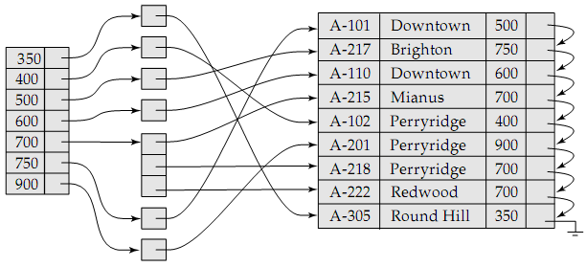
Figure: Another implementation of dense index.

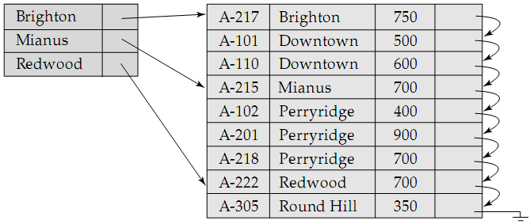Sparse Index
Figure: Sparse index.
Sparce index is the index where an index record appears for only some of the search-key values in the file.
As is true in dense indices, each index record contains a search-key value and a pointer to the first data record with that search-key value.
To locate a record, we find the index entry with the largest search-key value that is less than or equal to the search-key value for which we are looking. We start at the record pointed to by that index entry, and follow the pointers in the file until we find the desired record.

Comparative Analysis of Dense and Sparse Index
It is generally faster to locate a record if we have a dense index rather than a sparse index. However, sparse indices have advantages over dense indices in that they require less space and they impose less maintenance overhead for insertions and deletions.

A good trade-off
There is a trade-off that the system designer must make between access time and space overhead. Although the decision regarding this trade-off depends on the specific application, a good compromise is to have a sparse index with one index entry per block.

Why this trade-off is good
The dominant cost in processing a database request is the time that it takes to bring a block from disk into main memory. Once we have brought in the block, the time to scan the entire block is negligible.
Using this sparse index, we locate the block containing the record that we are seeking. Thus, unless the record is on an overflow block, we minimize block accesses while keeping the size of the index (and thus, our space overhead) as small as possible.

Multi-Level Indices

The problem with single-level indices
Even if we use a sparse index, the index itself may become too large for efficient processing. It is not unreasonable, in practice, to have a file with 100,000 records, with 10 records stored in each block. If we have one index record per block, the index has 10,000 records. Index records are smaller than data records, so let us assume that 100 index records fit on a block. Thus, our index occupies 100 blocks. So, how can we minimize disk access?
- If there are no overflow blocks in the index, we can use binary search. If there are B blocks, this will read as many as ⎡log ₂ (B)⎤ blocks (as many as 7 for our 100 blocks).
- If index has overflow blocks, then sequential search is typically used, reading all B index blocks.
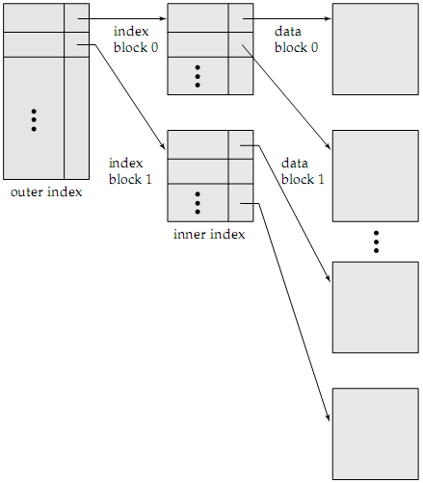Thus, the process of searching a large index may be costly.
Figure: Two level sparse index.

Solution to this problem
We treat the index just as we would treat any other sequential file, and construct a sparse index on the primary index, as in the figure beside.
To locate a record, we first use binary search on the outer index to find the record for the largest search-key value less than or equal to the one that we desire. The pointer points to a block of the inner index. We scan this block until we find the record that has the largest search-key value less than or equal to the one that we desire. The pointer in this record points to the block of the file that contains the record for which we are looking.
Using two levels of indexing, it is required to read only one block rather than seven with binary search, if we assume that the outer index is already in main memory.
For very large files, additional levels of indexing may be required.
Indices must be updated at all levels when insertions or deletion operations are performed.

Secondary Indices
A secondary index on a candidate key look just like a dense primary index, except that the records pointed to by successive values in the index are not sorted sequentially.
If the search key of a secondary index is not a candidate key, it is not enough to point to just the first record with each search-key value because the remaining records with the same search-key value could be anywhere in the file. Therefore, a secondary index must contain pointers to all the records.
We can use an extra-level of indirection to implement secondary indices on search keys that are not candidate keys. A pointer does not point directly to the file but to a bucket that contains pointers to the file.
A | Pointer
A-1
A-2
A-3
A-4
A-5
Index file on A
A | B | C
A-4 | a | 100
A-1 | b | 200
A-5 | a | 300
A-2 | d | 400
A-3 | c | 500
Relation file
B | Pointer
a
b
c
d
Index file on B
Figure: Secondary indices on candidate key A and non-candidate key B.
Secondary indices must be dense, with an index entry for every search-key value, and a pointer to every record in the file.
Secondary indices improve the performance of queries on that use keys other than the search key of the primary index. However, they impose a significant overhead on database modification.
The designer of the database decides which secondary indices are desirable on the basis of an estimate of the relative frequency of queries and modifications.

B⁺ Tree Index

The Problem with Indexed-Sequential File Organization
The main disadvantage of the index-sequential ﬁle organization is that performance degrades as the ﬁle grows, both for index lookups and for sequential scans through the data. Although this degradation can be remedied by reorganization of the ﬁle, frequent reorganizations are undesirable.

How B⁺ Tree Index Solves the Problem
B⁺ tree index structure maintains its efficiency despite frequent insertions and deletions. It automatically reorganizes itself with small local changes, in the face of insertions and deletions. It imposes performance overhead on insertion and deletion. Again, since nodes may be as much as half empty (if they have the minimum number of children), it adds space overhead. These overheads are acceptable even for frequently modified files, since the cost of reorganization is avoided.

Structure of a B⁺ Tree
A B⁺ tree index is a multilevel index but is structured differently from that of multi-level indexed-sequential files. It is a balanced tree in which every path from the root to a leaf is of the same length.
A typical node contains up to n – 1 search key values K₁, K₂, …, K_{n - 1}, and n pointers P₁, P₂, …, P_{n}. Search key values in a node are kept in sorted order, thus, if i < j, then K_{i} < K_{j}, i.e., K₁ < K₂ < … < K_{n – 1}.
P_{n - 1}
K_{n - 1}
P_{n}
P₁
K₁
P₂
…
Figure: Typical node of a B⁺ tree.
Leaf nodes
- All the pointers P_{i} (i = 1 to n – 1) in the leaf node points to either a file record with search key value K_{i}, or a bucket of pointers, each of which points to a file record with that search key value.
Bucket structure is used only if search key is not a primary key, and file is not sorted in search key order.
- Pointer P_{n} (n^{th} pointer in the leaf node) is used to chain leaf nodes together in linear order (search key order). This allows efficient sequential processing of the file.
- Each leaf has between ⎡(n – 1) / 2⎤ and n – 1 values. The ranges of values in each leaf do not overlap.
- If the B⁺-tree index is to be a dense index, every search key value must appear in some leaf node.
Non-leaf nodes
- Non-leaf nodes form a multilevel sparse index on leaf nodes. The structure of the non-leaf nodes is same as that of leaf nodes, except that all pointers are pointing to tree nodes.
- Each non-leaf node in the tree has between ⎡n / 2⎤ and n pointers, where n is ﬁxed for a particular tree. The number of pointers in a node is called the fan-out of the node.
Root node
Unlike other nonleaf nodes, the root node can hold fewer than ⎡n / 2⎤ pointers; however, it must hold at least two pointers, unless the tree consists of only one node.
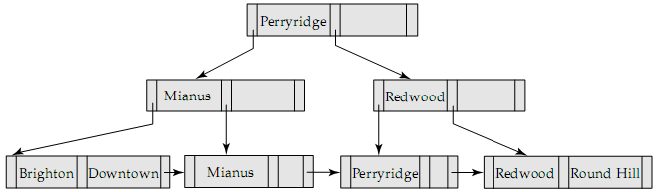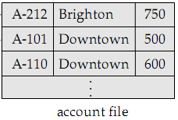
Figure: B+ tree structure with n = 3. Note that no bucket structure is used as the
search-key is a primary key and the file is sorted in the search-key order.

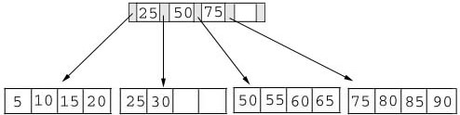
Operations on a B⁺ Tree
The figure beside shows a B⁺ tree. As the example illustrates, this tree does not have a full index page (we have room for one more key and pointer in the root page). In addition, one of the data pages contains empty slots.
The key-value determines a record’s placement in a B⁺ tree. The leaf pages are maintained in sequential order and a linked list (not shown) connects each leaf page with its sibling page(s). This linked list speeds data movement as the pages grow and contract.

Adding Records to a B⁺ Tree
We must consider three scenarios when we add a record to a B+ tree. Each scenario causes a different action in the insert algorithm. The scenarios are:
Leaf Page Full | Index Page Full | Action
NO | YES / NO | Place the record in sorted position in the appropriate leaf page.
YES | NO | - Split the leaf page.  - Place Middle Key in the index page in sorted order.  - Left leaf page contains records with keys below the middle key.  - Right leaf page contains records with keys equal to or greater than the middle key.
YES | YES | - Split the leaf page.  - Records with keys < middle key go to the left leaf page.  - Records with keys >= middle key go to the right leaf page.  - Split the index page.  - Keys < middle key go to the left index page.  - Keys > middle key go to the right index page.  - The middle key goes to the next (higher level) index.  If the next level index page is full, continue splitting the index pages.

Illustrations of the insert algorithm
Adding a record when the leaf page is not full
We’re going to insert a record with a key value of 28 into the B⁺ tree. The following figure shows the result of this addition.
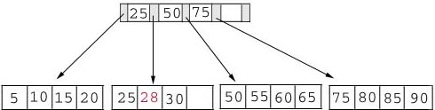
Adding a record when the leaf page is full but the index page is not
Now, we’re going to insert another record with a key value of 70 into our B+ tree. This record should go in the leaf page containing 50, 55, 60, and 65. Unfortunately, this page is full. This means that we must split the page as follows:
Left Leaf Page | Right Leaf Page
50 55 | 60 65 70
The middle key of 60 is placed in the index page between 50 and 75.
The following table shows the B⁺ tree after the addition of 70.
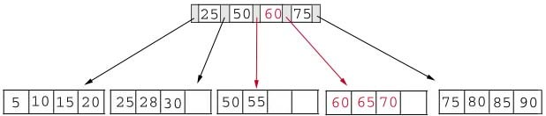
Adding a record when both the leaf page and the index page are full
As our last example, we’re going to add another record containing a key value of 95 to our B⁺ tree. This record belongs in the page containing 75, 80, 85, and 90. Since this page is full we split it into two pages:
Left Leaf Page | Right Leaf Page
75 80 | 85 90 95
The middle key, 85, rises to the index page. Unfortunately, the index page is also full, so we split the index page:
Left Index Page | Right Index Page | New Index Page
25 50 | 75 85 | 60
The following figure illustrates the addition of the record containing 95 to the B+ tree.
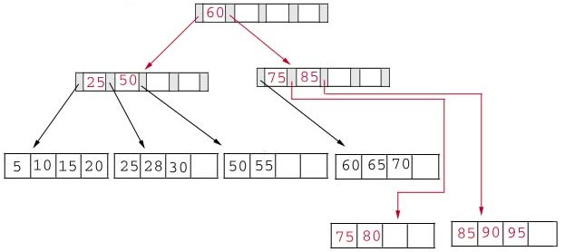

Deleting records from a B⁺ Tree
We must consider three scenarios when we delete a record from a B⁺ tree. Each scenario causes a different action in the delete algorithm. The scenarios are:
Leaf Page Below Fill Factor | Index Page Below Fill Factor | Action
NO | NO | Delete the record from the leaf page. Arrange keys in ascending order to fill void. If the key of the deleted record appears in the index page, use the next key to replace it.
YES | NO | Combine the leaf page and its sibling. Change the index page to reflect the change.
YES | YES | - Combine the leaf page and its sibling.  - Adjust the index page to reflect the change.  - Combine the index page with its sibling.  Continue combining index pages until you reach a page with the correct fill factor or you reach the root page.

Illustrations of the delete algorithm
Deleting a record that leaves the leaf page below fill factor, but not the index page
We begin by deleting the record with key 70 from the B⁺ tree. This record is in a leaf page containing 60, 65 and 70. This page will contain 2 records after the deletion. Since our fill factor is 50% or (2 records) we simply delete 70 from the leaf node. The following figure shows the B⁺ tree after the deletion:
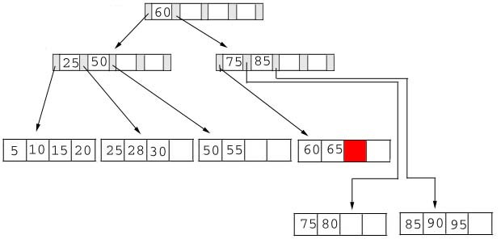

Deleting a record that leaves none of the pages below fill factor
Next, we delete the record containing 25 from the B+ tree. This record is found in the leaf node containing 25, 28, and 30. The fill factor will be 50% after the deletion; however, 25 appears in the index page. Thus, when we delete 25 we must replace it with 28 in the index page.
The following figure shows the B⁺ tree after this deletion:
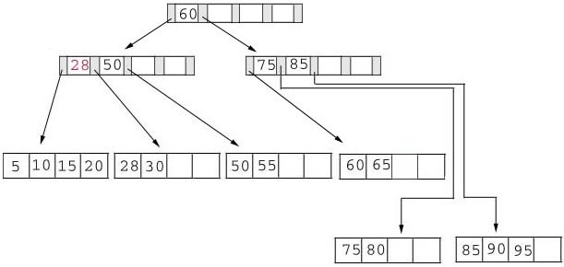
Deleting a record that leaves both of the pages below fill factor
As our last example, we’re going to delete 60 from the B+ tree. This deletion is interesting for several reasons:
- The leaf page containing 60 (60 65) will be below the fill factor after the deletion. Thus, we must combine leaf pages.
- With recombined pages, the index page will be reduced by one key. Hence, it will also fall below the fill factor. Thus, we must combine index pages.
- 60 appears as the only key in the root index page. Obviously, it will be removed with the deletion.
The following figure shows the B⁺ tree after the deletion of 60. Notice that the tree contains a single index page.
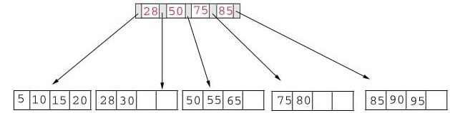

B⁺ Tree File Organization
The performance of index-sequential file organization degrades as the file grows. With growth, an increasing percentage of index records and actual records become out of order and are stored in overflow blocks. We solve the degradation of index lookup by using B⁺ tree indices on the file. We solve the degradation problem of storing the actual records by using the leaf level of B⁺ tree to organize the blocks containing the actual records.
- 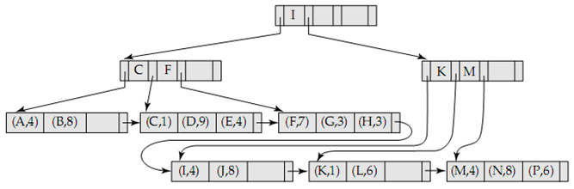In a B⁺ tree file organization, the leaf nodes of the tree store records instead of storing pointers to records.
Figure: B⁺ tree file organization.

- Since records are usually larger than pointers, the maximum number of records that can be stored in a leaf node is less than the maximum number of pointers in a non-leaf node.
- However, the leaf nodes are still required to be at least half full.
- Insertion and deletion from a B⁺ tree file organization are handled in the same way as that in a B⁺ tree index.
- When a B⁺ tree is used for file organization, space utilization is particularly important. We can improve the space utilization by involving more sibling nodes in redistribution during splits and merges. This technique is called rotation.
As an example, consider the B⁺ tree before the addition of the record containing a key of 70. As previously stated, this record belongs in the leaf node containing 50 55 60 65. Notice that this node is full, but its left sibling is not:
Using rotation we shift the record with the lowest key to its sibling. Since this key appeared in the index page we also modify the index page. The new B⁺ tree appears in the following figure:
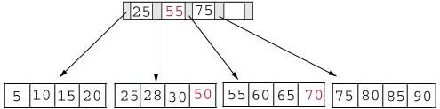

B-Tree Index
- B-tree indices are almost similar to B⁺ tree indices, but B-tree eliminates the redundant storage of search key values. In B⁺ tree, some search key values appear twice. A corresponding B-tree allows search key values to appear only once. Thus we can store the index in less space.
- Search keys in non-leaf nodes appear nowhere else in the B-tree; an additional pointer field for each search key in a non-leaf node must be included.
- For non-leaf node, pointers B_{i} are the bucket or file record pointers.
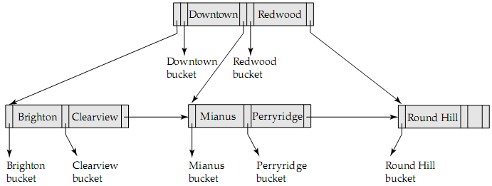
Figure: B⁺ tree (above) and the corresponding B-tree (below).

Advantages of B-Tree
- May use less tree nodes than a corresponding B⁺ tree.
- Sometimes it is possible to find the desired value before reaching a leaf node.

Disdvantages of B-Tree
- Only a small fraction of desired values are found before reaching a leaf node.
- Fewer search-keys appear in non-leaf nodes; hence, fan-out is reduced. Thus, B-trees typically have greater depth than a corresponding B⁺ tree.
- Insertion and deletion are more complicated than in B⁺ trees.
- Implementation is harder than B⁺ trees, since leaf and non-leaf nodes are of different sizes.
Typically, advantages of B-trees do not outweigh its disadvantages.

Hashing

The Problem with Sequential File Organization and How Hashing Solves It
One disadvantage of sequential ﬁle organization is that we must access an index structure to locate data, or must use binary search, and that results in more I/O operations. File organizations based on the technique of hashing allow us to avoid accessing an index structure. Hashing also provides a way of constructing indices.

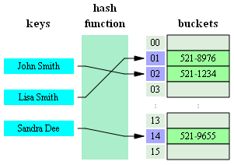Hash File Organization
Figure: A typical phone book as a hash table.

In a hash file organization, we obtain the address of the disk block containing a desired record directly by computing a hash function on the search-key value of the record.
A hash function h is a function from the set of all search-key values K to the set of all bucket addresses B: B_{i} = h(K_{i}).
The term bucket is used to denote a unit of storage that can store one or more records. A bucket is typically a disk block but may be smaller or larger than a disk block.

Manipulation of Records in Hash Files
- Insertion: To insert a record with search key K_{i}, compute h(K_{i}), which gives the address of the bucket of the record – assuming there is space for the record – and the record is inserted.
- Lookup: To perform a lookup on a search key value K_{i}, we compute h(K_{i}), and search the bucket with that address. If two search keys i and j map to the same address, because h(K_{i}) = h(K_{j}), then the bucket at the address obtained will contain records with both search key values. In this case we will have to check the search key value of every record in the bucket to get the ones we want.
- Deletion: If the search key value of the record to be deleted is K_{i}, compute h(K_{i}), then search the corresponding bucket for the record and delete the record form the bucket.

Hash Functions
- The worst possible hash function maps all search-key values to the same bucket. This is undesirable. A lookup has to examine every such record to find the desired one.
- An ideal hash function distributes the stored keys uniformly across all the buckets so that every bucket has the same number of records.

Distribution Qualities for Choosing a Hash Function
Since it cannot be known at design time precisely which search-key values will be stored in the file, such hash function should be chosen that assigns search-key values to buckets in such a way that the distribution has these qualities:
1. Uniform: The distribution is uniform. The hash function assigns each bucket the same number of search-key values from the set of all possible search-key values.
2. Random: The distribution is random. In the average case, each bucket will have nearly the same number of values assigned to it regardless of the actual distribution of the search-key values. More precisely, the hash value will not be correlated to any externally visible ordering on the search-key values, such as alphabetic ordering or ordering by the length of the search keys; the hash function will appear to be random.

Some Examples Illustrating These Qualities
Example 1:
Suppose we have 26 buckets, and map branch-names of account file beginning with i^{th} letter of the alphabet to the i^{th} bucket.
Problem:
This does not give uniform distribution. Many more names will be mapped to “B” and “R" than to “Q” and “X”.
Example 2:
Suppose we have 10 buckets, and a hash function to map search-key balance of account file. Supposing min and max values to be 1 and 100,000, we can use a hash function that divides the values into 10 ranges:
1 – 10,000, 10,001 – 20,000, …, 90,001 – 100,000.
Problem:
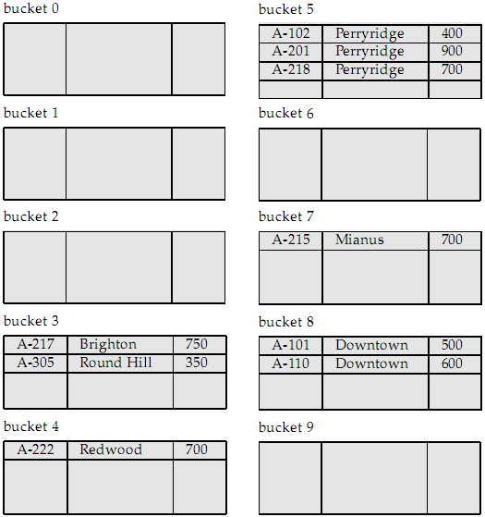The distribution is not random. It’s also not uniform as balances between 1 and 10,000 are far more common than are records with balances between 90,001 and 100,000.
Figure: Typical application of a hash function scheme.

How Hash Functions Should be Designed
Hash functions require careful design. A bad hash function may result in lookup taking time proportional to the number of search keys in the file. A well-designed function gives an average-case lookup time that is a small constant independent of the number of search-keys in the file.
Typical hash functions perform some operation on the internal binary machine representations of characters in the search-key. For example, for a string search-key, the binary representations of all the characters in the string could be added and the sum modulo number of buckets could be returned. The figure beside shows the application of such a scheme, with 10 buckets, to the account ﬁle, under the assumption that the i^{th} letter in the alphabet is represented by the integer i.

Handling of Bucket Overflows
So far, we have assumed that, when a record is inserted, the bucket to which it is mapped has space to store the record. If the bucket does not have enough space, a bucket overﬂow is said to occur.

Causes of bucket overflows
- Insufficient buckets. Our estimate of the number of records that the relation will have was too low, and hence the number of buckets allotted was not sufficient.
- Skew. Some buckets are assigned more records than are others, so a bucket may overflow even when other buckets still have space. This situation is called bucket skew.
Causes of Skew
- Multiple records may have the same search key.
- The chosen hash function may result in non-uniform distribution of search keys.

Reducing bucket overflows
To reduce the occurrence of overflows, we can:
- Choose the hash function more carefully, and make better estimates of the relation size.
- If the estimated size of the relation is n_{r} and number of records per block is f_{r}, allocate
(n_{r} / f_{r}) × (1 + d) buckets instead of (n_{r} / f_{r}) buckets. Here d is a fudge factor, typically around 0.2. Some space is wasted: about 20% of the space in the buckets will be empty. But the benefit is that some of the skew is handled and the probability of overflow is reduced.

Handling bucket overflows
Bucket overflows can be handled using two techniques:
- Closed Hashing. If records must be inserted into a bucket and the bucket is already full, they are inserted into overflow buckets which are chained together in a linked list. Overflow handling using such a linked list is called overflow chaining. The form of hash structure that we have just described is sometimes referred to as closed hashing.
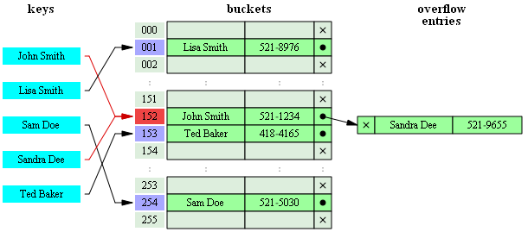
Figure: Bucket overflow handling using overflow chaining.

- Open Hashing. In this technique, the set of buckets is fixed, and there are no overflow chains. Instead, if a bucket is full, the system inserts records in some other bucket in the initial set of buckets. When a new entry has to be inserted, the buckets are examined, starting with the hashed-to slot and proceeding in some probe sequence, until an unoccupied slot is found. The probe sequence can be any of the following:
  - Liner probing. The interval between probes is fixed (usually 1).
  - Quadratic probing. The interval between probes increases by some constant (usually 1) after each probe.
  - Double hashing. The interval between probes is computed by another hash function.
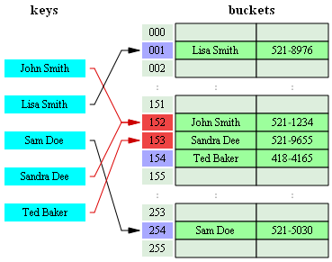
Figure: Hash collision (bucket overflow) resolved by open hashing with linear probing (interval=1).
Note that "Ted Baker" has a unique hash, but nevertheless collided with "Sandra Dee" which had previously collided with "John Smith".

Comparative analysis of closed and open hashing
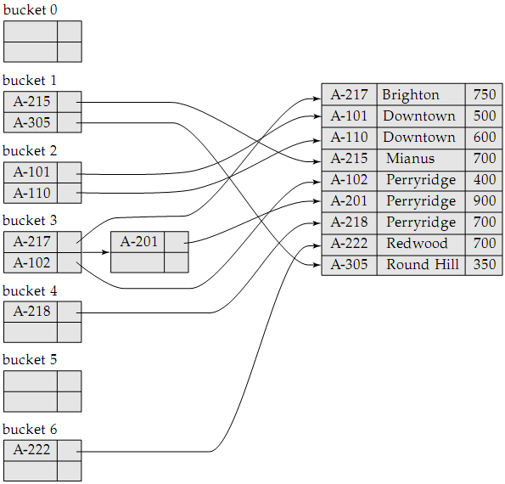Open hashing has been used to construct symbol tables for compilers and assemblers, but closed hashing is preferable for database systems. The reason is that deletion under open hashing is troublesome. Usually, compilers and assemblers perform only lookup and insertion operations in their symbol tables. However, in a database system insertion-deletion occurs frequently. Thus, open hashing is of only minor importance in database implementation.
Figure: Hash index on search key account-number of account file.
Here, B_{i} = h(sum of digits of the account number modulo 7)

Hash Indices
- Hashing can be used not only for file organization, but also for index-structure creation.
- A hash index organizes the search-keys, with their associated record pointers, into a hash file structure.
- We apply a hash function on a search key to identify a bucket, and store the key and its associated pointers in the bucket (or in overflow buckets).
- Hash indices are always secondary indices — if the file itself is organized using hashing, a separate primary hash index on it using the same search-key is unnecessary. However, we use the term hash index to refer to both secondary index structures and hash organized files.

Static and Dynamic Hashing
In static hashing, we need to fix the set B of bucket addresses. Since most databases grow over time, if we are to use static hashing for such a database, we have three classes of options:
- Choose a hash function based on the current size of the database. This option will result in performance degradation as the database grows.
- Choose a hash function based on the anticipated size of the file at some point of time in future. Although performance degradation is avoided, a significant amount of space may be wasted.
- Periodically reorganize the hash structure in response to the file growth. Such reorganization involves choosing a new hash function, re-computing the hash function on every record in the file and generating new bucket assignments. This reorganization is massive and time-consuming operation. Furthermore, it is necessary to forbid access to the file during reorganization.
Dynamic hashing techniques allow the hash function to be modified dynamically to accommodate the growth or shrinkage of the database while not degrading performance and without any space overhead. There are several dynamic hashing techniques, for example:
- Extendable Hashing
- Linear Hashing

Drawbacks of Hashing
- Hash function must be chosen when the system is implemented and it cannot be changed easily thereafter if the file being indexed grows or shrinks.
- Since the hash function maps search-key values to a fixed set of bucket addresses, space is wasted if the set of buckets is made large to handle further growth of the file.
- If the set of buckets is too small, they will contain records of many different search-key values and bucket overflow can occur. As the file grows, performance suffers.

Comparison of Ordered Indexing and Hashing
To make a wise choice of file organization and indexing techniques for a relation, a database designer must consider the following issues:
- Is the cost of periodic re-organization of index or hash structure acceptable?
- What is the relative frequency of insertion and deletion?
- Is it desirable to optimize average access time at the expense of increasing worst-case access time?
- What types of queries are users likely to pose?
This issue is critical to the choice between indexing and hashing.

Queries that specify a single value
Form: select A₁, A₂, ..., A_{n} from r where A_{i} = c
Average Case: Favors hashing.
Analysis:
- Index lookup takes time proportional to log of number of values in r for A_{i}.
- Hash structure provides average lookup time that is a small constant (independent of database size).
Worst Case: Favors Indexing.
Analysis:
- In hash structure, worst-case time is proportional to the number of values in r for A_{i}.
- In index structure, the worst-case time is still log of number of values in r.
Conclusion: The worst-case lookup time is unlikely to occur with hashing; hence, for these sorts of queries (having a specified value for the key), a hashing scheme is preferable.

Queries that specify a range of values
Form: select A₁, A₂, ..., A_{n} from r where A_{i} ≤ c and A_{i} ≥ c
Preferred Scheme: Indexing.
Analysis:
- Using an index structure, we can find the bucket for value c₁, and then follow the pointer chain to read the next buckets in alphabetic (or numeric) order until we find c₂.
- If we have a hash structure instead of an index, we can find a bucket for c₁ easily, but it is not easy to find the next bucket in sorted order. Because:
  - A good hash function assigns values randomly to buckets.
  - Each bucket may be assigned many search key values, so we cannot chain them together.
Conclusion: Index methods are preferable where a range of values is specified in the query.

Multiple-Key Indices

Problem with Multiple Single-Key Indices
If there are two indices on account file, one on branch-name and one on balance, then suppose we have a query like:
select loan-no from account where branch-name = ′Perryridge′ and balance = 1000
There are 3 possible strategies to process this query:
- Use the index on branch-name to find all records pertaining to Perryridge branch. Examine them to see if balance = 1000.
- Use the index on balance to find all records pertaining to accounts with balances of 1000. Examine them to see if branch-name = ‘Perryridge’.
- Use the index on branch-name to find pointers to records pertaining to ‘Perryridge’ branch. Also, use the index on balance to find pointers to records pertaining to 1000. Take the intersection of these two sets of pointers.
The third strategy takes advantage of the existence of multiple indices. This may still not work well if all the following conditions hold:
- There are a large number of Perryridge records AND
- There are a large number of 1000 records AND
- Only a small number of records pertain to both Perryridge and 1000.
To speed up the intersection operation, special structures such as bitmap indices can be used.

Advantages of Using Multiple-Key Indices
Suppose we have an index on combined search-key (branch-name, balance).
With the where clause where branch-name = ’Perryridge’ and balance = 1000, the index on the combined search-key will fetch only records that satisfy both conditions. Using separate indices in less efficient – we may fetch many records (or pointers) that satisfy only one of the conditions.
It can also efficiently handle where branch-name = ’Perryridge’ and balance < 1000.
However, it cannot efficiently handle where branch-name < ’Perryridge’ and balance = 1000. For each value of branch-name that is less than “Perryridge” in alphabetic order, the system locates records with a balance value of 1000. However, each record is likely to be in a different disk block, because of the ordering of records in the ﬁle, leading to many I/O operations.
To speed up the processing of general multiple search-key queries (involving one or more comparison operations), we can use special structures like grid file, R-tree etc.

Index Definitions in SQL

Creating an Index
create [unique] index index-name on relation-name (attribute-list)
The attribute-list is the list of attributes in relation r that form the search key for the index.
If the search key is a candidate key, we add the word unique to the definition. In that case,
- If the search-key is not a candidate key, an error message will appear.
- If the index creation succeeds, any attempt to insert a tuple violating this requirement will fail.
- The unique keyword is redundant if primary keys have been defined with integrity constraints already.
For example, to define an index on branch-name for the branch relation:
create index b-index on branch(branch-name)

Removing an Index
drop index index-name

Tuple: (computing and mathematics) a finite sequence of objects; a structure containing multiple parts.
There are some rules for designing efficient databases, one of which is “each field must contain atomic data” – i.e., data which represents only one thing, not several things.
Fill factor: The minimum number of keys that can exist in a node / page. Its value is ⎡n / 2⎤.
Fudge factor: A quantity that is added or subtracted in order to increase the accuracy of a scientific measure.

