Automata Theory
Study Guide
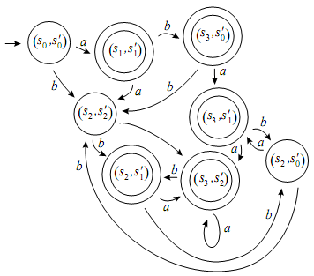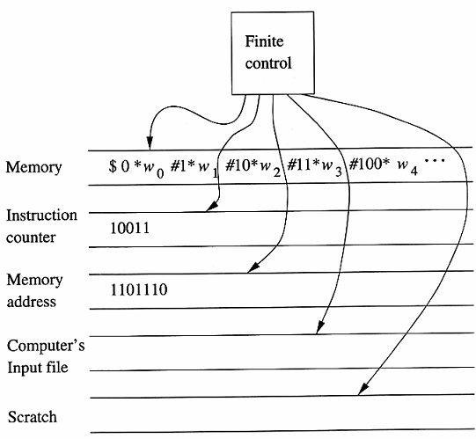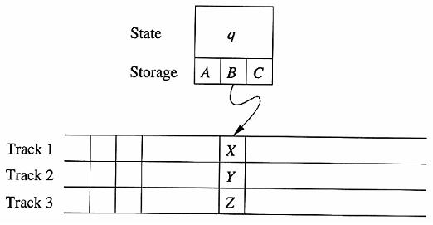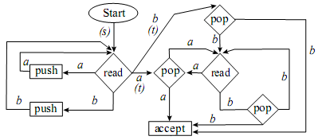

Prepared By
Sharafat Ibn Mollah Mosharraf
12th Batch (05-06)
Dept. of Computer Science & Engineering
University of Dhaka

Table of Contents

Chapter 1: The Methods and the Techniques 1
Chapter 2 & 3: Finite Automata, Regular Expressions and Languages 5
Chapter 4: Properties of Regular Languages 19
Chapter 5 & 6: Context-Free Grammar & Push-Down Automata 25
Chapter 8: Introduction to Turing Machines 30

Appendix A: Building Regular Expressions (Solution to Exercises of Ullman and Martin) 33
Appendix B: Solution to Selected Questions from the In-Course Exams of Previous Years 34

Chapter 1

The Methods and the Techniques

Concepts
1.1 | Easier representation of union and intersection of sets  A₁ $∪$ A₂ $∪$ A₃ = { x | x ∈ A₁ or x ∈ A₂ or x ∈ A₃ }  = { x | x is an element of at least one of the sets A₁, A₂ and A₃ }  More generally, if A₁, A₂, … are sets, we can write  $$\bigcup_{i=1}^{n}{A_{i}}=\left\{ x \right| x A_{i} for at least one i with 1≤i≤n \}$$  $$and \bigcup_{i=1}^{∞}{A_{i}}=\left\{ x \right| x A_{i} for at least one i ≥1 \}$$  $$and \bigcap_{i=1}^{n}{A_{i}}=\left\{ x \right| x A_{i} for every i with 1≤i≤n \}$$
1.2 | Power set of a set  For any set A, the set of all subsets of A is referred to as the power set of A, written as 2^{A}.  The reason for this terminology and this notation is that if A has n elements, then 2^{A} has 2^{n} elements.  For example, suppose A = {1, 2, 3}. Then,  2^{A} = { $∅$, {1}, {2}, {3}, {1, 2}, {1, 3}, {2, 3}, {1, 2, 3} }  Notice that $∅$ and A are both elements of 2^{A}. Therefore, the empty set ($∅$) is a subset of every set, and every set is a subset of itself.
1.3 | Shortening the description of a set  To say that x is an element of the set A, we write x A.  Using this notation, we might describe a set A as following:  B = { x | x ∈ A and x $≤$ 10 }  which we read “B is the set of all x such that x belongs to A and x $≤$ 10”.  A common way to shorten this slightly is to write  B = { x ∈ A | x $≤$ 10 }  which we read “B is the set of x in A such that x $≤$ 10.”
1.4 | Logical Quantifiers and Quantified Statements  A statement “there exists an x such that x² < 4” is called a quantified statement.  The phrase “there exists” is called the existential quantifier; the variable x is said to be bound to the quantifier and is referred to as a bound variable.  Existential Quantifier  $∃$x (x² < 4) - “There exists an x such that x² < 4”  $∃$x ∈ A(x² < 4) - “There exists an x in A such that x² < 4”  Universal Quantifier  $∀$x (x² < 4) - “For every x, x² < 4”  $∀$x ∈ A(x² < 4) - “For every x in A, x² < 4”
1.5 | Alphabet  An alphabet is a finite set of symbols. We denote it by Σ. For example:  Σ₁ = { a, b, c, d, …, z } : the set of (lowercase) letters in English  Σ₂ = { 0, 1, …, 9 } : the set of (base 10) digits  - The letters in an alphabet are usually denoted using the letters from the beginning portion in English alphabet, for example, a, b, c, d etc.
1.6 | String  A string over alphabet Σ is a finite sequence of symbols in Σ.  - Strings are usually denoted using the letters from the ending portion in English alphabet, for example, s, t, u, v, w, x, y, z etc.  - The length of a string x over Σ is the number of symbols in the string, and we denote this number by |x|.  For example, some of the strings over the alphabet {a, b} are a, baa, aab and aabba; and we have |a| = 1, |baa| = |aab| = 3 and |aabba| = 5.  - The null string or empty string (the string of length 0) is a string over Σ, no matter what alphabet Σ is. We denote it by $ϵ$ (epsilon), or λ (lowercase Greek Lambda), or Λ (uppercase Greek Lambda).  - For any alphabet Σ, the set of all strings over Σ is denoted by Σ*.  For example, for Σ = {a, b}, we have  Σ* = {a, b}* = {$ϵ$, a, b, aa, ab, bb, ba, aaa, aab, aba, …}
1.7 | Language  A language is a set of strings over an alphabet Σ. Languages are usually denoted by L.  A few examples of languages over Σ are:  L₁ = {$ϵ$, a, b, aa, ab, bb, ba}  L₂ = { ab, bab }* $∪$ { b }{ bb }*  L₃ = { x ∈ {a, b}* | |x| $≤$ 10}  L₄ = { x ∈ {a, b}* | |x| is odd}  - Σ* is a language for any alphabet Σ.  - $∅$, the empty or null language, is a language over any alphabet. A null language means that there is no string in that language.  - {$ϵ$}, the language consisting of only the empty string, is also a language over any alphabet. Note that $∅$ ≠ {$ϵ$}; the former has no strings and the latter has one string.  - As the set of all strings over Σ is Σ*, therefore, a language over Σ is a subset of Σ*. That is,  L ⊆ Σ*  - The number of languages that can be constructed from the alphabet Σ is 2^{Σ*}.  - The only important constraint on what can be a language is that all alphabets are finite.  Construction of new languages from an existing language  Because languages are sets of strings, new languages can be constructed using set operations.  The operations we can use to construct new languages from existing languages are as follows:  - Union  - Intersection  - Difference (which includes the complement operation)  - Concatenation (which includes the Kleen star operation)  For any two languages L₁, L₂ over an alphabet Σ, their union (L₁ $∪$ L₂), intersection (L₁ $∩$ L₂) and difference (L₁ – L₂) are also languages over Σ.  When we speak of the complement of a language L over Σ, we take the universal set to be the language Σ* so that L′ = Σ* – L.  The concatenation operation  If x and y are elements of Σ*, the concatenation of x and y is the string xy formed by writing the symbols of x and the symbols of y consecutively.  For example, if x = abb and y = ba, then xy = abbba and yx = baabb.  - For any string x, x$ϵ$ = $ϵ$x = x.  - A string x is a substring of another string y if there are strings w and z (either or both of which may be null), so that y = wxz.  - A prefix of a string is an initial substring. For example, the prefixes of aba are $ϵ$ (which is a prefix of every string), a, ab and aba.  - A suffix is a final substring.  Concatenation of languages  If L₁, L₂ ⊆ Σ*, then L₁L₂ = { xy | x ∈ L₁ and y ∈ L₂ }  For example,  L₁ = {hope, fear}  L₂ = {ful, less}  $∴$ L₁L₂ = {hopeful, hopeless, fearful, fearless}  - Just as concatenating a string x with $ϵ$ produces x, concatenating any language L with {$ϵ$} produces L. In other words, L{$ϵ$} = {$ϵ$}L = L.  Exponential notation in concatenation  We use exponential notation to indicate the number of items being concatenated. These can be individual symbols, strings, or languages. Thus, if Σ is an alphabet, a ∈ Σ, x ∈ Σ* and L ⊆ Σ*, then  a^{k} = aa…a  x^{k} = xx…x  Σ^{k} = ΣΣ…Σ = {x ∈ Σ* | |x| = k}  L^{k} = LL…L = $\bigcup_{i=0}^{k}{L^{i}}$ [L^{i} is the language L concatenated with itself i times]  where in each case there are k factors altogether.  An important special case is the one in which k = 0:  a⁰ = $ϵ$  x⁰ = $ϵ$  Σ⁰ = {$ϵ$}  L⁰ = {$ϵ$}  Therefore, the unit of concatenation for strings is $ϵ$, and for languages is {$ϵ$}.  - The set of all strings that can be obtained by concatenating any number of elements of L:  $$L^{*} = \bigcup_{i=0}^{∞}{L^{i}}$$  - The set of all strings that can be obtained by concatenating one or more elements of L:  $$L^{+} = \bigcup_{i=1}^{∞}{L^{i}}$$  - L⁺ = L*L = LL*; L* = $ϵ$ $∪$ L⁺ and L⁺ ⊆ L*.  - The operation * is also called the star, closure, Kleene star or Kleene closure operator.

Chapter 2 & 3

Finite Automata, Regular Expressions and Languages

Concepts
3.1 | Regular Language and Regular Expression  Simple Language  A language that contains a single string of length one or does not contain any string at all is called a simple language.  For example, let, Σ = {1, 2, 3}.  $∴$ Simple languages over Σ are $∅$, {$ϵ$}, {1}, {2} and {3}.  - $∅$, {$ϵ$} are common to all simple languages.  Regular Language  Languages which are constructed from simple languages by applying the operations union, concatenation and Kleene star are called regular languages.  Regular Expression  A regular expression is an algebraic formula whose value is a pattern consisting of a set of strings, called the language of the expression.  For example, let L = {w | w ends with 11} be a language over the alphabet {0, 1}.  Then the regular expression for L is: (0 + 1)*11  Recursive Definition of Regular Languages and Regular Expressions over Σ  The set R of regular languages over Σ and the corresponding regular expressions are defined as follows:  - $∅$ is an element of R, and the corresponding regular expression is $∅$.  - {$ϵ$} is an element of R, and the corresponding regular expression is $ϵ$.  - For each a ∈ Σ, {a} is an element of R, and the corresponding regular expression is a.  - If L₁ and L₂ are any elements of R, and r₁ and r₂ are the corresponding regular expressions, then  - L₁ $∪$ L₂ is an element of R, and the corresponding regular expression is (r₁ + r₂);  - L₁L₂ is an element of R, and the corresponding regular expression is (r₁r₂);  - L₁* is an element of R, and the corresponding regular expression is (r₁*).  - Only those languages that can be obtained by using statements 1 to 4 are regular languages over Σ.
3.2 | Finite Automata (FA) / Deterministic Finite Automata (DFA) / Finite State Machine (FSM)  An FA is a 5-tuple (Q, Σ, q₀, F, δ), where  Q is a non-empty finite set (whose elements are thought of as states);  Σ is a non-empty finite alphabet of input symbols;  q₀ ∈ Q (the initial state);  F ⊆ Q (the set of final / accepting states);  δ is a function from Q × Σ to Q (i.e., δ : Q × Σ → Q, the transition function)  For any element q ∈ Q and any symbol a ∈ Σ, we interpret δ(q, a) as the state to which the FA moves if it is in state q and receives the input a.  A DFA is usually denoted by M.  Example of DFA  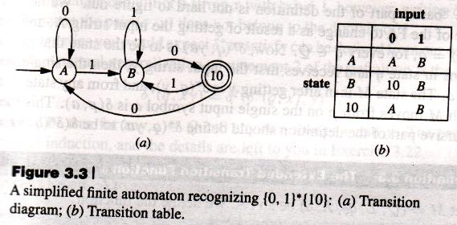  The Extended Transition Function $\hat{δ}$ for a DFA  Let M = (Q, Σ, q₀, F, δ) be an FA. We define the function  $\hat{δ}$ : Q × Σ∗ → Q  as follows:  - For any q ∈ Q, $\hat{δ}$ (q, $ϵ$) = q  - For any q ∈ Q, y ∈ Σ*, and a ∈ Σ, $\hat{δ}$ (q, ya) = δ($\hat{δ}$ (q, y), a)  Example:  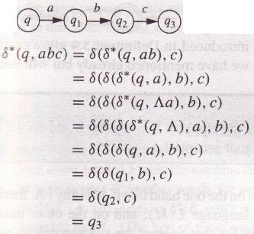  Acceptance of a string or language by a DFA  Let M = (Q, Σ, q₀, F, δ) be a DFA.  A string x ∈ Σ* is accepted by M if $\hat{δ}$ (q₀, x) ∈ F.  The language accepted / recognized by M, is the set  L(M) = { x ∈ Σ* | $\hat{δ}$ (q₀, x) ∈ F }  - If L = L(M) for some DFA, then L is a regular language.
3.3 | Nondeterministic Finite Automata (NFA)  An NFA is a 5-tuple (Q, Σ, q₀, F, δ), where  Q is a non-empty finite set (whose elements are thought of as states);  Σ is a non-empty finite alphabet of input symbols;  q₀ ∈ Q (the initial state);  F ⊆ Q (the set of final / accepting states);  δ is a function from Q × Σ to 2^{Q} (i.e., δ : Q × Σ → 2^{Q}, the transition function)  For any element q ∈ Q and any symbol a ∈ Σ, we interpret δ(q, a) as the set of states to which the NFA moves if it is in state q and receives the input a.  An NFA is usually denoted by N.  Example of NFA  Consider the language L = {w | w ends with 01}.  The NFA would be defined as N = ({q₀, q₁, q₂}, {0, 1}, q₀, {q₂}, δ), where δ is defined using the following rules:  δ(q₀, 0) = {q₀, q₁},  δ(q₀, 1) = {q₀},  δ(q₁, 1) = {q₂}  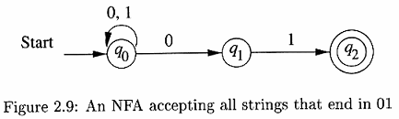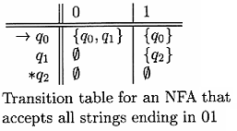  The Extended Transition Function $\hat{δ}$ for an NFA  Let N = (Q, Σ, q₀, F, δ) be an NFA. We define the function  $\hat{δ}$ : Q × Σ∗ → 2^{Q}  as follows:  1. For any q ∈ Q, $\hat{δ}$ (q, $ϵ$) = {q}  $$2. For any q ∈ Q, y ∈ {}^{*}, and a ∈ Σ, \hat{δ} (q, ya) = \bigcup_{r ∈ \hat{δ}\left(q, y\right)}{δ\left(r, a\right)}$$  Acceptance of a string or language by an NFA  Let N = (Q, Σ, q₀, F, δ) be an NFA.  A string x ∈ Σ* is accepted by N if $\hat{δ}$ (q₀, x) $∩$ F ≠ $∅$ (i.e., $\hat{δ}$(q₀, x) contains at least one accepting state).  The language accepted / recognized by N, is the set  L(N) = { x ∈ Σ* | $\hat{δ}$ (q₀, x) $∩$ F ≠ $∅$ }
3.4 | $ϵ$-NFA ($ϵ$-Transition of an NFA)  An NFA with $ϵ$-transitions (abbreviated $ϵ$-NFA) is a 5-tuple (Q, Σ, q₀, F, δ), where  Q is a non-empty finite set (whose elements are thought of as states);  Σ is a non-empty finite alphabet of input symbols;  q₀ ∈ Q (the initial state);  F ⊆ Q (the set of final / accepting states);  δ is a function from Q × (Σ $∪$ {$ϵ$}) to 2^{Q} (i.e., δ : Q × (Σ $∪$ {$ϵ$}) → 2^{Q}, the transition function)  Example of $ϵ$-NFA  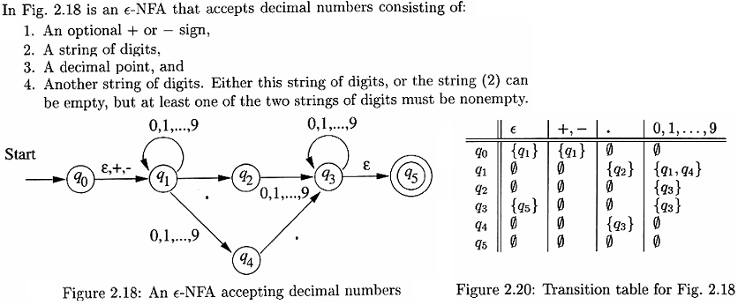  $ϵ$-Closure of a Set of States  [Informal definition: If $S$ is the set of states from where we can go to other states using $ϵ$-transitions, then the $ϵ$-closure of $S$ is the set of all states that can be reached from elements of $S$ by using zero, one or more $ϵ$-transitions.]  Let N = (Q, Σ, q₀, F, δ) be an $ϵ$-NFA, and let S be any subset of Q. The $ϵ$-closure of S is the set $ϵ$(S) defined as follows:  - Every element of S is an element of $ϵ$(S);  - For any q ∈ $ϵ$(S), every element of δ(q, $ϵ$) is in $ϵ$(S);  - No other elements of Q are in $ϵ$(S).  The Extended Transition Function $\hat{δ}$ for an $ϵ$-NFA  Let N = (Q, Σ, q₀, F, δ) be an $ϵ$-NFA. We define the function  $\hat{δ}$ : Q × Σ∗ → 2^{Q}  as follows:  1. For any q ∈ Q, $\hat{δ}$ (q, $ϵ$) = $ϵ$({q})  $$2. For any q ∈ Q, y ∈ {}^{*}, and a ∈ Σ, \hat{δ} (q, ya) = ϵ\left(\bigcup_{r ∈ \hat{δ}\left(q, y\right)}{δ\left(r, a\right)}\right)$$  Acceptance of a string or language by an $ϵ$-NFA  Let N = (Q, Σ, q₀, F, δ) be an $ϵ$-NFA.  A string x ∈ Σ* is accepted by N if $\hat{δ}$ (q₀, x) $∩$ F ≠ $∅$ (i.e., $\hat{δ}$(q₀, x) contains at least one accepting state).  The language accepted / recognized by N, is the set  L(N) = { x ∈ Σ* | $\hat{δ}$ (q₀, x) $∩$ F ≠ $∅$ }
3.5 | Kleene’s Theorem  Part 1: Any regular language can be accepted by a finite automaton.  Part 2: The language accepted by any finite automaton is regular.  Theorem 4.3 (of Martin) [It’s just Kleene’s theorem expressed in another way]  For any alphabet Σ, and any language L ⊂ Σ*, these three statements are equivalent if L is regular:  - L is recognized by an FA / DFA.  - L is recognized by an NFA.  - L is recognized by an $ϵ$-NFA.
3.6 | Algebraic Laws for Regular Expressions  x + y = y + x Commutative Law  (x + y) + z = x + (y + z) Associative Law for Union  (xy)z = x(yz) Associative Law for Concatenation  $∅$ + x = x + $∅$ = x Identity Law for Union  $ϵ$x = x$ϵ$ = x Identity Law for Concatenation  $∅$x = x$∅$ = $∅$ Annihilator Law for Concatenation  x(y + z) = xy + xz Left Distributive Law of Concatenation Over Union  (x + y) z = xz + yz Right Distributive Law of Concatenation Over Union  x + x = x Idempotence Law for Union  (x*)* = x*x* = x* Laws Involving Closures  (x + y)* = (x*y*)* = (x* + y*)*  (xy)*x = x(yx)*  $∅$* = $ϵ$[]  $ϵ$* = $ϵ$  x⁺ = xx* = x*x []  x* = x⁺ + $ϵ$ = xx* + $ϵ$ = x*x + $ϵ$ []  x? = $ϵ$ + x = x + $ϵ$ This is actually the definition for the ‘?’ operator.  x + yz ≠ (x + y)z Common mistakes made  xx ≠ x
3.7 | Building Regular Expressions  Let, Σ = {a, b, c}  Zero or more – a*  a* means “zero or more a’s.” To say “zero or more ab’s,” that is, {$ϵ$, ab, abab, ababab, …}, you need to say (ab)*. Don't say ab*, because that denotes the language {a, ab, abb, abbb, ...}.  One or more – a⁺ = aa* = a*a  Zero or one – a? = a + $ϵ$ = $ϵ$ + a  Any string at all – (a + b + c)*  Any non-empty string – (a + b + c)(a + b + c)*  This can be written as any character from Σ followed by any string at all: (a + b + c)(a + b + c)*.  Strings not containing ‘a’ – (b + c)*  Strings containing exactly one ‘a’ – (b + c)*a(b + c)*  To describe any string that contains exactly one a, put “any string not containing an a,” on either side of the a.  Strings containing no more than three a’s - (b + c)*a?(b + c)*a?(b + c)*a?(b + c)*  We can describe the string containing zero, one, two, or three a’s (and nothing else) as  a?a?a?  Now we want to allow arbitrary strings not containing a’s at the places marked by X’s:  Xa?Xa?Xa?X  So we put in (b + c)* for each X:  (b + c)*a?(b + c)*a?(b + c)*a?(b + c)*  This is equivalent to: (b + c)*(a + $ϵ$)(b + c)*(a + $ϵ$)(b + c)*(a + $ϵ$)(b + c)*.  Strings containing at least one occurrence of each symbol in Σ  The problem here is that we cannot assume the symbols are in any particular order. We have no way of expressing “in any order”, so we have to list the possible orders:  abc + acb + bac + bca + cab + cba  To make it easier to see what’s happening, let’s put an X in every place we want to allow an arbitrary string:  XaXbXcX + XaXcXbX + XbXaXcX + XbXcXaX + XcXaXbX + XcXbXaX  Finally, replacing the X’s with (a + b + c)* gives the final answer:  (a + b + c)*a(a + b + c)*b(a + b + c)*c + (a + b + c)*a(a + b + c)*c(a + b + c)*b +  (a + b + c)*b(a + b + c)*a(a + b + c)*c + (a + b + c)*b(a + b + c)*c(a + b + c)*a +  (a + b + c)*c(a + b + c)*a(a + b + c)*b + (a + b + c)*c(a + b + c)*b(a + b + c)*a𞎺  Strings containing no runs of a’s of length greater than two  We can fairly easily build an expression containing no a, one a, or one aa:  (b + c)*($ϵ$ + a + aa)(b + c)*  But if we want to repeat this, we need to be sure to have at least one non-a between repetitions:  (b + c)*($ϵ$ + a + aa)(b + c)*((b + c)(b + c)*($ϵ$ + a + aa)(b + c)*)*  Strings in which all runs of a’s have lengths that are multiples of three – (aaa + b + c)*
3.8 | Precedence of Regular Expression Operators  * ⁺ ? (Unary operators) Highest  . (Concatenation operator)  + (Union operator) Lowest
3.9 | Conversion Among RE, DFA, NFA and $ϵ$-NFA  $ϵ$-NFA  RE  NFA  DFA
3.10 | Converting DFA / NFA / $ϵ$-NFA into RE by Eliminating States  The process for constructing the regular expression is to first have only one initial and one terminal state. We then eliminate one state at a time from the state diagram and resulting transition graphs and in each case get a transition graph with e-arrows between states, where e is a regular expression. Eventually we get a transition graph of the form:  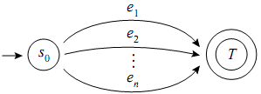  which accepts the expression e₁ + e₂ + … + e_{n}.  If there are more than one terminal states, say there are terminal states t₁, t₂, t₃, …, t_{n}, then replace the states  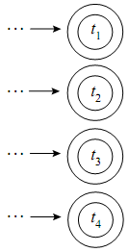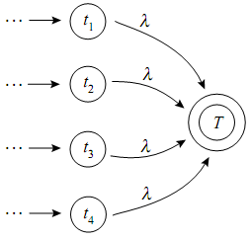  with  To eliminate the state s_{i}, we use the following rules:  Original Diagram Equivalent RE  s_{i} e₁, e₂, …, e_{n} s_{i} (e₁+e₂+…+e_{n})*  s_{i} e₂ s_{i+1} s_{i-1} e₁ e₃ s_{i+1} s_{i-1} e₁e₂*e₃  s_{i+1} s_{i-1} e₂ e₁ … e_{n} s_{i+1} s_{i-1} e₁+e₂+…+e_{n}  s_{i+1} s_{i-1} s_{i} e₁ e₂ e₃ s_{i+1} s_{i-1} e₁(e₂e₁)*e₃  Example 1  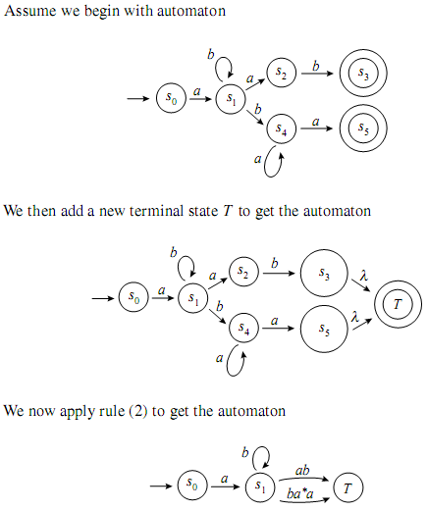  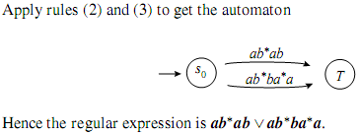  Example 2  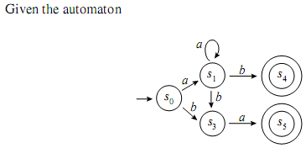  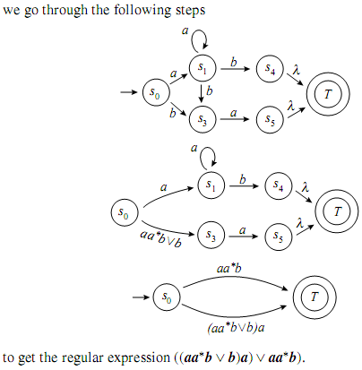  Example 3  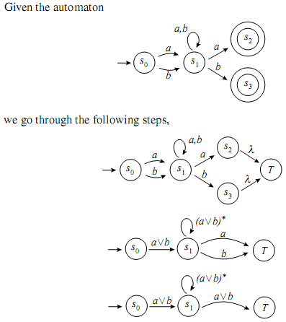  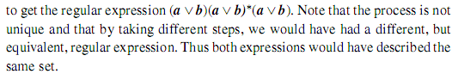
3.11 | Converting RE into $ϵ$-NFA  Original RE Equivalent Diagram  $$∅$$  $$ϵ$$  a  RS  R + S  R*  Example  Let’s convert the RE (0 + 1)*1(0 + 1) to an $ϵ$-NFA.  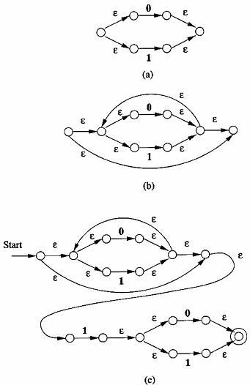
3.12 | Converting $ϵ$-NFA into NFA by Eliminating $ϵ$-Transitions  Suppose we want to replace an $ϵ$-move from vertex v₁ to vertex v₂. Then we proceed as follows:  - Find all the edges starting from v₂.  - Duplicate all these edges starting from v₁, without changing the edge labels.  - If v₁ is an initial state, make v₂ also an initial state.  - If v₂ is a final state, make v₁ as the final state.  Example:  Consider the $ϵ$-NFA below:  q₁  q₂  q₀  $$ϵ$$  $$ϵ$$  1  2  0  We go through the following steps to remove the $ϵ$-moves:  q₁  q₂  q₀  1  $$ϵ$$  1  2  0  $$ϵ$$  q₁  q₂  q₀  1  $$ϵ$$  1  2  0  2  q₁  q₂  q₀  1  2  1  2  0  2  (a)  (b)  (c)
3.13 | Converting $ϵ$-NFA into DFA  Let, E = (Q, Σ, q₀, F, δ) be an $ϵ$-NFA.  The corresponding DFA is M = (Q', Σ, q₀', F', δ') such that  - Q' is defined as: $ϵ$(q) ∈ Q' where q ∈ Q.  - q₀' is $ϵ$(q₀).  - F' = {$ϵ$(q_{a}) ∈ F' | $ϵ$(q_{a}) $∩$ F ≠ $∅$}.  - δ' is defined as:  For each element of $ϵ$(q), find δ(q, a$ϵ$). The destination DFA state is the state which contains only the resultant $ϵ$-NFA states.  Example  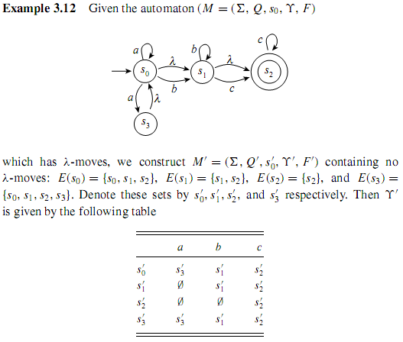  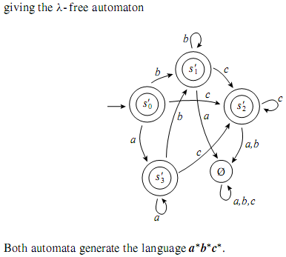
3.14 | Converting NFA into DFA by Subset Construction  Let, N = (Q, Σ, s₀, F, δ) be an NFA.  The corresponding DFA M = (Q', Σ, {s₀}, F', δ') can be constructed using the following algorithm:  - Begin with the state {s₀} where s₀ is the start state of the nondeterministic automaton.  - For each a_{i} ∈ Σ, construct an a_{i}-arrow from {s₀} to the set consisting of all states such that there is an a_{i}-arrow from s₀ to that state.  - For each newly constructed set of states s_{j} and for each a_{i} ∈ Σ, construct an a_{i}-arrow from s_{j} to the set consisting of all states such that there is an a_{i}-arrow from an element of s_{j} to that state.  - Continue this process until no new states are created.  - Make each set of states s_{j} that contains an element of the acceptance set of the nondeterministic automaton, into an acceptance state.  Example 1  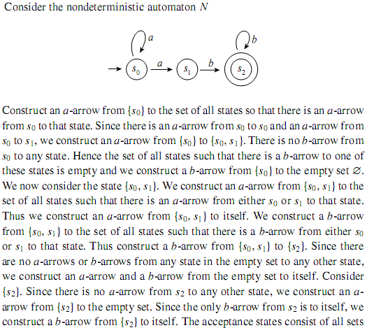  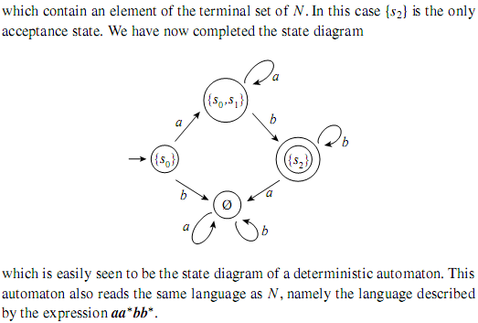  Example 2  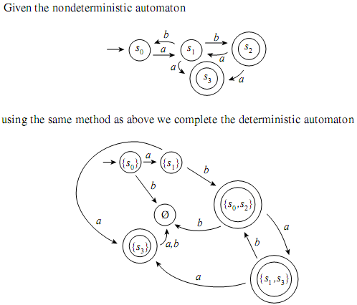
3.15 | Applications of Regular Expressions  - Finding Patterns in Text. The regular expression notation is valuable for describing searches for interesting patterns. For example, the regular expression for a valid e-mail address is as follows:  ^[_a-z0-9-]+(.[_a-z0-9-]+)*@[a-z0-9-]+(.[a-z0-9-]+)*(.[a-z]{2,8})  - Lexical Analysis. One of the oldest applications of regular expressions was in specifying the component of a compiler called a lexical analyzer. This component scans the source program and recognizes all tokens, those substrings of consecutive characters that belong together logically. Keywords and identifiers are common examples of tokens, but there are many others.

Chapter 4

Properties of Regular Languages

Concepts
4.1 | Concatenation of Two DFAs  Let, M₁, M₂ be two DFAs. To make M₁M₂, the following rules are followed:  - Place M₂ after M₁.  - For each of the states in M₁ which has an arrow – e.g., labeled a – towards the accepting states, place another arrow from that state towards the initial state of M₂ with the same label (in this case, a).  - Make all the accepting states in M₁ non-accepting.  Example 1  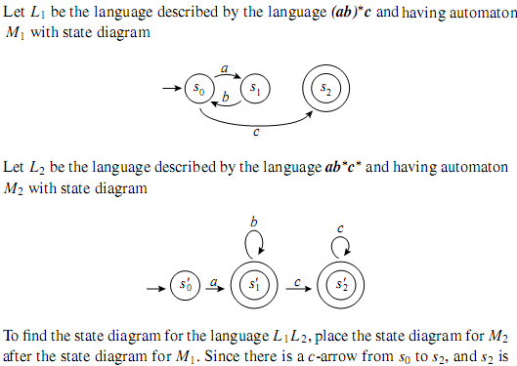  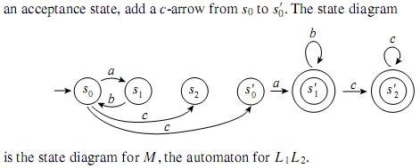  Example 2  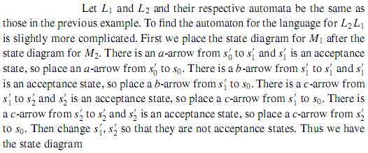  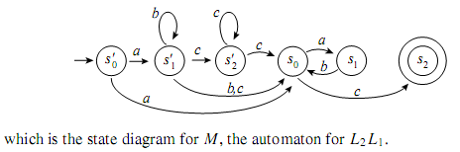
4.2 | Union of Two DFAs  Let, M₁, M₂ be two DFAs. To make M₁ $∪$ M₂, the following rules are followed:  - Create a new initial state.  - Detect which arrows are out from each of the initial states of M₁ and M₂. Add similar arrows from the new initial state towards those states where those arrows were gone.  Example 1  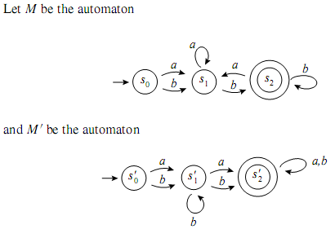  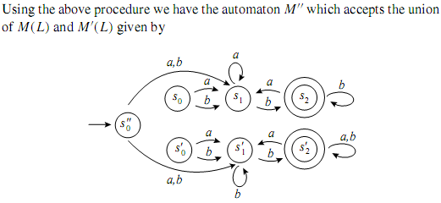  Example 2  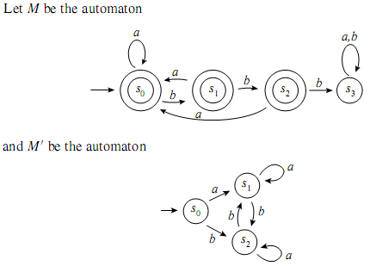  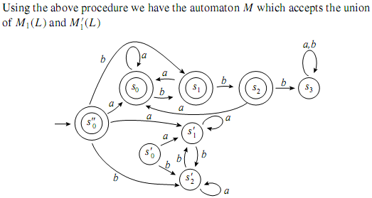
4.3 | Complement / Transpose of a DFA  Let, M be a DFA. To make $\overline{M}$, just make the non-final states final and the final states non-final.  Example  q₀  q₁  0  Figure: an FA M.  q₂  1  0  1  0, 1  q₀  q₁  0  Figure: an FA $\overline{M}$  q₂  1  0  1  0, 1
4.4 | Intersection of Two Regular Languages  Let, M₁, M₂ be two DFAs. Then, M₁ ∩ M₂ = $\overline{\overline{M_{1}}∪\overline{M_{2}}}$.  Difference of Two Regular Languages  Let, M₁, M₂ be two DFAs. Then, M₁ - M₂ = M₁ ∩ $\overline{M_{2}}$ is the set of strings that are in language M₁ but not in language M₂.
4.5 | Equivalence of States  Two states q₁ and q₂ are equivalent (denoted by q₁ ≡ q₂) if both δ(q₁, x) and δ(q₂, x) are final states, or both of them are non-final states for all x ϵ Σ*.  Minimization of DFA  To minimize a DFA, the following rules are followed:  - For each set of pair of states {p, q}, determine whether one of these states is final and the other is not. If so, p and q can never be collapsed without altering the language accepted. Mark this pair for “non-collapse”!  - For each remaining unmarked pair {p, q} and each symbol b in the alphabet, note {δ(p, b), δ(q, b)}. If δ(p, b) and δ(q, b) are distinct and the pair they form was marked in the previous round, then p and q can never be collapsed without altering the language recognized. Mark such pair for “non-collapse”!  - Repeat step 2 until, when the step is completed, no new pairs has been marked.  Note that for each pair {p, q} remaining unmarked at this stage: for any string s of symbols of the alphabet, δ(p, b) and δ(q, b) (starting in states p and q, the string s is read) must be either both final states or both non-final states.  - Collapse the states in each group into a single state. A group is final if it contains a final state of the original DFA.  Example  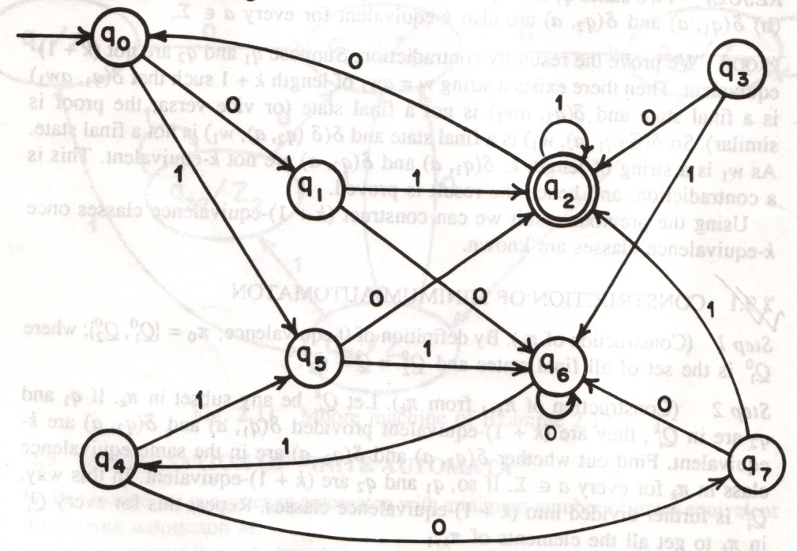  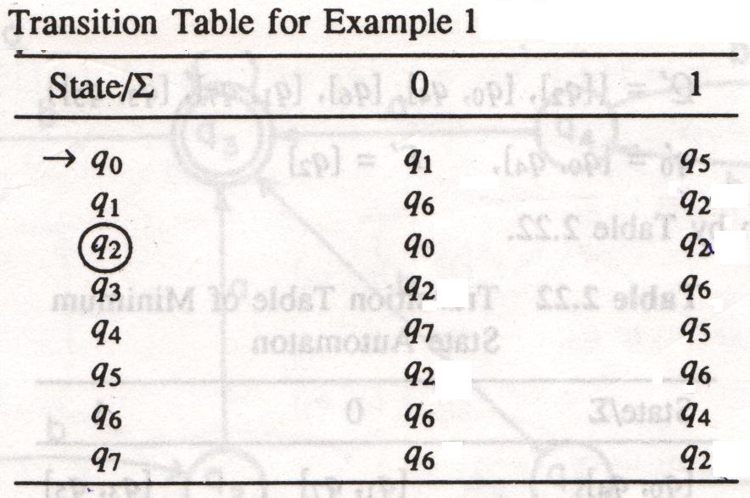  π₀ = {{q₂}, {q₀, q₁, q₃, q₄, q₅, q₆, q₇}}  π₁ = {{q₂}, {q₀, q₄, q₆}, {q₁, q₇}, {q₃, q₅}}  π₂ = {{q₂}, {q₀, q₄}, {q₆}, {q₁, q₇}, {q₃, q₅}}  ∴ The minimum state automaton is  M' = (Q', {0, 1}, δ', q₀', F')  where Q' = {[q₂], [q₀, q₄], [q₆], [q₁, q₇], [q₃, q₅]},  q₀' = [q₀, q₄],  F' = [q₂]  and δ' is given by the following table:  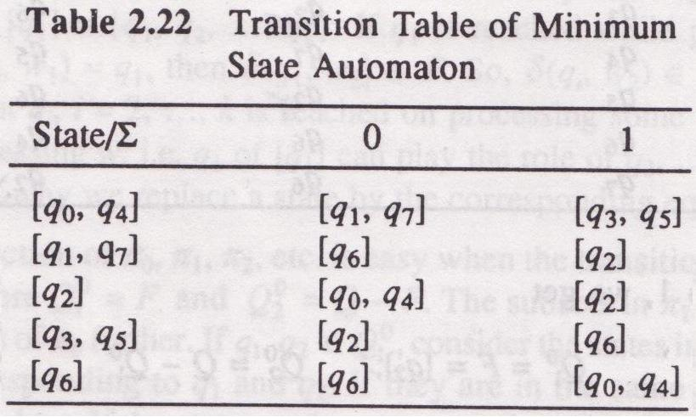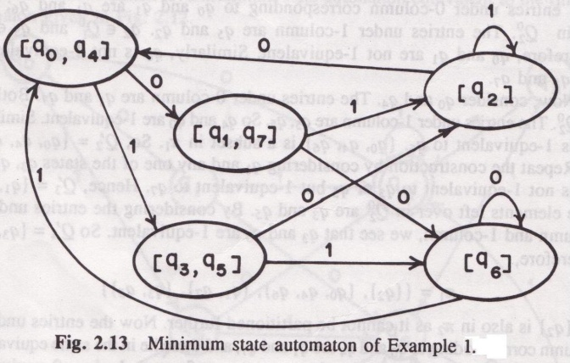
4.4 | The Pumping Lemma for Regular Languages  Let L be a regular language. Then there exists a constant n (which depends on L) such that for every string w in L such that |w| ≥ n, we can break w into three strings, w = xyz, such that:  - y ≠ ϵ  - |xy| ≤ n  - For all k ≥ 0, the string xy^{k}z is also in L.  Prove that the language L consisting of all strings with an equal number of 0’s and 1’s (not in any particular order) is not a regular language.  Let, L is regular and n be the number of states in the FA accepting L.  Let, w = 0^{n}1^{n}. Then, |w| = 2n > n.  By pumping lemma, we can write w = xyz such that |xy| ≤ n and y ≠ ϵ.  Since |xy| ≤ n and xy comes at the front of w, therefore, x and y consist of only 0’s.  Consider the string xy⁰x, i.e., xz.  Now, xz has n 1’s, since all the 1’s of w are in z.  However, xz has fewer than n 0’s, because we lost the 0’s of y and y ≠ ϵ.  ∴ xz ∉ L.  This is a contradiction.  ∴ L is not regular.  Show that L = {0^{n} | n is a perfect square} is not regular.  Let, L is regular and n be the number of states in the FA accepting L.  Let, w = $0^{n^{2}}$. Then, |w| = n² > n.  By pumping lemma, we can write w = xyz such that |xy| ≤ n and y ≠ ϵ.  Since |xy| ≤ n, then y consists of between 1 and n 0’s.  Consider the string xy²z, i.e., xyyz.  xyyz has length between n² + 1 (when y consists of 1 0) and n² + n (when y consists of n 0’s).  Since the next perfect square after n² is (n + 1)² = n² + 2n + 1, we know that the length of xyyz lies strictly between the consecutive perfect squares n² and (n + 1)². Thus, the length of xyyz cannot be a perfect square. But if the language were regular, then xyyz would be in the language, which contradicts the assumption that the language of strings of 0’s whose length is a perfect square is a regular language.  ∴ L is not regular.  Prove that L = {ww^{R} | w ϵ {0, 1}*} is not regular.  Let, L is regular and n be the number of states in the FA accepting L.  Let, w = 0^{n}1^{n}1^{n}0^{n}. Then, |w| = 4n > n.  By pumping lemma, we can write w = xyz such that |xy| ≤ n and y ≠ ϵ.  Since |xy| ≤ n and xy comes at the front of w, therefore, x and y consist of only 0’s.  Consider the string xy⁰x, i.e., xz.  Now, xz has fewer than n 0’s on the left, because we lost the 0’s of y and y ≠ ϵ.  ∴ xz has fewer 0’s on the left than on the right and so cannot be of the form ww^{R}.  ∴ xz ∉ L.  This is a contradiction.  ∴ L is not regular.  Prove that L = {w ϵ {1}* | |w| is a prime} is not regular.  Let, L is regular and n be the number of states in the FA accepting L.  Consider some prime p ≥ n + 2; there must be such a p, since there are infinite primes.  Let, w = 1^{p}. Then, |w| > n.  By pumping lemma, we can write w = xyz such that |xy| ≤ n and y ≠ ϵ.  Let, |y| = m. Then, |xz| = p – m.  Now consider the string xy^{p – m}z, which must be in L by the pumping lemma, if L really is regular.  However, |xy^{p – m}z| = |xz| + (p – m)|y| = p – m + (p – m)m = (m + 1)(p – m)  It looks like |xy^{p – m}z| is not a prime, since it has two factors m + 1 and p – m. However, we must check that neither of these factors are 1, since then (m + 1)(p – m) might be a prime after all.  But m + 1 > 1, since y ≠ ϵ tells us that m ≥ 1.  Also, p – m > 1, since p ≥ n + 2 was chosen, and m ≤ n since m = |y| ≤ |xy| ≤ n.  ∴ p – m ≥ 2.  Therefore, we have derived a contradiction by showing that some string not in the language was required by the pumping lemma to be in the language.  Thus, we conclude that L is not a regular language.

Chapter 5 & 6

Context-Free Grammar & Push-Down Automata

Concepts
5.1 | Grammar / Context-Free Grammar (CFG)  A CFG is a 4-tuple (T, V, S, P), where  T is a finite alphabet of symbols, called terminals or terminal symbols, that form the strings of the language being defined;  V is a finite set of variables, also called nonterminals or nonterminal symbols or syntactic categories, where each variable represents a language, i.e., a set of strings;  S ∈ V (the start symbol, which represents the language being defined);  P is a finite set of productions or grammar rules of the form A → α, where A ∈ V and  α ∈ (V ∪ T); A is called the head of the production, and the string α is called the body of the production.  A CFG is usually denoted by G.  Example  Let’s define a CFG that represents expressions in a typical programming language. First, we hall limit ourselves to the operators + and *, representing addition and multiplication. We shall allow only the letters a and b and the digits 0 and 1 as identifiers. Every identifier must begin with a or b, which may be followed by any string in {a, b, 0, 1}*.  Then, the CFG is G = (T, V, S, P), where  T = {+, *, (, ), a, b, 0, 1}  V = {E, I}  S = E  P = {E → I | E + E | E * E | (E),  I → a | b | Ia | Ib | I0 | I1}  Context-Free Language (CFL) / The Language Generated by a CFG  Let G = (T, V, S, P) be a CFG. The language generated by G is  L(G) = {x ∈ T* | S ${}_{G}^{*}$ x}  A language L is a CFL if there is a CFG G so that L = L(G).  Justification for the Name Context-Free Grammar  Considering the expression grammar above, it is easy to check that there is a derivation  E ⇒ I ⇒ Ib ⇒ ab  As a result, for any strings α and β, it is also true that  αEβ ⇒ αIβ ⇒ αIbβ ⇒ αabβ  The justification is that we can make the same replacements of production bodies for heads in the context of α and β as we can in isolation. In fact, it is this property of being able to make a string-for-variable substitution regardless of context that gave rise originally to the term “context-free”. There is a more powerful classes of grammars, called “context-sensitive”, where replacements are permitted only if certain strings appear to the left and/or right. Context-sensitive grammars do not play a major role in practice today.
5.2 | Conventional Notations for CFG Derivations  - Lower-case letters near the beginning of the alphabet, a, b and so on, are terminal symbols. We shall also assume that digits and other characters such as + or parentheses are terminals.  - Upper-case letters near the beginning of the alphabet, A, B and so on, are variables.]  - Lower-case letters near the end of the alphabet, w, x and so on, are strings of terminals.  - Upper-case letters near the end of the alphabet, X, Y and so on, are either terminals or variables.  - Lower-case Greek letters, such as α and β, are strings consisting of terminals and/or variables.
5.3 | Leftmost and Rightmost Derivations  In order to restrict the number of choices we have in deriving a string, it is often useful to require that at each step we replace the leftmost variable by one of its production bodies. Such a derivation is called a leftmost derivation, and is indicated using the relations $\overset{⇒}{lm}$ and ${* \atop \overset{⇒}{lm}}$, for one or many steps respectively.  Similarly, it is possible to require that at each step the rightmost variable is replaced by one of its bodies. If so, we call the derivation rightmost and use the symbols $\overset{⇒}{rm}$ and ${* \atop \overset{⇒}{rm}}$, for one or many rightmost derivation steps respectively.  Example of Leftmost and Rightmost Derivations  Given the grammar G = (T, V, S, P), where  T = {+, *, (, ), a, b, 0, 1}  V = {E, I}  S = E  P = {E → I | E + E | E * E | (E),  I → a | b | Ia | Ib | I0 | I1}  Find the leftmost and rightmost derivations of the string a * (a + b00).  E $\overset{⇒}{lm}$ E * E E $\overset{⇒}{rm}$ E * E  $\overset{⇒}{lm}$ I * E $\overset{⇒}{rm}$ E * (E)  $\overset{⇒}{lm}$ a * E $\overset{⇒}{rm}$ E * (E + E)  $\overset{⇒}{lm}$ a * (E) $\overset{⇒}{rm}$ E * (E + I)  $\overset{⇒}{lm}$ a * (E + E) $\overset{⇒}{rm}$ E * (E + I0)  $\overset{⇒}{lm}$ a * (I + E) $\overset{⇒}{rm}$ E * (E + I00)  $\overset{⇒}{lm}$ a * (a + E) $\overset{⇒}{rm}$ E * (E + b00)  $\overset{⇒}{lm}$ a * (a + I) $\overset{⇒}{rm}$ E * (I + b00)  $\overset{⇒}{lm}$ a * (a + I0) $\overset{⇒}{rm}$ E * (a + b00)  $\overset{⇒}{lm}$ a * (a + I00) $\overset{⇒}{rm}$ I * (a + b00)  $\overset{⇒}{lm}$ a * (a + b00) $\overset{⇒}{rm}$ a * (a + b00)
5.4 | Parse Trees  There is a tree representation for derivations that has proved extremely useful. This tree shows us clearly how the symbols of a terminal string are grouped into substrings, each of which belongs to the language of one of the variables of the grammar. But perhaps more importantly, the tree, known as a parse tree when used in compiler, is the data structure of choice to represent the source program. In a compiler, the tree structure of the source program facilitates the translation of the source program into executable code by allowing natural, recursive functions to perform this translation process.  Yield of a Parse Tree  If we look at the leaves of any parse tree and concatenate them from left, we get a string, called the yield of the tree, which is always a string that is derived from the root variable.  Example  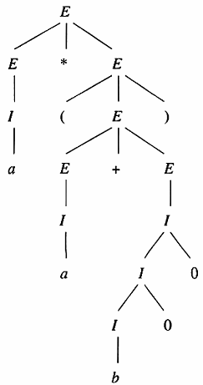The figure above shows the parse tree for the string a * (a + b00) which belongs to the CFG described in the example of 5.3.
5.5 | Applications of CFG  - Grammars are used to describe programming languages. More importantly, there is a mechanical way of turning the language description as a CFG into a parser, the component of the compiler that discovers the structure of the source program and represents that structure by a parse tree.  - The development of XML (Extensible Markup Language) is widely predicted to facilitate electronic commerce by allowing participants to share conventions regarding the format of orders, product descriptions, and many other kinds of documents. An essential part of XML is the Document Type Definition (DTD), which is essentially a CFG that describes the allowable tags and the ways in which these tags may be nested.
5.6 | Ambiguous CFG  A CFG G is ambiguous if there is at least one string in L(G) having two or more distinct derivation (parse) trees (or, equivalently, two or more distinct leftmost or rightmost derivations).  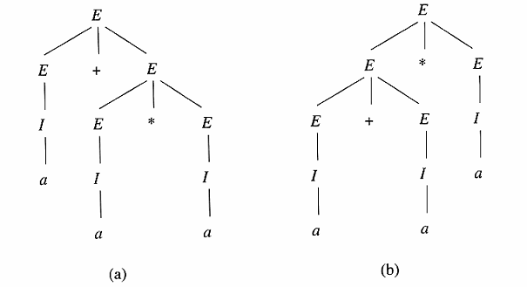  Figure: Trees with yield a + a * a, demonstrating the ambiguity of our expression grammar.  The Causes of Ambiguity in the Grammar Above  - The precedence of operators is not respected.  - A sequence of identical operators can group either from the left or from the right. For example, E + E + E can be grouped by either (E + E) + E or E + (E + E).  Removing the Ambiguity in the Grammar Above  The solution to the problem of enforcing precedence is to introduce several different variables, each of which represents those expressions that share a level of “binding strength”. Specifically:  - A factor is an expression that cannot be broken apart by any adjacent operator, either a * or a +. The only factors in our expression language are:  - Identifiers.  - Any parenthesized expression, no matter what appears inside the parentheses.  - A term is an expression that cannot be broken by the + operator. In our example where + and * are the only operators, a term is a product of one or more factors. For instance, the term a * b cannot be broken apart by placing an additive term, such as a + to its left or + a to its right.  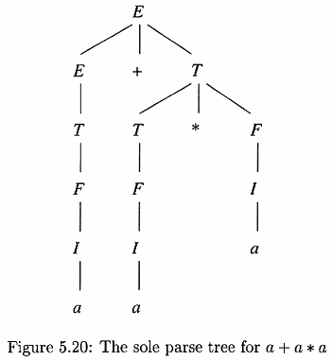  - An expression will henceforth refer to any possible expression, including those that can be broken by either an adjacent * or an adjacent +. Thus, an expression for our example is a sum of one or more terms.  The following figures show an unambiguous grammar that generates the same language as the grammar above, and the sole parse tree for the expression a + a * a.  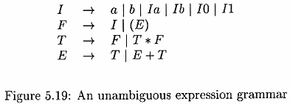
6.1 | Push-Down Automata (PDA)  A PDA is a 7-tuple (Q, Σ, Γ, q₀, Z₀, F, δ), where  Q is a non-empty finite set of as states;  Σ and Γ are non-empty finite sets (the input and stack alphabets, respectively);  q₀ ∈ Q (the initial state);  Z₀ ∈ Γ (the initial stack symbol);  F ⊆ Q (the set of final / accepting states);  δ : Q × (Σ ∪ {∈}) × Γ → the set of finite subsets of Q × Γ*  A PDA is usually denoted by P.  Note that the PDA is essentially an ∈-NFA with the addition of a stack.  The Transition Function of a PDA  δ takes as argument a triple δ(q, a, X), where:  - q ∈ Q (q is the state),  - a ∈ Σ ∪ ∈ (a is either an input symbol in Σ or a = ∈),  - X ∈ Γ (X is a stack symbol)  The output of δ is a finite set of pairs (p, γ), where p is the new state, and γ is the string of stack symbols that replaces X at the top of the stack. For example, if γ = ∈, then the stack is popped, if γ = X, then the stack is unchanged, and if γ = YZ, then X is replaced by Z, and Y is pushed onto the stack.  Example  Let’s design a PDA that accepts the language $L_{ww^{R}}$ = {ww^{R} | w is in (0 + 1)*}  The PDA for $L_{ww^{R}}$ can be described as  P = ({q₀, q₁, q₂}, {0, 1}, {0, 1, Z₀}, δ, q₀, Z₀, {q₂})  Where δ is defined by the following rules:  δ(q₀, 0, Z₀) = {(q₀, 0Z₀)}  δ(q₀, 1, Z₀) = {(q₀, 1Z₀)}  …  δ(q₁, ϵ, Z₀) = {(q₂, Z₀)}  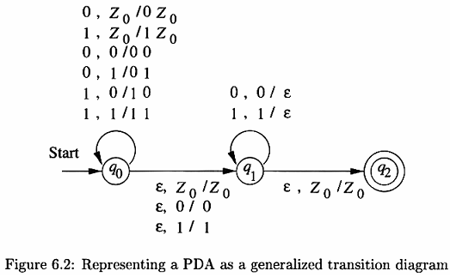
6.2 | Language of a PDA  Acceptance by Final State  Let P = (Q, Σ, Γ, q₀, Z₀, F, δ) be a PDA. Then L(P), the language accepted by P by final state, is  {w | (q₀, w, Z₀) ├${* \atop P}$ (q, ϵ, α)}  for some state q in F and any stack string α. That is, starting in the initial ID with w waiting on the input, P consumes w from the input and enters an accepting state. The content of the stack at that time is irrelevant.  Acceptance by Empty Stack  For each PDA P = (Q, Σ, Γ, q₀, Z₀, F, δ), we also define  N(P) = {w | (q₀, w, Z₀) ├* (q, ϵ, ϵ)}  for any state q. That is, N(P) is the set of inputs w that P can consume and at the same time empty its stack.  Note: The N in N(P) stands for null stack, a synonym for empty stack.

Chapter 8

Introduction to Turing Machines

Concepts
8.1 | Turing Machine (TM)  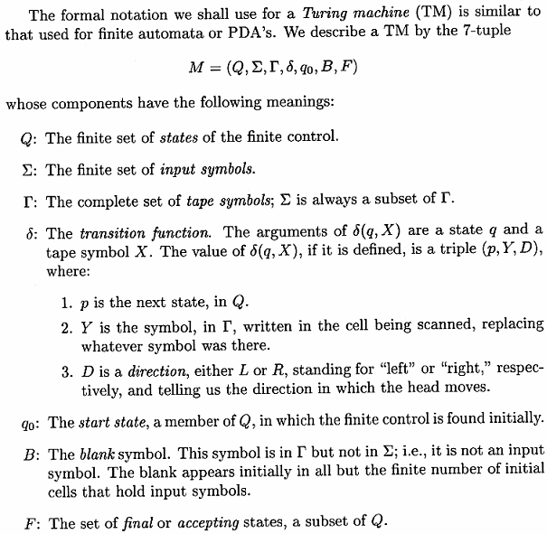  The Language of a Turing Machine  Let M = (Q, Σ, Γ, q₀, B, F, δ) be a TM. Then L(M), the language accepted by M, is  {w ϵ Σ* | q₀w ├* αpβ}  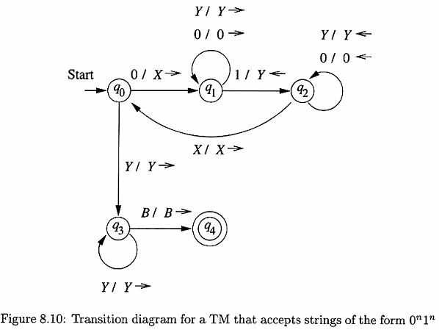  for some state p in F and any tape strings α and β.  The set of languages accepted by a TM is often called the recursively enumerable (RE) languages.  Example  Design a TM that accepts the language {0^{n}1^{n} | n ≥ 1}.  The TM is  M = ({q₀, q₁, q₂, q₃, q₄}, {0, 1}, {0, 1, X, Y, B}, δ, q₀, B, {q₄}),  where δ is given by the following table:  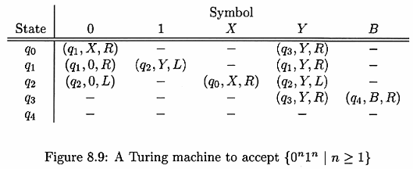
8.2 | Problem  Design a Turing Machine taking advantage of the programming techniques discussed in section 8.3 that accepts the language a^{n}b^{n}c^{n} (n ≥ 1).  General Design of the Turing Machine  q₀  q₁  q₂  q₃  q₄  q₅  a / X →  b / Y →  c / Z ←  Y / Y →  a / a →  b / b →  Z / Z ←  a / a ←  Y / Y ←  b / b ←  Z / Z →  X / X →  Y / Y →  Y / Y →  Z / Z →  B / B →  Design of the Turing Machine using storage in the state and multiple tracks techniques:  Let the Turing Machine be defined as M = (Q, Σ, Γ, δ, [q₀, B], [B, B], {[q₅, B]})  where Q = Set of States = {q₀, q₁, … q₅} × {a, b, c, B}  Σ = Set of Input Symbols = {a, b, c}  Γ = Set of Tape Symbols = {B, *} × {a, b, c, B}  δ = Transition Function  [q₀, B] = Initial State  [B, B] = Blank Symbol  {[q₅, B]} = Set of Final States  Transition Diagram of M:  [q₀, B]  [B, a] / [*, a] →  [q₁, a]  [B, a] / [B, a] →  [q₂, b]  [B, b] / [*, b] →  [B, b] / [B, b] →  [q₃, c]  [B, c] / [*, c] ←  [B, b] / [B, b] ←  [*, b] / [*, b] ←  [B, a] / [B, a] ←  [*, a] / [*, a] →  [*, b] / [*, b] →  [*, c] / [*, c] →  [*, c] / [*, c] ←  [q₄, b]  [*, b] / [*, b] →  [*, b] / [*, b] →  [*, c] / [*, c] →  [q₅, B]  [B, B] / [B, B] →  Transition Table of M:  States Input Symbols  [B, a] [B, b] [B, c] [*, a] [*, b] [*, c] [B, B]  →[q₀, B] ([q₁,a],[*,a],R) — — — ([q₄,B],[*,b],R) — —  [q₁, a] ([q₁,a],[B,a],R) ([q₂,b],[*,b],R) — — ([q₁,a],[*,b],R) — —  [q₂, b] — ([q₂,b],[B,b],R) ([q₃,c],[*,c],L) — — ([q₂,b],[*,c],R) —  [q₃, c] ([q₃,c],[B,a],L) ([q₃,c],[B,b],L) — ([q₀,B],[*,a],L) ([q₃,c],[*,b],L) ([q₃,c],[*,c],L) —  [q₄, b] — — — — ([q₄,B],[*,b],R) ([q₄,B],[*,c],R) ([q₅,B],[B,B],R)  [q₅, B] — — — — — — —  Design of the Turing Machine using subroutine:  q₁  q₂  q₃  b / Y →  c / Z ←  Y / Y →  a / a →  b / b →  Z / Z →  Start  Figure 1: The subroutine Check.  q₀  q₁  q₃  q₄  q₅  a / X →  Check  Y / Y →  Y / Y →  Z / Z →  B / B →  X / X →  Z / Z ←  a / a ←  Y / Y ←  b / b ←  Figure 2: The complete program that accepts strings of the language a^{n}b^{n}c^{n} (n ≥ 1) using the subroutine Check.

Appendix A

Building Regular Expressions

(Solution to Exercises of Ullman and Martin)
  - Solved by Md. Abdul Kader
Martin: The language of all strings containing exactly two 0’s.
Answer: 1*01*01*
Martin: The language of all strings containing at least two 0’s.
Answer: (1+0)* 01*0 (1+0)*
Martin: The language of all strings that do not end with 01.
Answer: (1+0)*(00+10+11)+(1+0+e)
Martin: The language of all strings that begin or end with 00 or 11.
Answer: (00+11)(1+0)*+(0+1)*(00+11)
Martin: The language of all strings not containing the substrings 00.
Answer: (01+1)*(0+e)
Martin: The language of all strings in which the number of 0’s is even.
Answer: (1*01*01*)*
Martin: The language of all strings containing no more than one occurrence of the string 00.
Answer: (01+1)*(00+0+e)(10+1)* //special case 0
Martin: The language of all strings in which every 0 is followed immediately by 11.
Answer: 1*(011)*1*
Martin: The language of all strings containing both 11 and 010 as substrings.
Answer: (1+0)*11(1+0)* 010(1+0)* + (1+0)*010(1+0)* 11(1+0)*
Ullman: The set of strings of 0’s and 1’s whose tenth symbol from the right end is 1.
Answer: (1+0)*1(1+0)
Ullman: The language of all strings with at most one pair of consecutive 1’s.
Answer: (10+0)* (11+1+e) (01+0)*
Ullman: The language of all strings whose no of 0’s is divisible by five.
Answer: (1*01*01*01*01*01*)*
Unknown: The language of all strings whose no of 0’s are even and no of 1’s are odd.
Answer: X = (1+010) //base case
Y = (1010+1001+0101+0110+00+11)* //recursive case
Final RE = YXY
Ullman: The set of strings over alphabet {a,b,c} containing at least one ‘a’ and at least one ‘b’.
Answer: X = (a+b+c)*
Final RE = XaXbX + XbXaX
Ullman: The set of all strings of 0’s and 1’s such that every pair of adjacent 0’s appears before any pair of adjacent 1’s.
Answer: X = Does not contain 00 as a sub-set.
X = (01+1)*(0+e)
Final RE = (0+1)*11X + X

Appendix B

Solution to Selected Questions from the In-Course Exams of Previous Years

- Draw the transition diagram of the DFA accepting the set of all strings over {0, 1} that contain 1010 as a substring.
A
B
C
D
E
1
0
0
1
0, 1
0, 1

Step 1: (Draw the NFA)
A
B
C
D
E
1
0
0
1
0, 1
0
0
1
1

Step 2: (Make it DFA)

- Draw an FA accepting the language {x0y : x, y ∈ {0, 1}* and |x| + |y| = 5}.
Step 1: (Draw the NFA accepting the language where |x| = 5)
A
B
C
D
F
0, 1
0, 1
0, 1
0, 1
E
0, 1
Step 2: (Draw the NFA accepting the language where |y| = 5)
G
H
I
J
L
0, 1
0, 1
0, 1
0, 1
K
0, 1
Step 3: Now, as the string is like x0y, therefore, we must start from the NFA of step 1 and finish at the NFA at step 2. However, we have to insert a 0-transition from the DFA of step 1 to the DFA of step 2. Now, if |x| = 0, then |y| must be 5. So, we can insert a 0-transition from state A to G.
G
H
I
J
L
0, 1
0, 1
0, 1
0, 1
K
0, 1
A
B
C
D
F
0, 1
0, 1
0, 1
0, 1
E
0, 1
0
Step 4: Similarly, if |x| = 1, then |y| must be 4. So, we can insert a 0-transition from state B to H. And in similar manner, we get:
G
H
I
J
L
0, 1
0, 1
0, 1
0, 1
K
0, 1
A
B
C
D
F
0, 1
0, 1
0, 1
0, 1
E
0, 1
0
0
0
0
0
0

- Simplify the RE as much as possible: a*b + a*bbb* + a* and draw the equivalent FA.
a*b + a*bbb* + a*
= a*(b + bbb* + $ϵ$)
= a*(b ($ϵ$ + bb*) + $ϵ$)
= a*(bb* + $ϵ$) [ $ϵ$ + xx* = x*]
= a*b* [ $ϵ$ + x* = x*]
A
B
$$ϵ$$
a
b
Equivalent $ϵ$-NFA:
A
B
b
a
b
Equivalent NFA:
A
B
b
a
b
$$∅$$
a
a, b
Equivalent DFA:

- Find a string that
- is represented by both the regular expressions r and s and
- is not represented by either r or s
where r = a* + b* and s = ab* + ba* + b*a + (a*b)*
- a
- aba

- Write down an RE that represents all strings w over {0, 1} such that the first and last characters of w are the same and w contains at least three 0’s.
Step 1: The string contains at least three 0’s.
000
Step 2: There may be any number of 0’s or 1’s before and after each 0.
(0 + 1)* 0 (0 + 1)* 0 (0 + 1)* 0 (0 + 1)*
Step 3: The first and the last characters must be the same. Let, the first and last characters are 1.
1 (0 + 1)* 0 (0 + 1)* 0 (0 + 1)* 0 (0 + 1)* 1
Step 4: Let, the first and last characters are 0.
0 (0 + 1)* 0 (0 + 1)* 0
Step 5: Combine the two using union.
1 (0 + 1)* 0 (0 + 1)* 0 (0 + 1)* 0 (0 + 1)* 1 + 0 (0 + 1)* 0 (0 + 1)* 0
- Given a DFA accepting a language L, how do we construct the DFA accepting the complement of L? Does your construction work for NFAs and NFAs with epsilon transitions? Justify your answer. [Marks: 4]
Given a language L, we can construct the complement DFA of L by making the final states of the DFA accepting L as non-final and vice-versa.
This construction does not work for NFAs or $ϵ$-NFAs. Because, in NFAs or $ϵ$-NFAs, there may be states which have multiple transitions. In that case, the final states cannot be identified properly and hence the construction will not work. But in DFAs, the final states are fixed and can be identified properly. So, this construction works for DFAs only.
For example, let L = {w | w ends with 0}.
Then, L' = {w | w does not end with 0}.
A
B
0
0, 1
0
Now, the NFA for L is:
A
B
0
1
0
1
And the DFA for L is:
A
B
0
1
0
1
Therefore, the DFA for L' is:

A
B
0
0, 1
0
But the NFA for L' would be:
Which is not correct, as it also accepts the strings ending with 0.

- Construct a DFA accepting binary numbers that are divisible by 3.
A
C
0
0
0
1
B
1
1
- Simplify the following RE: (a + b)($ϵ$ + aa)⁺ + (a + b).
(a + b)($ϵ$ + aa)⁺ + (a + b)
= (a + b) (($ϵ$ + aa)⁺ + $ϵ$)
= (a + b)($ϵ$ + aa)* [x⁺ + $ϵ$ = x*]
= (a + b)($ϵ$*(aa)*)* [(x + y)* = (x*y*)* = (x* + y*)*]
= (a + b)((aa)*)*
= (a + b)(aa)* [(x*)* = x*]
- Find an FA that accepts all strings over {a, b} that begin or end with aa or bb.
Step 1: RE that accepts all strings that begin with aa or bb:
(aa + bb)(a + b)*
Step 2: RE that accepts all strings that end with aa or bb:
(a + b)*(aa + bb)
Step 3: RE that accepts all strings that begin or end with aa or bb:
(aa + bb)(a + b)* + (a + b)*(aa + bb)
Step 4: NFA for (aa + bb)(a + b)*:
A
D
b

a

a
B
b

a, b
C
Step 5: NFA for (a + b)*(aa + bb):
E
H
b

a

a
F
b

a, b
G
Step 6: $ϵ$-NFA for (aa + bb)(a + b)* + (a + b)*(aa + bb):
E
H
b

a

a
F
b

a, b
G
A
D
b

a

a
B
b

a, b
C
S
$$ϵ$$
$$ϵ$$
Equivalent NFA:
E
H
b

a

a
F
b

a, b
G
D
b

a

a
B
b

a, b
C
S
a, b
a
b

- Draw the transition diagram of the DFA accepting the languages over {0, 1}
  - The set of all strings that has at least two 0’s.
  - The set of all strings that does not end in 0010.
A
B
C
0
0
0, 1
1
1

- Step 1: DFA that accepts strings that end with 0010:
A
B
C
D
E
0
0
0
1
0
1
0
1
1
1
Step 2: DFA that accepts strings that does not end with 0010:
A
B
C
D
E
0
0
0
1
0
1
0
1
1
1

- Write down a regular expression for the language L = {w ∈ {a, b}* | w does not contain an occurrence of ab}.
Step 1: w should not contain ab. So, the RE for w cannot be a*b, ab* or a*b*. However, the RE for w may be $ϵ$, a*, b*, or b*a*. Note that the RE b*a* includes the REs $ϵ$, a* and b*.
Step 2: Therefore, the final RE is b*a*.

- Find and draw the minimum-state DFA for the DFA below:
1
2
3
4
6
5
7
a
b

a
b

a
b

a
b

a
b

a
b

a
b

Transition Table of the given DFA:
State | a | b
→ 1 | 2 | 3
2 | 4 | 5
3 | 6 | 7
* 4 | 4 | 5
5 | 6 | 7
* 6 | 4 | 5
* 7 | 6 | 7
Minimization of the given DFA:
Step 1: Separating final and non-final states, we get the following groups:
{1, 2, 3, 5} {4, 6, 7}
Step 2: From the group {4, 6, 7}, we separate the group {4, 6} as they move to the non-final group {1, 2, 3, 5} for the input symbol b.
{1, 2, 3, 5} {4, 6} {7}
Step 3: From the group {1, 2, 3, 5}, we separate the group {3, 5} as they move to the final group {7} for the input symbol b.
{1, 2} {3, 5} {4, 6} {7}
Step 4: From the group {1, 2}, we separate the elements into two groups as for the symbol a, state 1 remains in the same group whereas state 2 moves to the group {4, 6}.
{1} {2} {3, 5} {4, 6} {7}
Diagram of the minimum-state DFA:
1
2
35
46
7
b

a
b

a
b

a
b

a
b

a

- Find the regular expression equivalent to the DFA in the following figure:
States | Inputs
 | 0 | 1
→* Q₁ | Q₁ | Q₂
Q₂ | Q₃ | Q₂
Q₃ | Q₁ | Q₄
Q₄ | Q₁ | Q₂
Step 1: Draw the transition diagram.
Q₁
Q₂
Q₃
Q₄
1
0
1
0
1
0
1
0
Step 2: Eliminate Q₂.
Q₁
Q₃
Q₄
11*0
1
0
0
11*0
0
Step 3: Eliminate Q₃.
Q₁
Q₄
11*01
0
11*00
11*01
0 + 11*00
Q₁
Q₄
11*01
0 + 11*00
11*01
0 + 11*00
Step 4: Eliminate Q₄.
Q₁
11*01 (11*01)* (0 +11*00)

0 + 11*00
Q₁
0 + 11*00 + 11*01 (11*01)* (0 +11*00)

Step 5: Eliminate loop.
Q₁
(0 + 11*00 + 11*01 (11*01)* (0 +11*00))*

Final RE: (0 + 11*00 + 11*01 (11*01)* (0 +11*00))*

In a recursive definition, there are three steps: - Certain objects are defined to be in the set. - Rules are listed for producing new objects in the set from other objects already in the set. - There are no other elements in the set. Mathematical induction is a special case of a recursive definition.
The closure of $∅$ contains only the string $ϵ$.
x⁺ = x + xx + xxx + … x* = $ϵ$ + x + xx + xxx + … $∴$ xx* = x$ϵ$ + xx + xxx + … = x + xx + xxx + … = x⁺
x* = $ϵ$ + x + xx + xxx + … = $ϵ$ + x⁺ = x⁺ +$ϵ$

